EUMETSAT Satellite Application Facility on Climate Monitoring



Combined Technical Notes

Evaluation report on the homogeneous transition of cloud physical properties from MSG to MTG

&

Evaluation report on the transition of TOA radiation components from MSG to MTG

Reference Number: | SAF/CM/RMIB/TN/CDOP3/WP2340
Issue/Revision Index: | 1.0
Date: | 15.11.2022

Document Signature Table
 | Name | Function | Date
Author | Jan Fokke Meirink (KNMI)  Nicolas Clerbaux (RMIB) | Scientist  Scientist | 15.07.2022  15.07.2022
Editor | Marc Schröder (DWD) | Science Coordinator | 15.11.2022
Approval | CM SAF Steering Group
Release | Rainer Hollmann (DWD)

DRP: NC
Non-public document

Document Change Record
Issue/ Revision | Date | DCN No. | Changed Pages/Paragraphs
1.0 | 15.11.2022 | SAF/CM/RMIB/TN/CDOP3/WP2340 | First issue

Contents

Executive Summary 5
1 Introduction 6
1.1 Structure of this document 6
1.2 Reference documents 6
1.3 Related CM SAF / EUMETSAT products 7
1.3.1 The CLAAS (Interim) Climate Data Record ((I)CDR) 7
1.3.2 The GERB+SEVIRI ed02 dataset 7
1.3.3 The CM SAF MVIRI+SEVIRI dataset 8
1.3.4 The GERB products 8
1.3.5 EUMETSAF CF OLR Product 8
2 Data and Methods 10
2.1 MTG / MSG spectral responses curves 10
2.2 FCI L1c Test Dataset [RD4] 11
2.3 Radiative transfer computations for cloud retrieval 11
2.4 Radiative transfer computations for TOA radiation products 12
3 SEVIRI level 1.5 from FCI Level 1c 13
3.1 Introduction 13
3.2 Repeat cycle and temporal averaging 13
3.3 Spatial processing 13
3.4 Spectral band corrections – Solar channels 13
3.5 Spectral band corrections – Thermal channels 14
3.6 MTG solar calibration consideration 15
3.7 Illustrations using the FCI l1c test data 15
3.8 Activities during MTG commissioning 16
4 Transition of cloud products from MSG to MTG 17
4.1 Comparison of atmospheric correction for SEVIRI and FCI 17
4.2 Cloud optical and microphysical property retrievals based on test data 20
4.3 Activities during MTG commissioning 24
5 TOA radiation products 25
5.1 Using FCI for TOA radiation in CLAAS 25
5.1.1 Spectral bands adjustment 25
5.1.2 Empirical relations for MTG 25
5.2 Exploiting the improved capabilities of MTG/FCI 26
5.2.1 Estimation of the BroadBand (BB) unfiltered solar radiance 26
5.2.2 Estimation of the BroadBand (BB) unfiltered thermal radiance 28
5.2.3 Angular Dependency Models (ADMs) for solar radiation 30
5.2.4 Angular Dependency Models for thermal radiation 31
5.3 Activities during MTG commissioning 31
6 Summary 33
Acknowledgements 33
References 34
Acronyms 35
Annex 1 : Spectral band adjustments for solar channels 39
Annex 2 : Spectral band adjustments for thermal channels 43
Annex 3 : Meteosat Reference Operation Baseline (as of March 2022) 49
Annex 4 : Prepare for future instruments and releases (WP 2340) - Extract from the CDOP3 Project proposal 50

Executive Summary

This combined report summarizes activities done in preparation of the transition from Meteosat Second Generation (MSG) to Meteosat Third Generation (MTG) for the Climate Monitoring Satellite Application Facility (CM SAF) clouds and TOA radiation products. The report compiles 2 deliverables of the CDOP-3 Work Package WP-2340 (detailed in Annex 4): one about the transition of the cloud products, one for the TOA radiation products.
As MTG-I1 has not yet been launched (launch planned for 14 Dec 2022), this report is based on the FCI Test Dataset. To consolidate the conclusions of this report, a series of activities are proposed to be conducted during the MTG-I1 commissioning (2023).
A first topic of investigation is on the continuation of the CM SAF regional MSG/SEVIRI record (CLAAS) with the SEVIRI “heritage” channels present on MTG/FCI. Given the significant differences in Spectral Response Functions (SRFs) between the 2 generations of imagers, simple spectral band adjustments are not recommended. Instead, specific Look Up Tables (LUTs) should be created to account for the specificities of MTG/FCI spectral responses, especially for the visible 0.8 µm and near infrared 1.6 µm channels that show marked differences with the corresponding SEVIRI channels.
When applied to the FCI test data, the outputs of the CPP algorithm do not match perfectly the corresponding MSG-SEVIRI retrievals, especially for the cloud effective radius. Currently it is not known whether this is due to the radiative transfer computations used in the CPP retrieval or to the creation of the FCI test data. Further investigations will be performed to resolve this, and improved insight is expected when real data become available during the MTG-I1 commissioning phase.
A second point of investigation is on the use of the 5 additional solar channels that will be available with MTG/FCI (the new channels at 0.4µm, 0.5µm, 0.9µm, 1.2µm and 2.2µm). Concerning TOA radiation, these additional channels allow a significant improvement of the estimation of the broadband integrated solar radiance with respect to SEVIRI. Using regressions on the 8 solar channels, the uncertainty on the BB radiance is estimated at 1.3% (RMSE) while it is 4.3% with the 3 SEVIRI solar channels. This would make a Reflected Solar Flux (RSF) product from MTG close to what is obtained with the broadband SW channel of the GERB instrument (which has an associated unfiltering error of about 0.5%).

Introduction

Structure of this document
This document is structured as follows:
- Sections 1.2 and 1.3 list the reference documents and products.
- Section 2 presents the data used in the study: the spectral response functions, the FCI test data, and the Radiative Transfer Model (RTM) simulations.
- Section 3 analyzes how the MSG/SEVIRI can be simulated from the MTG/FCI observations, with focus on the spectral band adjustments.
- Section 4 discusses the transition of the cloud products from MSG to MTG. It first discusses the atmospheric corrections for the FCI channels, then it shows how the CPP retrieval on the FCI test data agrees with the SEVIRI products, finally it discusses activities to be performed during FCI commissioning.
- Section 5 discusses the transition of the TOA radiation products from MSG to MTG. It first discusses how FCI and SEVIRI can be combined to form a homogeneous record of TOA radiation fluxes, e.g. in CLAAS-4. Then, it analyzes how the full set of FCI spectral channels can be used to continue the record of the GERB broadband instruments. Finally it discusses activities to be performed during FCI commissioning.
- Section 6 concludes the report.

Reference documents
[RD1] | MTG FCI L1 Product User Guide [FCIL1PUG]
[RD2] | MTG-FCI: ATBD for Outgoing Longwave Radiation Product
[RD3] | MTGTD-392 FCI SRF for Users
[RD4] | MTGTD-360 FCI L1c Test Dataset
[RD5] | Algorithm Theoretical Basis Document SEVIRI cloud physical products (SAF/CM/KNMI/ATBD/SEV/CPP/3.3)
[RD6] | Product User Manual SEVIRI cloud products Edition 3 (CLAAS-3) (SAF/CM/KNMI/PUM/SEV/CLD/3.1)
[RD7] | MSG-SEVIRI: ATBD for Outgoing Longwave Radiation Product

Related CM SAF / EUMETSAT products

The CLAAS (Interim) Climate Data Record ((I)CDR)
The CLoud property dAtAset using SEVIRI (CLAAS) is a climate data record (CDR) of cloud properties derived from Spinning Enhanced Visible and InfraRed Imager (SEVIRI) observations onboard the EUMETSAT METEOSAT Second Generation (MSG) satellites. The third edition, CLAAS-3, is planned to be published in late 2022. It follows the earlier editions CLAAS-1 (Stengel et al. 2014) and CLAAS-2 (Benas et al., 2017). In addition to the CDR, spanning the period from 2004 to 2020, CLAAS-3 features an Interim Climate Data Record (ICDR), starting in 2021 and extended operationally with low latency into the present. The ICDR is produced with the same algorithms as the CDR but with a few differences in input data.
CLAAS-3 contains the following cloud properties: (probabilistic) cloud mask / fractional cloud cover, cloud top height/pressure/temperature, cloud thermodynamic phase, liquid and ice water path, optical thickness, and particle effective radius as well as droplet number concentration and geometrical thickness of liquid clouds. All parameters can be accessed on Level-2 basis, which means in original SEVIRI pixel size (3 x 3 km² at sub-satellite point) and at 15-minute resolution. The products are also available as daily and monthly composites on a regular latitude/longitude grid with a spatial resolution of 0.05° × 0.05° degrees. Additionally, monthly aggregations of cloud top pressure and optical thickness into joint cloud property histograms and monthly mean diurnal cycles with a temporal resolution of one hour are provided on a 0.25° × 0.25° grid. More information can be found in the CLAAS-3 Product User Manual [RD6].
CLAAS-3 has been demonstrated to be an overall very stable data record. To a large extent this stability is enabled by the use of nearly identical SEVIRI instruments (Meteosat-8 to Meteosat-11), which have been carefully calibrated (Meirink et al., 2013). In the next CM SAF phase (CDOP-4), the release of a fourth CLAAS edition is planned, in which the successor of SEVIRI, i.e. the Flexible Combined Imager (FCI) onboard MTG, needs to be incorporated. Since the spatial, temporal and spectral characteristics of FCI are different from those of SEVIRI, achieving a smooth transition between the instruments poses a significant challenge to the cloud product processing system. This report describes a number of preparatory investigations to reach this goal.

The GERB+SEVIRI ed02 dataset
The TOA Radiation GERB/SEVIRI record from CM SAF provides estimates of the Top Of Atmosphere broadband radiative fluxes derived from the Geostationary Earth Radiation Budget (GERB) and the Spinning Enhance Visible and InfraRed Imager (SEVIRI) sensors onboard the Meteosat Second Generation satellites. The outgoing radiation is reported in terms of TOA Reflected Solar (TRS) and TOA Emitted Thermal (TET) fluxes. The original GERB level 2.0 High Resolution (HR) and SEVIRI level 1.5 observations have been processed to estimate solar and thermal fluxes in hourly boxes on the GERB HR grid. From the hourly values, the daily mean, the monthly mean and the monthly mean diurnal cycle are estimated. Finally, the data is regridded on a regular latitude-longitude grid covering 70°N - 70° and 70°W-70°E, with a spatial resolution of 0.1°. Being based on 15' geostationary observations, the data record is very well suited to study the diurnal cycle of atmospheric radiation, e.g. the effect of convection on the OLR. The spatial resolution of the data, 0.1°, allows studying the effect on the radiation budget of processes taking place at fine spatial scale, e.g. valley fog. Combining the all-sky and clear-sky allows quantifying the cloud radiative effects at high spatial and temporal resolution.
Information about this dataset is available at https://doi.org/10.5676/EUM_SAF_CM/TOA_GERB/V002

The CM SAF MVIRI+SEVIRI dataset
The CM SAF Top of Atmosphere Radiation MVIRI/SEVIRI Data Record provides a homogeneous satellite-based climatology of the TOA Reflected Solar (TRS) and Emitted Thermal (TET) radiation in all-sky conditions. The MVIRI and SEVIRI instruments on board the METEOSAT First and Second Generation satellites are combined to generate a long Thematic Climate Data Record covering a period of time of 32 years, from 1 February 1983 to 30 April 2015. The TOA radiation products are provided as daily mean, monthly mean and monthly averages of the hourly integrated values (diurnal cycle). The data is provided on a regular grid at a spatial resolution of 0.05°x0.05° and covers the region between ±70° longitude and ±70° latitude. In addition to covering a long time period, the MVIRI/SEVIRI data record is also featured by excellent spatial and temporal samplings, similar to CLAAS. Information about this dataset is available in (Urbain et al., 2017) and also at https://doi.org/10.5676/EUM_SAF_CM/TOA_MET/V001
In this report we do not specifically address the continuation of such a record, combining MVIRI+SEVIRI+FCI. No particular problems are expected concerning the estimation of heritage VIS+WV+IR channels from FCI.

The GERB products
The GERB instruments (Harries et al., 2005) are flying on all of the 4 MSG satellites. The GERB instrument provides broadband (BB) observations with and without a quartz filter (respectively shortwave (SW) and total (TOT) channels). A LW channel can be defined by subtraction of the SW contribution in the TOT channel. Although the instrument provides BB measurements, the data still needs to be “unfiltered” to correct for small variation of the spectral sensitivity of the instrument and its 5-mirrors optics. The unfiltering error is evaluated at about 0.5% for the SW channel (Clerbaux et al, 2008a) and about 0.1% for the LW channel (Clerbaux et al, 2008b).
There is no BB observation on the MTG and EPS-SG systems. It is generally admitted that the large number of NB observations (resp. 16 and 20 spectral channels), covering the main atmospheric reflections and absorptions processes, would enable the estimation of Earth Radiation Budget (ERB) products with sufficient accuracy, as well for climate monitoring as for processes studies. Continuation of the GERB record using MTG-FCI is one of the topics covered by this report. Funding for GERB operations is assured until 29/2/2024. Therefore, GERB data should be available at least during MTG commissioning and probably longer.

EUMETSAF CF OLR Product
The EUMETSAT Central Facility provides recipes for OLR estimation from the MSG/SEVIRI thermal channels. Regressions are provided for 3 cloudiness classes: cloud free, opaque cloud and semi-transparent clouds. The coefficients are provided in a technical document for the 4 MSG spacecrafts [RD7].
The algorithm will be applied to MTG FCI data in the FDHSI mode (i.e. 10’ repeat cycle, 2km spatial resolution), see [RD2]. The input cloud information will be extracted from the SCE-CLA product, specifically the Cloud Type (CT) information, which is itself produced using the SAF on Nowcasting (NWC SAF) software. The method is well described in [RD2], but the coefficients for MTG seem not to be published yet (the ATBD just specifies that “it is assumed here that a set of such coefficients exist, pre-computed in some offline (science) environment”). A-priori, the continuation of this product with FCI is not a problem given the closeness of the thermal spectral band.

Data and Methods

MTG / MSG spectral responses curves
The study is based on spectral responses from SEVIRI on MSG4 and FCI on MTG-I1. The MSG spectral responses are published by EUMETSAT as excel sheets (in document MSG_SEVIRI_Spectral_Response_Characterisation.XLS ) available via
https://www.eumetsat.int/media/8871
The FCI responses are available via the sftp site [RD3]:
https://sftp.eumetsat.int/public/folder/UsCVknVOOkSyCdgpMimJNQ/User-Materials/MTGUP/Materials/FCI-SRF_Apr2022/
EUMETSAT mentions that: The dataset represents the best knowledge of the FCI Spectral Response Functions (SRF) in September 2021. The SRF, as obtained by Thales Alenia Space (France) and ESA, has been established by a combination of theoretical modelling and measurements (NIR and IR filters and windows, as well as VIS retinas). (...). For each channel, the SRF has been computed for all detector elements. The set of SRFs have been averaged to get a single-averaged SRF per channel. The SRFs have been normalised by dividing the average SRF by its maximum value in order to obtain a normalised spectral response function. Note that the SRFs are provided for each spectral channel regardless of their spatial sampling configurations. For instance, the SRF of VIS0.6 represents the SRF of FDVIS0.6 (FDHSI at 1 km) and HRVIS0.6 (HRFI at 0.5 km) products. The same is true for NIR2.2, IR3.8 and IR10.5.
Figure 1 shows the 8 MTG/FCI and 3 MSG/SEVIRI solar channels, respectively in black and red. The FCI CH03 is close to the VIS006 channel, although a bit narrower. The FCI CH04 is clearly shifted with respect to the MSG VIS008 channel and there is almost no spectral overlap. The central wavelength moves from 0.83µm to 0.87µm. Finally, the near infrared channel at 1.6µm is much narrower for MTG.
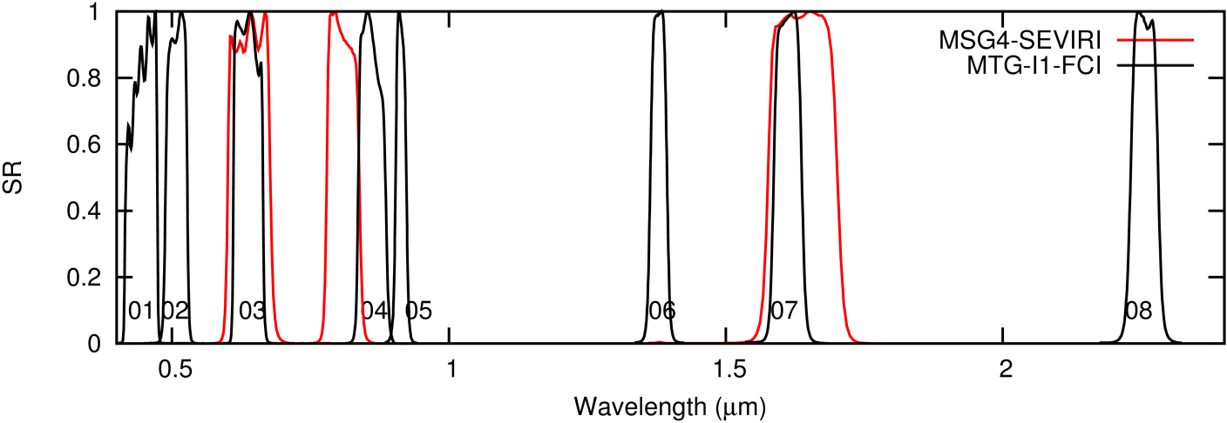
Figure 1 : MTG-I1 FCI (black) and MSG4 SEVIRI (red) spectral response curves for the solar channels.
The FCI instrument presents the same (number of) thermal channels as SEVIRI. Figure 2 shows good spectral agreements for the first 5 channels but significant differences for the last 3 channels, the CH14 (10.8µm), CH15 (12.0 µm) and CH16 (CO2 channel at 13.4 µm).
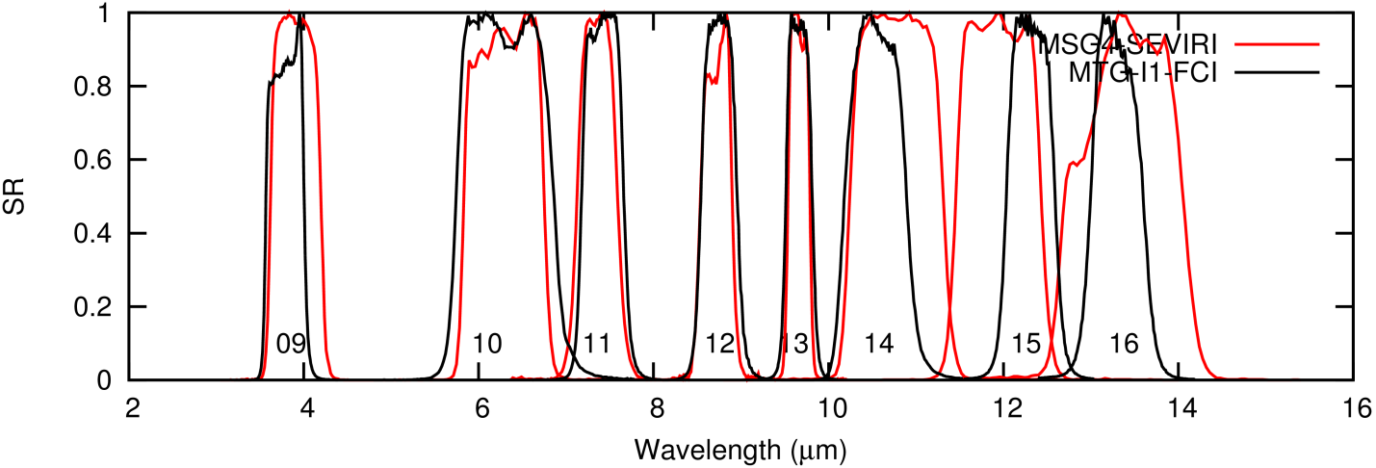
Figure 2 : MTG-I1 FCI (black) and MSG4 SEVIRI (red) spectral response curves for the thermal channels.

FCI L1c Test Dataset [RD4]
This dataset contains a 24-h simulation for all FCI channels that are spectrally representative of the actual output, using the latest FCI spectral response functions. The package contains CharLS-compressed and uncompressed versions of the data.
The dataset can be downloaded from:
https://www.eumetsat.int/new-fci-l1c-24h-spectrally-representative-test-dataset
For this study the uncompressed version has been used.
In addition, SEVIRI L1.5 data for all channels were generated based on the same underlying simulated spectra used to create the FCI data. These were made available by Alessio Bozzo (EUMETSAT).

Radiative transfer computations for cloud retrieval
The retrieval of cloud optical thickness and particle effective radius, and derived variables, relies on pre-calculated look-up tables of simulated TOA reflectances for cloudy skies. The simulations are performed with the DAK radiative transfer model (De Haan et al. 1987; Stammes 2001) for an atmosphere without trace gases (except ozone) at wavelengths of 0.64 µm, 1.63 µm and 3.83 µm, close to the centre of the respective satellite imager narrowbands. The simulations include Rayleigh scattering by air molecules and absorption by ozone, but neglect absorption by other atmospheric gases (see [RD5] for more details). Before a reflectance simulated by DAK can be compared to an observed reflectance, the absorption by atmospheric gases in the band has to be taken into account. This so-called atmospheric correction has been implemented based on MODTRAN4.2 (Berk et al. 2000) radiative transfer simulations. The atmosphere-corrected TOA reflectance ($R_{atm.corr.}$) is calculated as:
$$R_{atm.corr.}=R t_{a,ac}\left(θ_{0}, H_{c}, \text{WVP}, \text{TCO}\right) t_{a,ac}\left(θ,{ H}_{c}, \text{WVP}, \text{TCO}\right)$$
where R is the reflectance at the central wavelength and $t_{a,ac}$ is the above-cloud atmospheric transmissivity. Fixed (Mid-Latitude Summer) vertical profiles of water vapour and ozone are assumed, so that $t_{a,ac}$becomes a function of the viewing or solar zenith angle ($θ$ /$θ_{0}$), the cloud top height ($H_{c}$), water vapor path (WVP) and total column ozone (TCO). Absorption by trace gases within and below the cloud is neglected. The two-way transmissivity, i.e. the product of the two transmissivities in the equation, is a function of the geometrical air mass factor (AMF = 1/cos($θ_{0}$) + 1/cos($θ$)). This two-way transmissivity is in practice simulated by MODTRAN using a Lambertian surface, with arbitrary reflectance, placed at the cloud top height, and stored in a (Look Up Table) LUT with dimensions AMF, $H_{c}$, WVP, and TCO. For the current preparatory study a new LUT based on the spectral response functions of the FCI channels has been produced.

Radiative transfer computations for TOA radiation products
For the TOA radiation part of this study, 2 large databases of simulated TOA radiance spectra are used. These simulations cover the full spectrum (i.e. 0.2µm – 5µm for solar reflected radiation and 2.5 µm – 500 µm for the thermal emission) and can then be used to estimate broadband quantities used in Earth radiation budget science.
database | # spectra | Features | Reference
Version 1 | 4260 | SBDART, solar and thermal, cloudy and clear, Lambertian surface reflection. | Clerbaux et al. (2008b)
Version 2 | 750 | Libradtran, only solar radiation, clear and cloudy. | Clerbaux et al. (2008a)

SEVIRI level 1.5 from FCI Level 1c

Introduction
Except the “broadband” HRV channel, the FCI imager features all the SEVIRI channels. It is therefore a-priori possible to generate “SEVIRI-like” data from FCI and apply any retrieval developed for MSG. In this section we assess how MTG/FCI data can be “downgraded” to simulate MSG/SEVIRI data. A particular point of investigation is the “spectral band adjustments” which are needed as the spectral channels are not identical for SEVIRI and FCI (not the same filters and detector technologies).

Repeat cycle and temporal averaging
The FCI scanning modes are described in the MTG FCI L1 Product User Guide [RD1]. The Full Disc High Spectral resolution Imagery (FDHSI) mission provides 10' repeat cycles while the corresponding SEVIRI Full Earth Scan is providing 15’ repeat cycles. There is no way to closely mimic the SEVIRI acquisition timing with MTG. However, the higher acquisition frequency is expected to have a marginal impact on the hourly/daily/monthly averages of geophysical quantities. If deemed necessary, the SEVIRI Rapid Scan data (5’ repeat cycle) could be used to investigate the effect of switching from 15’ to 10’ retrieval (not done).

Spatial processing
The spatial processing would consist in averaging MTG pixels to simulate the SEVIRI 3x3km (at subsatellite point) pixels. This is not a problem for the solar channels where a simple averaging of 3x3 MTG pixels would reproduce a standard SEVIRI pixels, assuming perfect “square” Point Spread Functions (PSFs). Things are a bit more complex for the longwave as there is no direct correspondence between the 2km MTG pixels and the 3km SEVIRI pixels. For the atmospheric window channels the 1km channels (CH09 and CH14) might be used in this resampling. Another difficulty comes from the (erroneous) rectification on the MSG/SEVIRI grid that affected data over 2004-2018 (actually, MTG would better reproduce the “erroneous” data than the one after bug correction, for 2018 onward).
The TOA radiation products are planned to be derived on the native FCI “thermal” grid (2km) and can be combined with retrieval at 3km from SEVIRI. The effect of the change of native resolution is expected to be invisible in the level 3 TOA radiation products when averaged in 0.1°x 0.1° grid boxes which is the spatial resolution of the CM SAF GERB/SEVIRI ed02 record.
For the cloud products it will be considered to follow a two-step approach: (i) downscale the IR channels from 2km to 1km using channel 14, and (ii) average the resulting radiances as well as those for the shortwave channels over 3x3 grid cells to arrive at 3km pixels. This approach will be tested as soon as real measurements become available.

Spectral band corrections – Solar channels
Various kinds of spectral band corrections are discussed in Annex 1 and the recommended conversions are summarized in the following table, where all quantities are in reflectance (unitless, usually between 0 and 1). The residual error is also given as root mean square error (RMSE, unitless) and as percentage of the mean reflectance in the channel.
Regressions for MTG → MSG solar channels | RMSE | (%)
VIS006 = 0.000236 +1.005716 * CH03 | 0.0021 | 0.5%
VIS008 = -0.001942 + 0.067589* CH02 + 0.735623* CH04 + 0.240638* CH05 | 0.0080 | 1.7%
IR_016 = -0.000813 + 0.026045 * CH05 + 0.991830 * CH07 | 0.0052 | 1.7%

For the VIS006 channel, the Spectral Band Adjustment Function (SBAF) approach provides sufficiently accurate results (RMSE of 0.5%). For the VIS008 and IR_016 channels, the spectral adjustments are not fully accurate and a residual RMS error of about 1.7% remains after the adjustment. Of course, this error is not a random error and will be more or less systematic as a function of the scene spectral signature. When possible, it is therefore recommended not to apply SBAFs but, instead, to derive dedicated LUTs for MTG (based on the CH03, CH04 and CH07 channels). For TOA radiation, new NB-to-BB regressions should be used, also based on the 3 SEVIRI-heritage channels.

Spectral band corrections – Thermal channels
Various kinds of spectral band corrections are discussed in Annex 2 and the recommended conversions are summarized in the following table, where all quantities are in brightness temperature, in Kelvin units. The residual error is also given as root mean square error (RMSE, in Kelvin) and as percentage of the mean brightness temperature in the channel.
Regressions for MTG → MSG thermal channels | RMSE | (%)
CH09> 240K : IR_039 = 8.448914 + 0.964314 * CH09  CH09<240 : IR_039 = 56.269095 + 0.763111 * CH09 | 0.6 K  2.3 K | 0.22%  1.00%
WV_062 = 1.880384 +1.041622 * CH10 - 0.051980 * CH11 | 0.21 K | 0.09%
WV_073 = -1.722645 + 0.050784 * CH10 +1.038748*CH11 - 0.083994 * CH16 | 0.17 K | 0.07%
IR_087 = 0.245946 + 0.996822 * CH12 | 0.03 K | 0.01%
IR_096 = 0.204206 + 1.012747 * CH13 -0.014151 * CH14 | 0.04 K | 0.02%
IR_108 = -3.008842 + 0.890533 * CH14 + 0.120727 * CH15 | 0.14 K | 0.06%
IR_120 = 0.111141+0.208530*CH14 + 0.866020 * CH15 -0.075872 * CH16 | 0.13 K | 0.05%
IR_134 = 19.312592 + 0.909768 * CH16 | 0.94 K | 0.39%

In general, the MSG thermal channels can accurately be estimated from FCI, and the associated errors remain in general lower than the channel’s requirements in terms of NEdT (Noise Equivalent delta Temperature, in Kelvin). As exceptions, the SBAF approach does not perform very well for the IR_039 channels (especially at low temperature) and also for the IR_134 channel (CO₂ sounding channel). For this reason, if an algorithm uses these channels it is recommended not to use SBAF but instead to compute dedicated LUTs for the MTG/FCI thermal channels.

MTG solar calibration consideration
The FCI calibration is based on a Metallic Neutral Density (MND) filter for the VIS/NIR channels and a blackbody for the IR channels.
For the solar channels, it is not yet known to what extent the new MND calibration will be consistent with the SEVIRI operational calibration based on the SEVIRI Solar Channel Calibration (SSCC) method. In CM SAF, KNMI recalibration of the SEVIRI solar channels has been used for the cloud products (Meirink et al., 2013). The method will be applied to the SEVIRI heritage channels on FCI to verify the MND calibration. Since Aqua MODIS, the reference instrument in the KNMI calibration, is approaching end of life, it may be needed to switch to EUMETSAT MetImage or NOAA-20 VIIRS.

Illustrations using the FCI l1c test data
As illustration, Figure 3 shows the reflectance in the original CH04 (vis_08) channel from the FCI test data (left) and the corresponding VIS008 channels as estimated using the SBAF. Note that at the FCI MAG it was reported that the FCI CH04 test data are likely too bright.
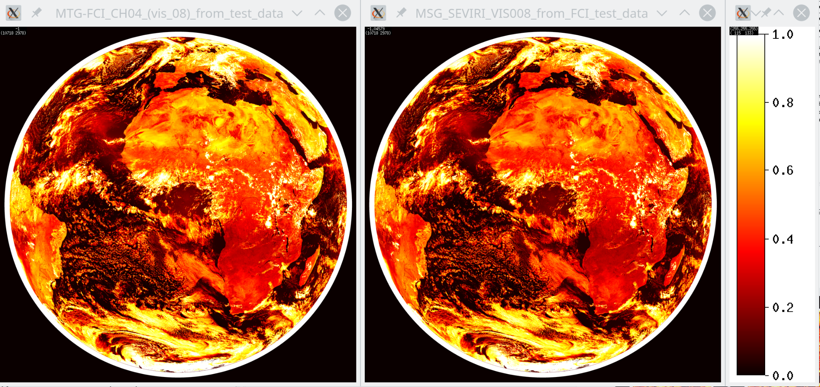
Figure 3 : Reflectance in the FCI CH04 (left) and corresponding SEVIRI VIS008 reflectance obtained using the spectral band adjustment (right). The images are for the repeat cycle 72 (12:00 UTC) of the test data [RD4].
As further illustration, Figure 4 shows the brightness temperature in the original CH11 (wv_73) channel from the FCI test data (left) and the corresponding WV_073 channels as estimated using the SBAF.
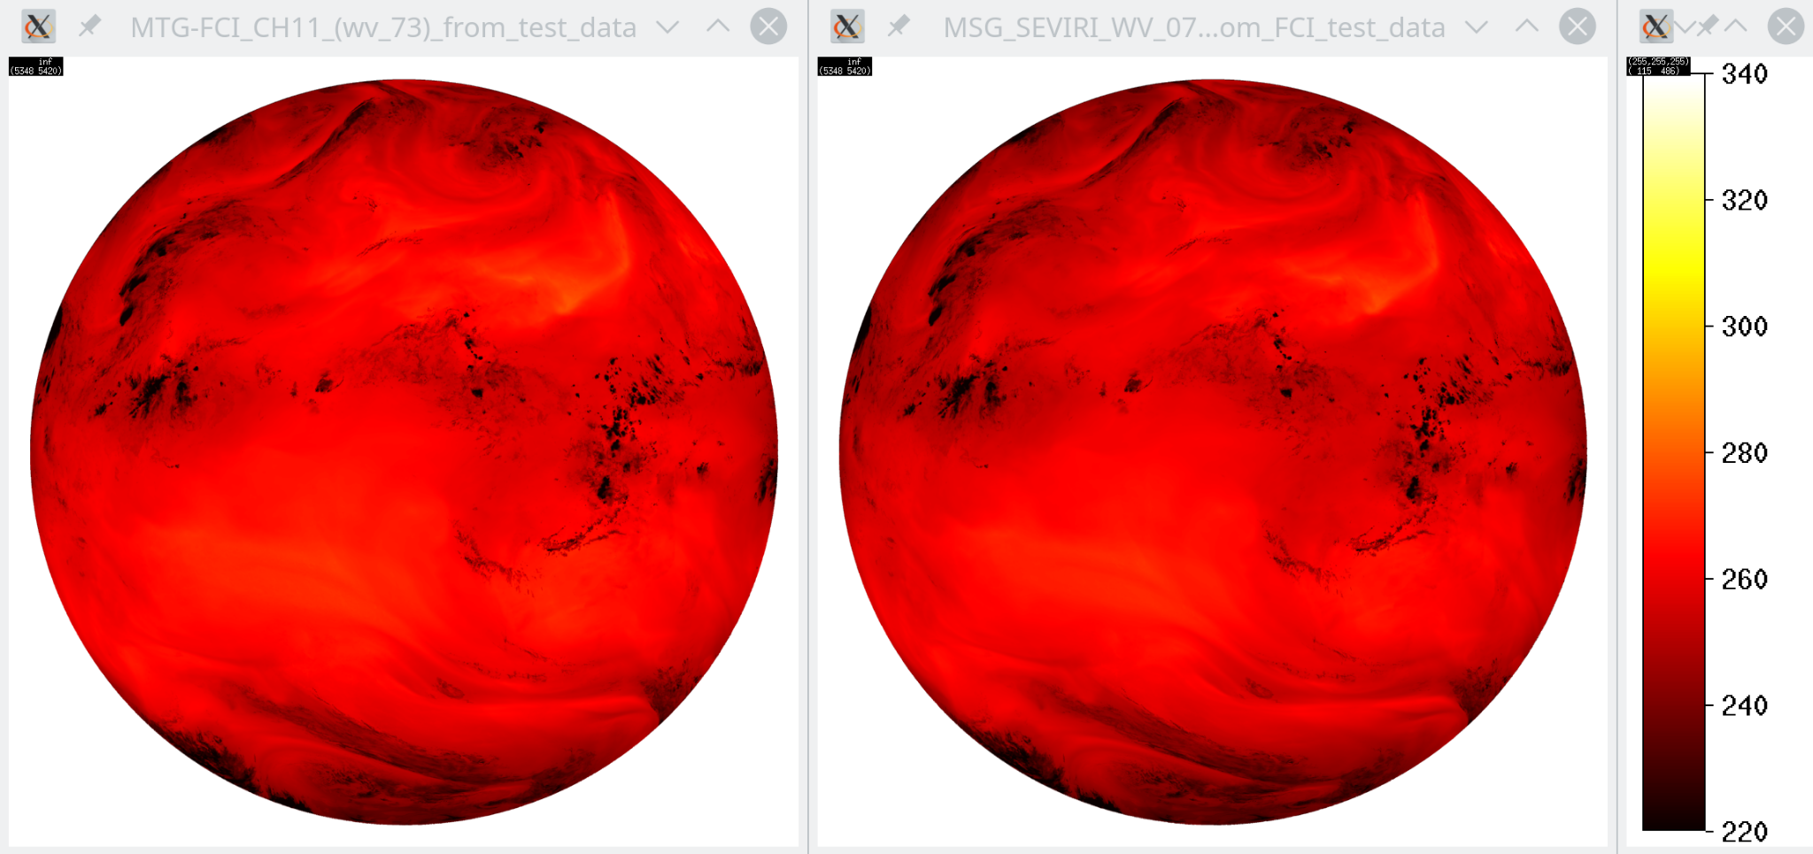
Figure 4 : Brightness temperature (K) in the FCI CH11 (left) and corresponding SEVIRI WV_073 brightness temperature obtained using the spectral band adjustment (right). The images are for the repeat cycle 72 (12:00 UTC) of the test data [RD4].

Activities during MTG commissioning
- The SBAF discussed in this section should be further evaluated based on simultaneous observations from MTG-I1/FCI and MSG3/SEVIRI data (at that time MSG4 will be located at 9.5° east for the RSS service). Empirical SBAF relations might be proposed that better represent the scene types present in the Meteosat FOV.
- The FCI/MSG calibration consistency should be addressed using scenes with elevated radiance level and known spectral signature (low level optically thick clouds for the solar bands and warm clear sky Tropical Ocean for the thermal bands). This assessment will probably suffer from late availability of calibrated FCI data during commissioning. Similarly, the calibration consistency will be verified using the inter-calibration method with MODIS or VIIRS.
- The limited difference in viewing direction (3.4° in terms of sub-satellite longitude) should be corrected using angular models of the solar/thermal radiation. Another approach is to limit data collection to the 1.7° West Meridian (i.e. just in between the 2 satellite positions) when the Sun crosses this longitude. In this case, the 2 satellites have the same VZA, SZA and RAA observation angles and should, in average, collect the same radiation. This approach could be valuable to assess the consistency in calibration but the data will not be sufficient to derive empirical SBAF relations representative of the entire Meteosat FOV.

Transition of cloud products from MSG to MTG

Comparison of atmospheric correction for SEVIRI and FCI
The SRFs of corresponding SEVIRI and FCI channels are different and therefore the amount of absorption in these channels will also differ. The required atmospheric correction of the reflectance from both instruments is presented in this section. Figure 5 shows results for the 0.6 µm channels. The main absorbing gas here is ozone (lower right panel). Note that ozone absorption is already included in the monochromatic cloudy-sky simulations (with a column amount of 332 DU), so the atmospheric correction can become negative in case of lower column amounts and thus less absorption. Water vapour is mildly absorbing (lower left), and this gas also mainly explains the increase in atmospheric correction for low CTH (upper left), when there is more water vapour above the clouds. Finally, there is more absorption when the light path is longer, i.e. AMF increases (upper right).
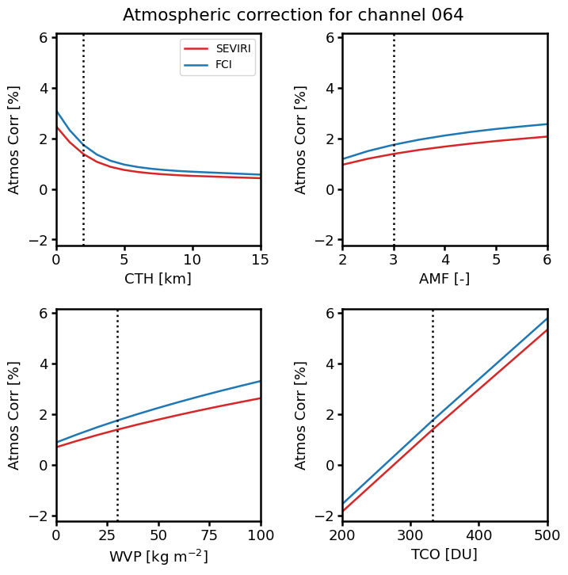
Figure 5: Simulated atmospheric correction for the SEVIRI and FCI 0.6 µm channels (channels 1 and 3, respectively), expressed as (1 - R_{atm.corr.}/R)*100%. The atmospheric correction is shown as a function of CTH, AMF, WVP and TCO. In each plot one of these parameters varies, while the others are kept constant at the values indicated by vertical dotted lines. These values (CTH = 2 km, AMF = 3, WVP = 30 kg m-2, and TCO = 332 DU) are representative of liquid water clouds in mid-latitude summer conditions.
The simulated atmospheric corrections for SEVIRI and FCI are rather similar. The mean and maximum absolute differences between the atmospheric corrections over all points in the LUT are 0.4% and 2.2%, respectively. These are small numbers, which would lead to modest retrieval errors (e.g., smaller than due to a typically assumed calibration error of 3%) even if the differences between the instruments were not accounted for. Therefore, no inconsistencies between the retrievals are expected as a result of differential absorption in the 0.6 µm channels.
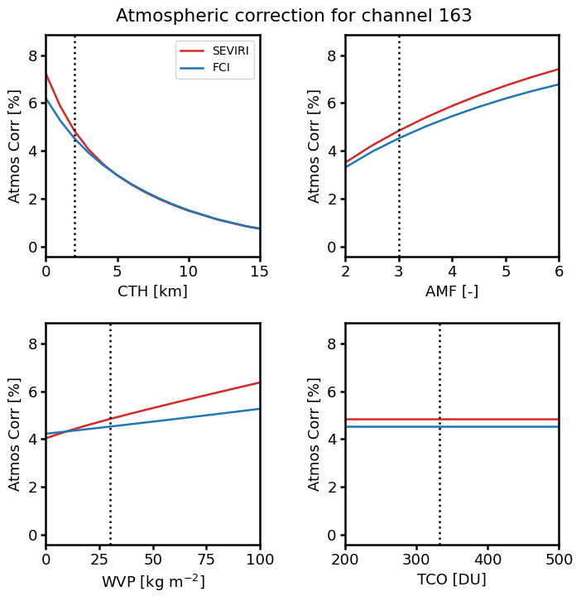
Figure 6: As Figure 5 but for the 1.6 µm channels (SEVIRI channel 3 and FCI channel 7).
Results of the simulations for the 1.6 µm channels are displayed in Figure 6. Here the main absorbing gases are water vapour, carbon dioxide and methane. They determine the strong increase of absorption with decreasing CTH and increasing AMF, both giving rise to increased light paths. The mean and maximum absolute differences between the atmospheric corrections over all points in the LUT are 0.5% and 7.2%, respectively. The latter occurs for extreme values of AMF and WVP and a cloud at the surface. Normally, the difference is below 1%, which would yield acceptable retrieval errors even if the differences in SRFs were not accounted for.
For the 3.8 µm channels (Figure 7) atmospheric corrections are much larger than for the 1.6 µm channels due to strong absorption by a range of trace gases: apart from H₂O, CO₂ and CH₄ also N₂O and N₂-continuum. However, the dependencies of the SEVIRI and FCI atmospheric corrections on the various parameters are rather similar. As a result the maximum absolute difference between the atmospheric corrections over all points in the LUT is still reasonably small: 15.1% (compared with a mean difference of 6.5%). For such differences, consideration of the respective SRFs is necessary and, if applied, should guarantee consistent retrievals from both instruments.
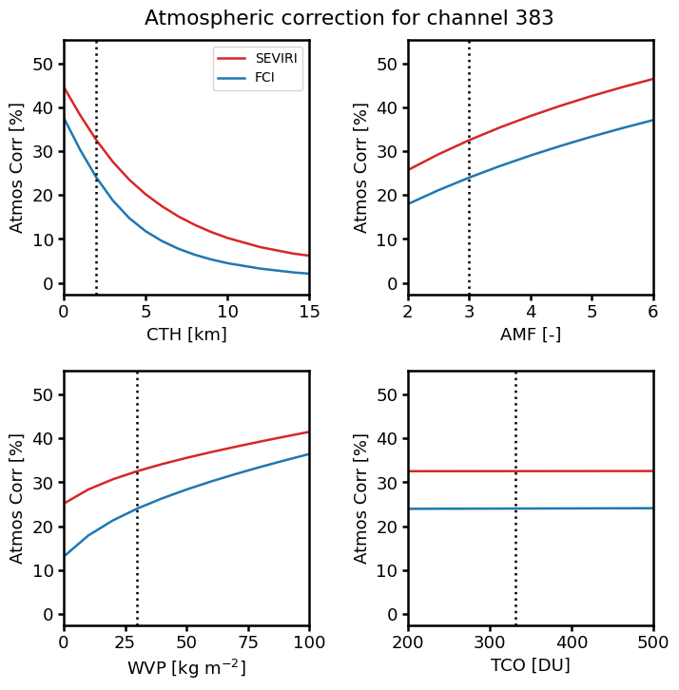
Figure 7 : As Figure 6 but for the 3.8/3.9 µm channels (SEVIRI channel 4 and FCI channel 9).
Finally, results for the 0.8 µm channels are shown in Figure 8. While CPP can run with the 0.8 µm channel (instead of 0.6 µm), this has not been done in the past CLAAS editions and it is not planned in the future. One of the reasons is the strong absorption by atmospheric water vapour, which adds uncertainty to the retrievals. The absorption is much smaller for FCI, which could make the 0.8 µm channel a suitable option, at least over ocean, for applications in which no backward compatibility with SEVIRI is required.
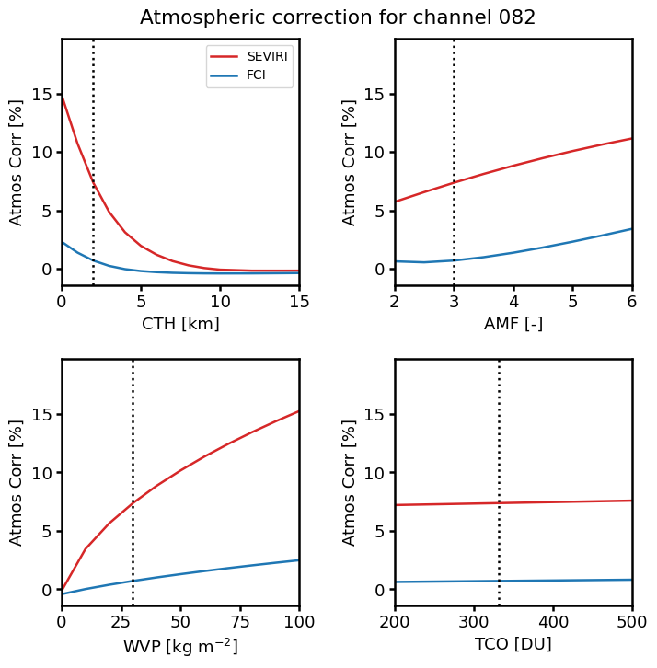
Figure 8: As Figure 5 but for the 0.8 µm channels (SEVIRI channel 2 and FCI channel 4).

Cloud optical and microphysical property retrievals based on test data
The CPP code was adapted to run on MTG1 FCI test data. This included reading the L1c data in NetCDF format and applying the atmospheric correction factors as outlined in the previous section. Since the underlying spatial sampling of the FCI L1c test dataset is that of SEVIRI, the data was reduced to the SEVIRI grid for all channels. In that way, a direct comparison with retrievals on corresponding synthetic SEVIRI L1.5 data is enabled.
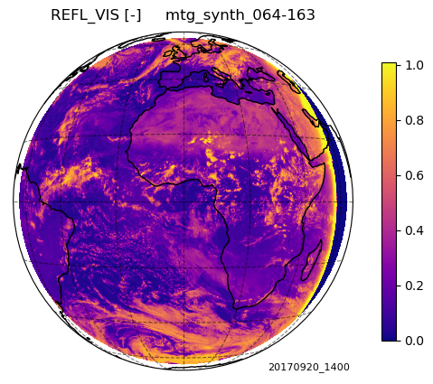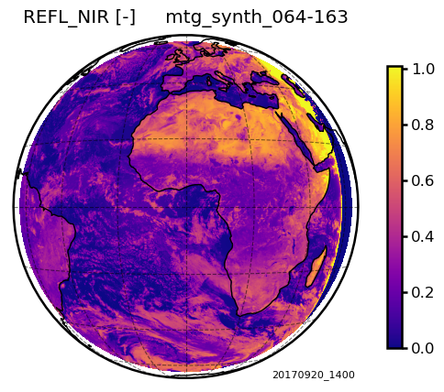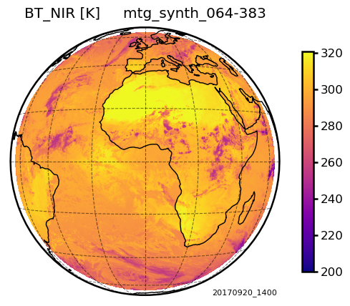
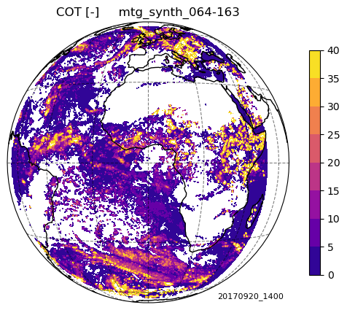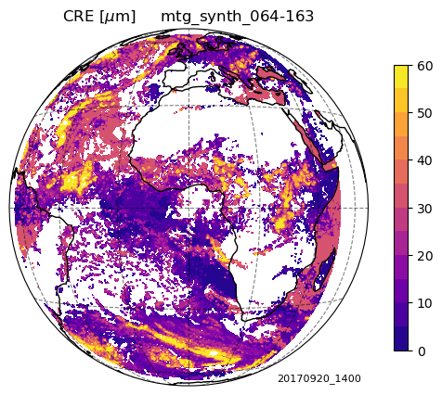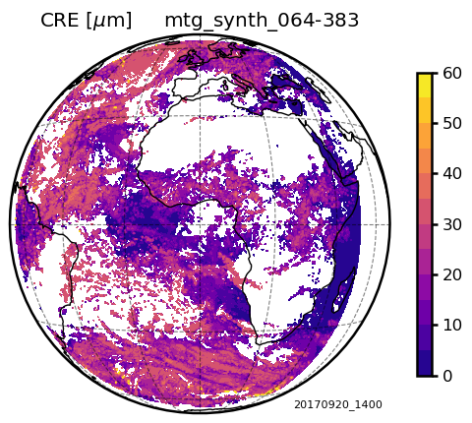
Figure 9 : MTG FCI L1c test data and corresponding CPP retrievals for 20/09/2017 14:00 UTC: CH04 reflectance (top left), CH07 reflectance (top center) and CH09 brightness temperature (top right), cloud optical thickness (bottom left), and particle effective radius using either CH07 (bottom center) or CH09 (bottom right).
Examples of full-disk L1c data and corresponding retrievals are shown in Figure 9. The expected features such as high visible reflectance for deep convective tropical clouds and thick extratropical clouds, and high 1.6 µm reflectance / 3.8 µm brightness temperature over the Sahara Desert can be observed. The fact that retrievals of effective radius from the 1.6 µm and 3.8 µm channels look different is not necessarily a bad sign. Evaluation results from the CLAAS-3 dataset show that in particular larger ice cloud effective radii are retrieved from the 1.6 µm channel, which is consistent with Figure 9.
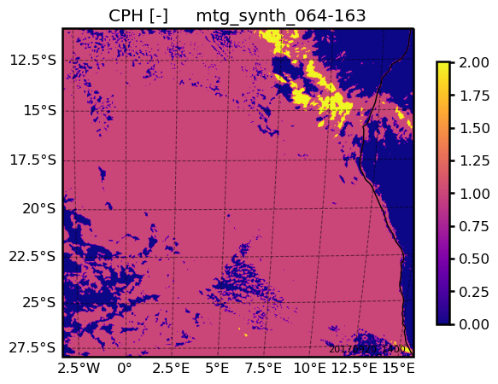
Figure 10 : Cloud phase retrieved from the FCI test data over the southeast Atlantic region selected for further comparisons: 0 = clear-sky, 1 = liquid clouds, 2 = ice clouds.
For further evaluation we focus on an area in the southeast Atlantic which is dominated by liquid water clouds (Figure 10). The synthetic MTG FCI L1c data and retrievals are compared with corresponding (synthetic) MSG SEVIRI data. For the visible channel the differences in reflectance are small (Figure 11, left panel), as expected from the very similar spectral response functions, with FCI having on average a 2% higher reflectance. The retrieved COT is slightly higher for FCI (Figure 11, right panel) but there is a high correlation between FCI and SEVIRI COT.
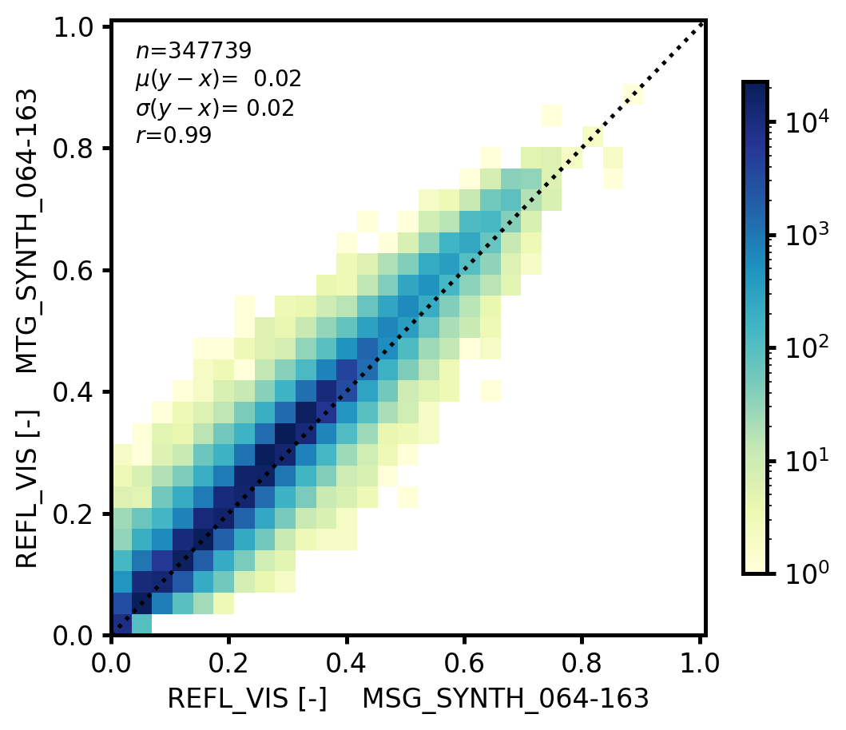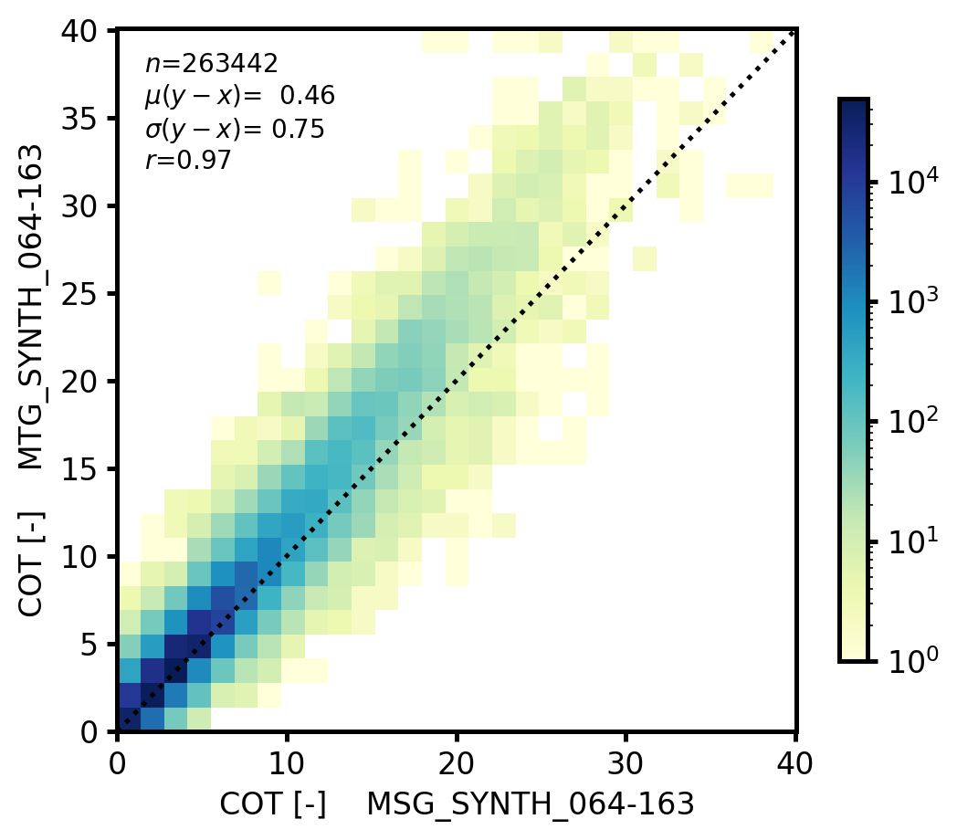
Figure 11 : Scatter density plots of (simulated) visible reflectance FCI CH04 against SEVIRI CH01 (left) and corresponding retrieved COT of liquid clouds (right) for the southeast Atlantic area shown in Figure 10. The color bars show the number of pixels on a log scale. Total number of pixels, mean difference, standard deviation of the difference, and Pearson correlation coefficient are indicated in the plots.
The simulated 1.6 µm channel reflectances for both instruments are again very similar (Figure 12). The retrieved effective radii show larger differences. This is simply because the effective radius retrieval is - especially for thin clouds - very sensitive to the NIR reflectance. The overall higher CRE values of FCI can be explained by its higher visible reflectance rather than by its marginally higher NIR reflectance. However, apart from this bias there is still a high correlation (r = 0.81) between both retrievals.
Analogous results for the 3.8 µm channel are shown in Figure 13, in which brightness temperatures have been converted to reflectances. The FCI reflectance is considerably smaller than the SEVIRI reflectance over basically the whole dynamical range. As a result, much larger droplets are retrieved from FCI, with typical differences ranging between 5 and 10 µm for small and large droplets, respectively. The correlation coefficient (r = 0.83) is similar to that for the 1.6 um.
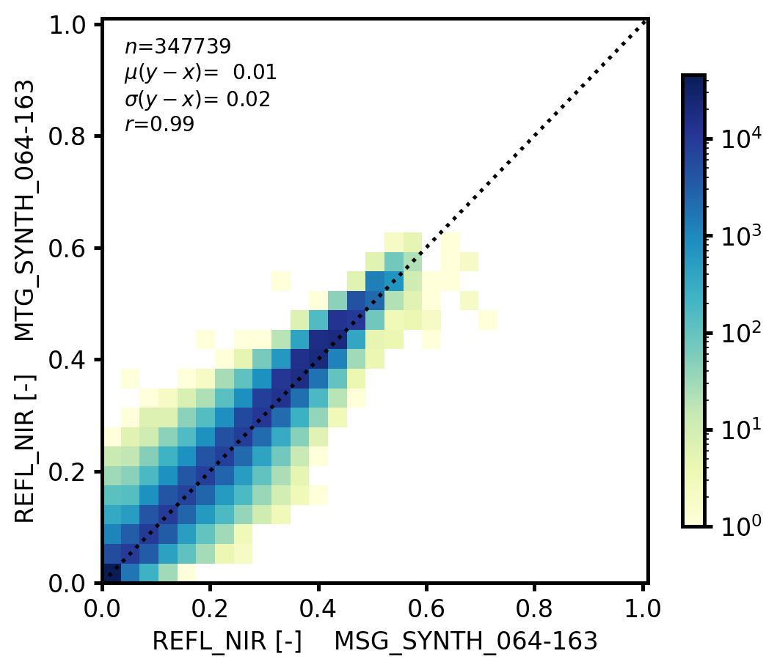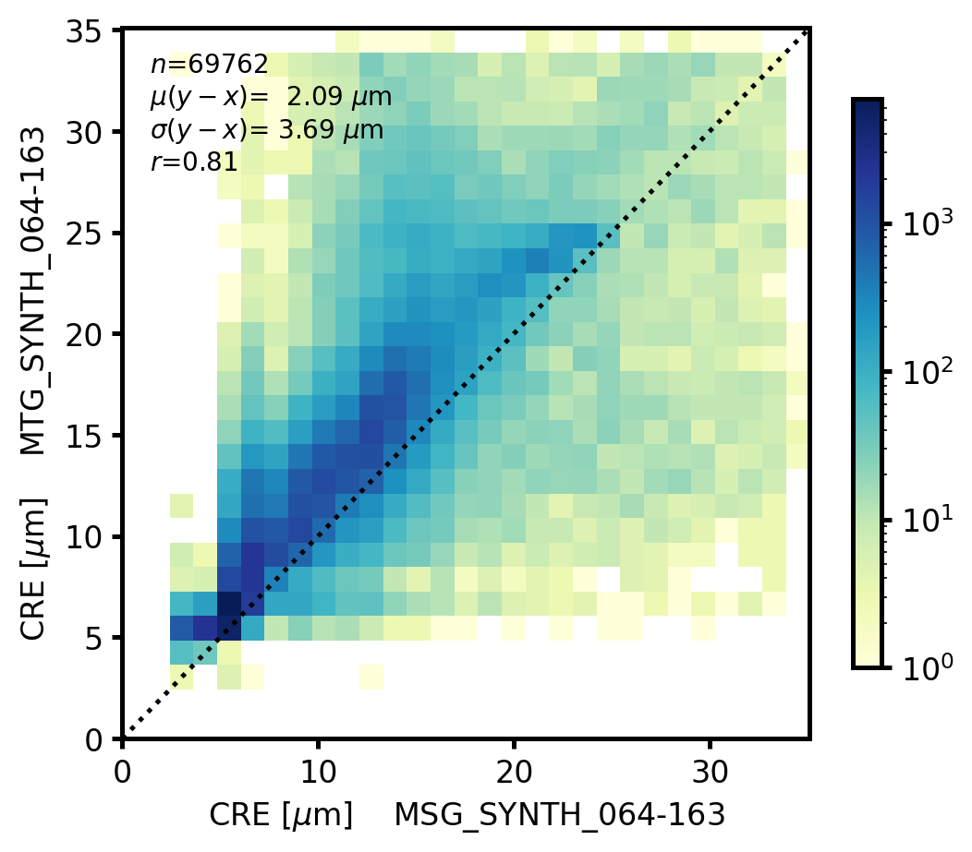
Figure 12 : Same as Figure 11 but for FCI CH07 against SEVIRI CH03 and corresponding retrieved liquid CRE.
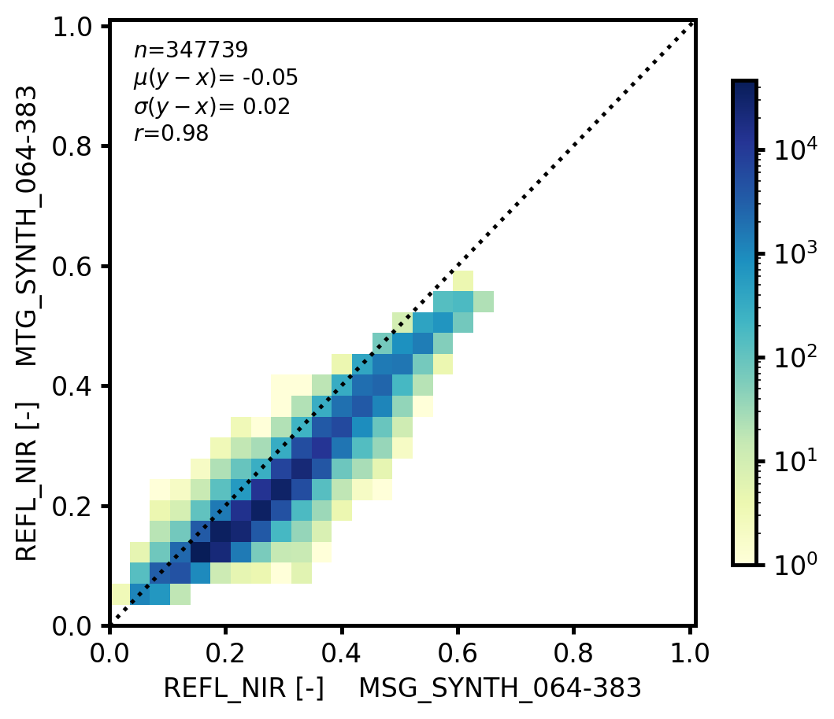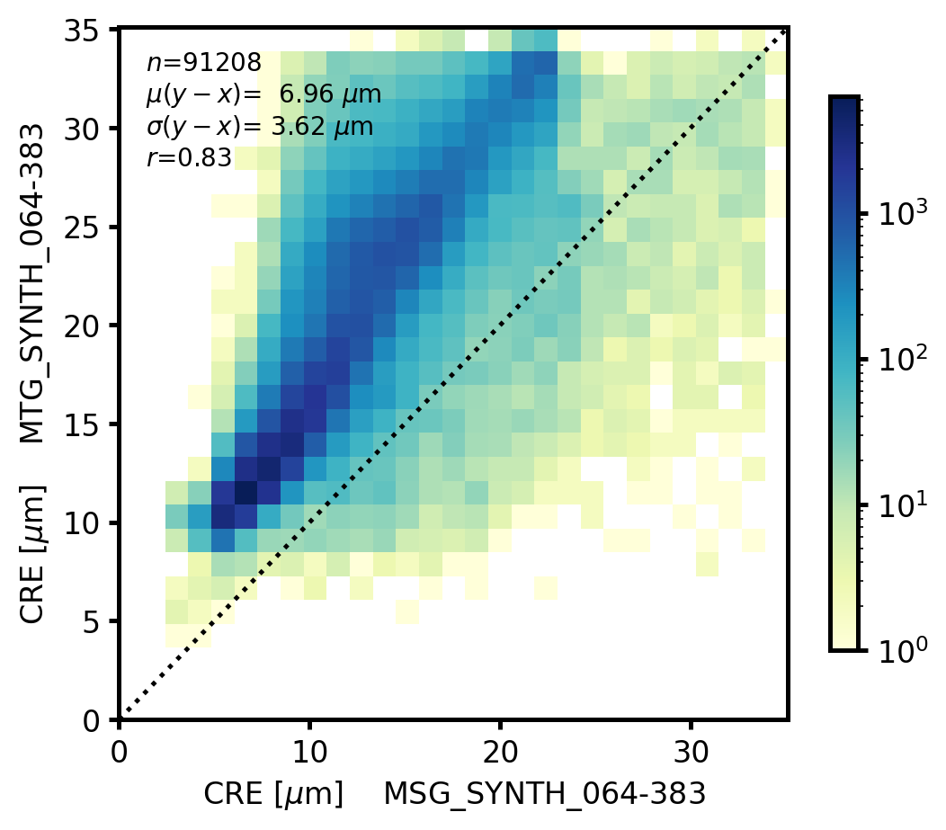
Figure 13 : Same as Figure 11 but for FCI CH09 against SEVIRI CH04 and corresponding retrieved liquid CRE. The ‘total’ brightness temperature is expressed here as a reflectance.
While we are not sure about reasons for the deviations we found, Figure 14 might give an indication for mismatches between the simulated datasets. It shows 3.8 µm reflectance and retrieved CRE of synthetic FCI against real SEVIRI data. These are more in line with each other and the number of pixels for which both CRE retrievals are successful is about twice as large (which is because the synthetic SEVIRI retrievals have a much higher failure rate than the others). However, at the high end FCI CRE still shows a considerable overestimation.
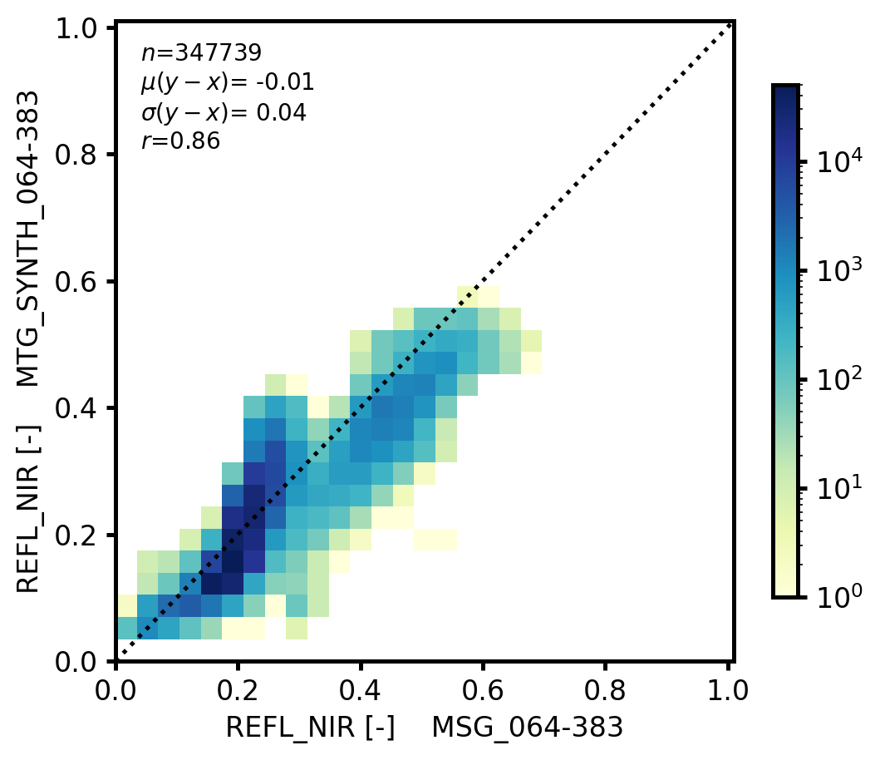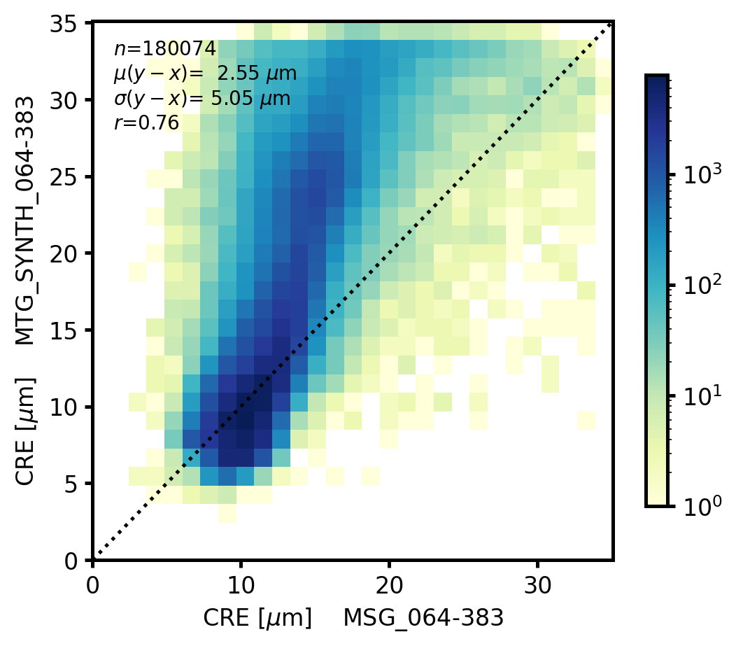
Figure 14 : Same as Figure 13 but now for simulated FCI CH09 and real SEVIRI CH04 data, and corresponding retrieved liquid CRE.
Based on the experiments performed here no firm conclusions on the feasibility of a smooth transition from SEVIRI to FCI can be drawn. The differences between the retrievals from both synthetic datasets that are currently obtained may be close to acceptable for cloud optical thickness but obviously not good enough for effective radius. As discussed, there might be some general inconsistencies either in the simulated radiances or in the retrieval scheme, which need to be further investigated.

Activities during MTG commissioning
KNMI will be involved as “close loop user” during the MTG commissioning. The main activity regarding cloud properties to be carried out during the commissioning phase is to test the retrieval algorithms based on corresponding real FCI and SEVIRI data. This concerns not only the cloud physical property algorithms discussed in this report but also the cloud mask and height algorithms as well as the new phase algorithm that is planned to be introduced in CLAAS-4. The aim is to reach sufficiently small differences between the retrievals. It is still an open question what ‘sufficiently small is’. Clearly, identical results will not be obtained because:
- the instruments differ in spatial and temporal characteristics, i.e. there will be spatial resolution effects and temporal sampling mismatches;
- it will not be possible to completely account for the differences in spectral response;
- the satellites will be located at a different longitude (3.4 degrees apart), so they will not have the same viewing geometry.
Therefore, optimal agreement will be sought given these limitations.

TOA radiation products

Using FCI for TOA radiation in CLAAS
During the MTG commissioning, two approaches will be compared on real FCI/SEVIRI data:
- The use of SBAFs discussed in sections 3.4 (solar bands) and 3.5 (thermal bands) followed by the same narrowband-to-broadband (NB→BB hereafter) regressions as for MSG.
- The derivation of dedicated NB→BB regressions for the FCI instrument. To maximize the consistency with MSG, the BB solar radiance will be estimated from the CH03, CH04 and CH07 channels. The BB thermal radiance will be estimated from the channels CH10 to CH16 (CH09 not used due to solar contamination during day time).
Both approaches, which are further discussed in the following sections, have advantages and drawbacks and should ideally be evaluated on real data before making a decision regarding the use of the FCI in the CLAAS dataset for generating TOA radiation products.

Spectral bands adjustment
The SBAF approach allows exploiting the empirical relations between SEVIRI NB and GERB BB observations collected since 2004. As this dataset is now quite large, the NB→BB regressions can be derived for a large number of scene types and solar/viewing geometries or even at regional scale (e.g. NB→BB relations in 1°x1° lat-lon boxes).
As discussed in section 3, the estimation of the VIS008 and IR_016 SEVIRI-like reflectances from the FCI reflectance is not fully accurate. We estimate the associatred error through the propagation of this error in the BB reflectance as about 0.7% (indeed, the weighting of the IR_016 channel is negligible in the NB→BB regression and the weight of the VIS008 channel lies typically in the range 0.3 - 0.5). Such an error level is acceptable given the typical NB→BB uncertainty of ~ 4% for the SEVIRI solar channels.

Empirical relations for MTG
This approach necessitates the availability of BB observations during the MTG commissioning. The following missions are to be considered and matching software will be ready during commissioning: the Cloud and Earth’s Radiant Energy System (CERES, Wielicki et al., 1996).
Tools have been implemented to match the BB observations of the CERES instruments with the NB observations of any of the geostationary imagers. They can be used during MTG commissioning, once the data is of sufficient quality (including the radiometric calibration). To allow a good coverage of the full Meteosat FOV, CERES observation in Rotating Azimuth Plan Scan (RAPS) mode must be preferred, as otherwise the coangular data are restricted to the tropical regions. It is expected that the CERES instrument on S-NPP (FM5, afternoon satellite) will be operated in RAPS mode during MTG-I1 commissioning. The addition of morning observations would be beneficial but it is not sure if the Terra mission will continue to provide data in 2023 and beyond.
GERB
During MTG-I1 commissioning, BB observations will be available from the GERB-1 (located at 45.5°E), the GERB-3 (currently at 9.5°E but will be located at 0°W in 2023) and GERB-4 (currently prime at 0°, but will be located at 9.5°E in 2023 for the Rapid Scanning Service (RSS)). Therefore it is likely the GERB-3 instrument that will be used for MTG-I1 NB→BB derivation. The difference in spacecraft’s longitude is 3.4° which has proved to be acceptable in the past. In practice, the BB radiances (SW and LW) observed by GERB from the 0° longitude are converted to the radiances that would be measured from the MTG-I1 position, at 3.4°W. This conversion is done using the angular dependency models that are also used for the GERB flux estimation.
In comparison to CERES, the main problems with GERB are the very large PSF (~60 km), the difficulty to get accurate geolocation of the measurements, and the relative uncertainty that developed in the GERB SW spectral response (in-orbit aging of the SW channel affecting mostly the shortest wavelengths).
EarthCARE BBR
On the Earth Cloud, Aerosol and Radiation Explorer (EarthCARE), the BroadBand Radiometer (BBR) provides 3 views (nadir, forward and backward) with very high spatial resolution (~600m) but limited to a very narrow swath (18km nadir view, 30km oblique views). This instrument appears very suited to derive/evaluate NB→BB regressions at fine spatial resolution. However, co-angular observation with MTG will be restricted to 3 very limited regions (one around 45°N, one around the Equator and one at 45°S).
It is worth mentioning that the foreseen launch of EarthCARE in October 2023 will likely be postponed due to unavailability of the Soyuz launcher. A decision on an alternative launcher is expected in autumn 2022.

Exploiting the improved capabilities of MTG/FCI

Estimation of the BroadBand (BB) unfiltered solar radiance
The new solar bands of the FCI, in particular at wavelengths where the solar illumination is maximum at around 0.5 µm, are expected to allow an accurate estimation of the BB radiance from the 8 NB radiance measurements. This is often presented as the reason for not having a BB radiometer to continue the GERB BB observations with the MTG satellites.
In terms of radiances in our database (libRadtran), we have the following average values for a standard geometry (SZA=30°, VZA=30°, RAA=90°):
- BB (no filter): 131.48 W/m²/sr,
- SEVIRI filters: 12.65 + 7.80 + 2.20 = 22.62 W/m²/sr,
- FCI filters: 10.44 + 8.38 + 8.80 + 5.44 + 1.76 + 0.22 + 0.90 + 0.20 = 36.14 W/m²/sr.
Although the FCI filters are in general narrower than the SEVIRI ones, more solar reflected radiation is actually measured especially thanks to the CH01 and CH02.
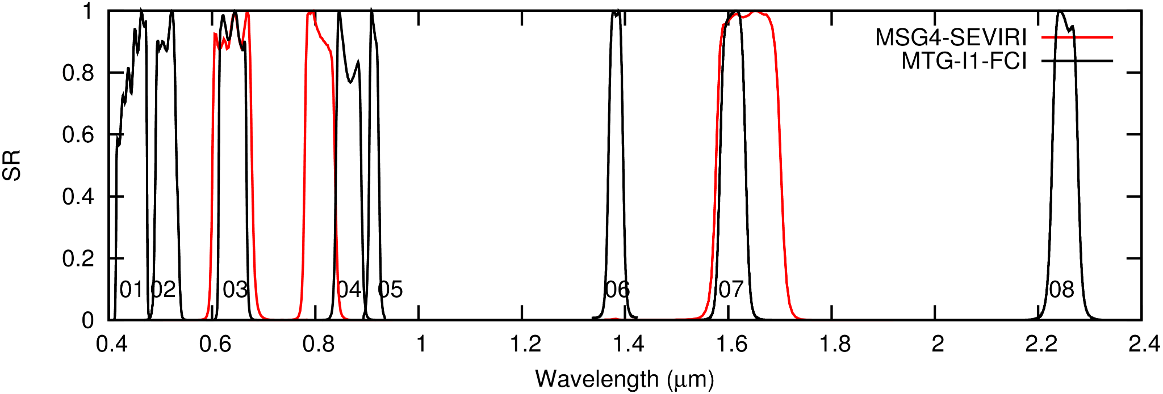
Figure 15 (same as Figure 1): MTG-I1 FCI (black) and MSG4 SEVIRI (red) spectral response curves for the solar channels.
The BB reflectance is estimated as a regression on the imager NB reflectances. Here we discuss one particular geometry (SZA=30°, VZA=30°, RAA=90°) but similar results are obtained for other geometries.
For MSG, a second order regression on the VIS006, VIS008 and IR_016 reflectances has a RMSE of 0.015 in absolute value which is 4.3% of the average BB reflectance of 0.35 in the dataset of RTM simulations. This level of accuracy is consistent with accuracy observed on empirical approaches, e.g. when combining SEVIRI and CERES (Clerbaux et al., 2005).
For MTG, significantly better results can be expected. On the same database, a first order regression on the 8 channel’s reflectances gives:
ρ_{BB} = 0.006186 + 0.189801 ρ_{CH01}+0.117313 ρ_{CH02}+0.143711 ρ_{CH03}+ 0.101815 ρ_{CH04} + 0.212839 ρ_{CH05} + 0.051021 ρ_{CH06} + 0.078351 ρ_{CH07} + 0.038385 ρ_{CH08}
with a RMSE of 0.0031 which is 0.9% of the average BB reflectance (0.35). Note that, to estimate the regression’s coefficients, the inputs (FCI reflectances) are randomly affected by a 2% noise to avoid overfitting the radiative transfer simulations. This noise is not applied when estimating the performances of the NB→BB. This has almost no effect on the RMSE (with a RMSE of 0.0032 instead of 0.0031) but should provide better results on real data as it reduces the dependence on the noise and on the channel’s calibration.
The performance is not far from the error introduced during the GERB unfiltering (about 0.5% according to Clerbaux et al., 2008). On this database, the ‘stand-alone’ GERB unfiltering is featured with an error of about 0.0029 (0.8%) while adding NB information from the SEVIRI channels (especially the 1.6 µm reflectance) in the GERB unfiltering decreases the error to 0.0008 (0.24%).
When all the geometries are considered together, the best regression is
ρ_{BB} = 0.006803 +0.216001 ρ_{CH01} +0.078684 ρ_{CH02} +0.154844 ρ_{CH03} + 0.098725 ρ_{CH04} +0.216894 ρ_{CH05} +0.050769 ρ_{CH06} + 0.080074 ρ_{CH07} + 0.033495 ρ_{CH08}
with a RMSE of 0.005 which is 1.3% of the average BB reflectance (0.35).
As for the SBAF, the availability of real MTG data, with corresponding GERB observations from a nearby spacecraft would allow to further tune these NB→BB relations and further assess the associated error.
As an illustration, Figure 16 shows the estimated BB solar reflectance ρ_{BB} from the 8 FCI solar channels CH01-CH08 (“all geometries together” regression).
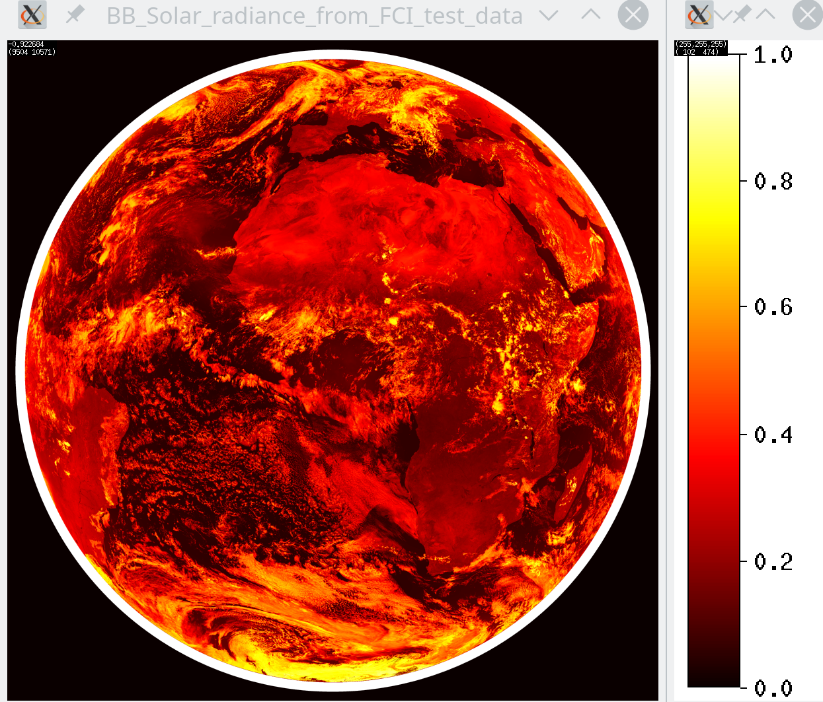
Figure 16 : Broadband solar reflectance estimated from the 8 MTG FCI solar channels (repeat cycle 72 of the FCI test data [RD4]). The outer white circle corresponds to the VZA>80° region.

Estimation of the BroadBand (BB) unfiltered thermal radiance
As the channels CH09, CH14, CH15, CH16 of MTG are significantly narrower than the corresponding SEVIRI ones we could expect slightly worse results for the NB→BB conversion.
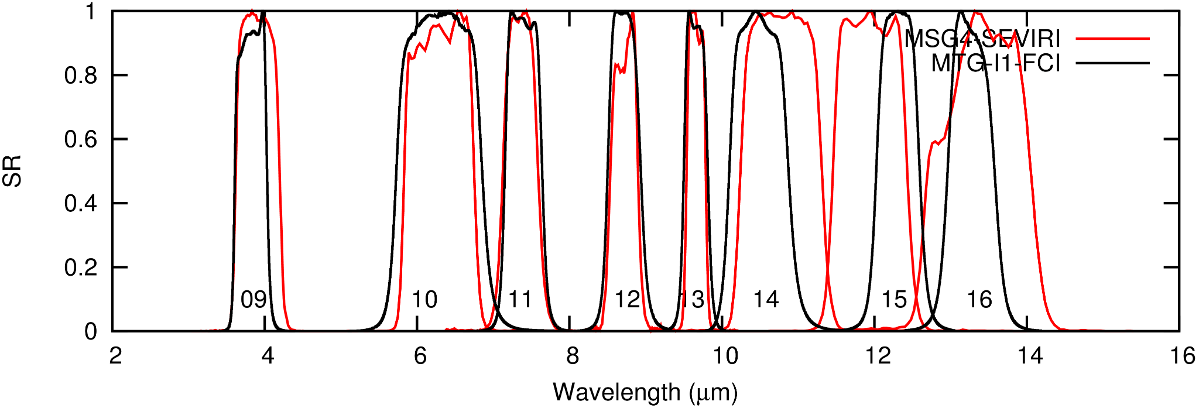
Figure 17 (same as Figure 2): MTG-I1 FCI (black) and MSG4 SEVIRI (red) spectral response curves for the thermal channels.
As this process can be seen as a kind of weighted summation of the NB radiances, the NB→BB conversion is done in terms of radiances, in W/m²/sr, instead of brightness temperatures, in Kelvin. The following table gives the residual RMS error on the estimated BB thermal radiance from the NB thermal channels of MSG and MTG (here for the particular VZA=30° viewing zenith angle).
 | RMSE
 | 1st order regression | 2nd order regression
MSG/SEVIRI | 0.84 W/m²/sr (1.2%) | 0.45 W/m²/sr (0.65%)
MSG/SEVIRI with IR_O39 | 0.77 W/m²/sr (1.1%) | 0.45 W/m²/sr (0.65%)
MTG/FCI | 0.92 W/m²/sr (1.3%) | 0.51 W/m²/sr (0.74%)
MTG/FCI with CH09 | 0.84 W/m²/sr (1.2%) | 0.51 W/m²/sr (0.74%)

Although the IR_039 (MSG) and CH09 (MTG) slightly improve the BB estimation when a first order regression is used, no improvement is observed with second order regressions. This channel can therefore be safely ignored in the NB→BB.
Figure 18 shows the estimated BB thermal radiance (W/m²/sr) from the FCI thermal channels CH10-CH16 (repeat cycle 072 of the test data).

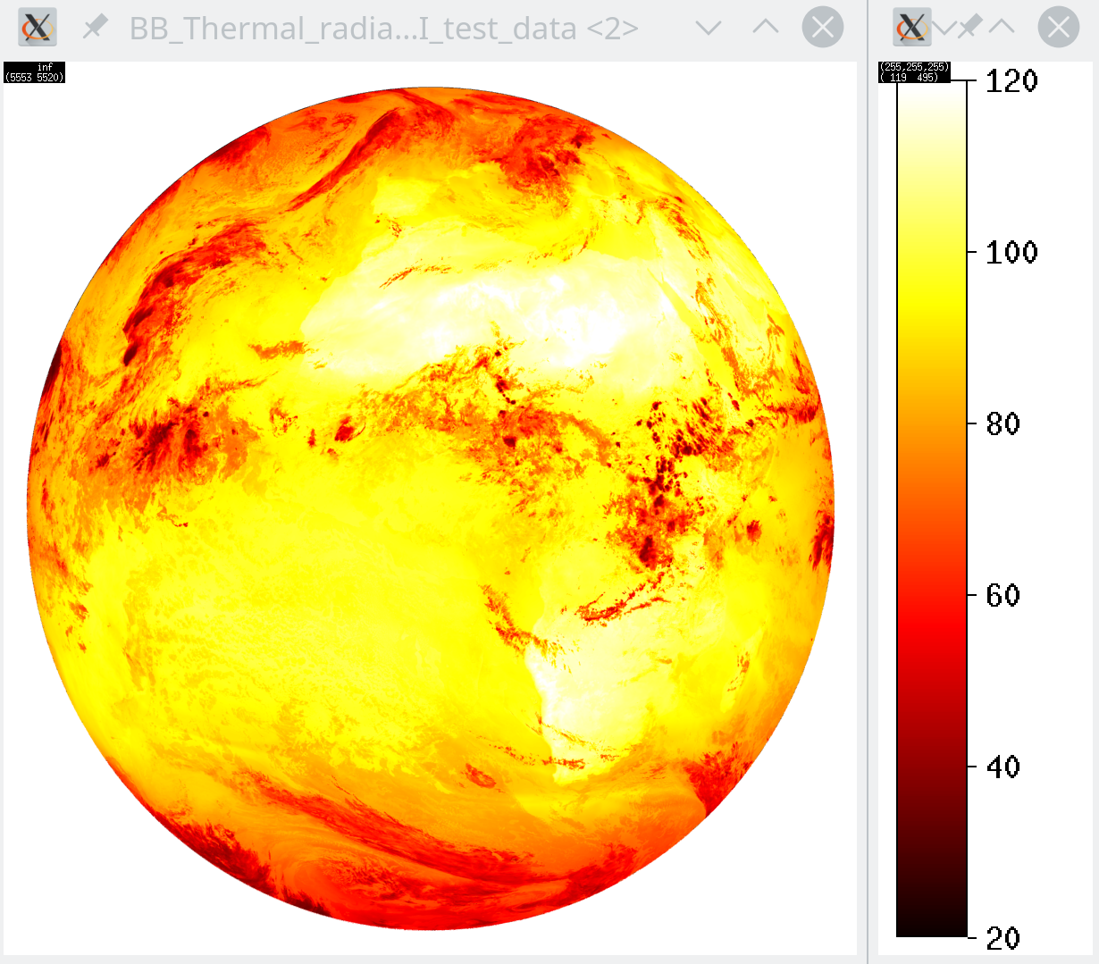
Figure 18 : Broadband thermal radiance (W/m²/sr) estimated from 7 MTG FCI thermal channels (repeat cycle 72 of the FCI test data [RD4]). The CH09 (ir_038) is not used in the regression due to daytime solar contamination.

Angular Dependency Models (ADMs) for solar radiation
Angular dependency models are used to convert the BB (directional) radiance into TOA (hemispheric) flux. These models represent the anisotropy of the radiance field at the TOA and are therefore dependent on the scene type (surface, clouds, aerosols and atmospheric profiles).
When processing geostationary satellite observations, the CERES Tropical Rainfall Measuring Mission (TRMM) ADMs are usually used because they fully cover all the possible SZA, VZA and RAA geometries (as the TRMM satellite is on a precessing orbit). However, due to the low inclination of the satellite orbit (35°), the models do not represent the higher-latitudes and polar scenes well but this is not a (major) problem for geostationary observations. The major limitation of the models is that they are built from a limited period of CERES observations (9 months, with 1 day out of 3 in RAPS mode). The stratification is therefore limited (e.g. there are only 4 different land surface types).
New sets of ADMs have been constructed to process the CERES Terra and CERES Aqua observations. The CM SAF is investing effort to implement these new models in the CM SAF cLoud, Albedo and surface Radiation dataset from AVHRR data (CLARA) CDR and possibly also in the CLAAS-4 CDR. The models have been received from the CERES team and implemented in C-language routines. CM SAF is now investigating if these new models are better than the CERES TRMM ones when processing geostationary observations. Likely, the CERES Terra+Aqua models will improve the fluxes estimation over the ocean (clear or cloudy) but will not be applicable over land surface.
The selection of the ADMs is based on a scene identification that is based on the VIRS imager (for CERES TRMM) or MODIS (for Terra and Aqua). The following inputs are needed:
Scene type | TRMM ADMs | Terra+Aqua ADMs
Clear ocean | Wind speed (NWP) | Wind speed (NWP)  Aerosol Optical Depth (AOD)  Aerosol mode
Cloudy ocean | Cloud fraction  Cloud optical depth  Cloud phase (water/ice) | Cloud fraction  Cloud optical depth  Cloud phase (water/ice)
Clear land | Fixed map based on IGBP | NDVI map
Cloudy land | Clear land +  Cloud fraction  Cloud optical depth  Cloud phase (water/ice) | Clear land +  Cloud fraction  Cloud optical depth  Cloud phase (water/ice)
Clear Snow and ice | - | snow/ice fraction  SIBI (Sea Ice Brightness Index)
Cloudy Snow and ice | - | Cloud optical depth  SIBI
The improved capabilities of MTG/FCI will be valuable at this level, in particular for the aerosol characterization.

Angular Dependency Models for thermal radiation
Two approaches are followed for the LW ADM: empirical or theoretical ADM. With respect to what is feasible with MSG, no significant improvement is expected with MTG given the closeness of the thermal channels (the better cloud characterization permitted with the new MTG solar channels is not fully relevant for thermal ADM as it is in general expected to use a consistent processing scheme for day- and night-time).

Activities during MTG commissioning
RMIB will be involved as “close loop user” during the MTG commissioning. The Institute proposed to evaluate the TOA radiation products derived from MTG using a GERB-like processing and compare with the actual GERB products. In practice it is foreseen to:
- Implement the SBAFs (section 3) and process MTG data using the heritage SEVIRI channels.
- Intercomparison (consistency) of the calibration heritage channels calibration.
- Produce MTG “heritage” GERB-like products
- Intercompare with GERB (out of eclipse season)
- Implement theoretical NB→BB for the full MTG channels (section 5.1)
- Intercompare with GERB (out of eclipse season)
- Collect MTG-I1 and CERES co-angular collocated observation, also extract MSG3 data
- Develop empirical NB→BB based on CERES
- Collect MTG-I1 and GERB3 co-angular collocated observation, also extract MSG3 data
- Develop empirical NB→BB based on CERES
- Intercompare with GERB (out of eclipse season)
As a preparation, a single MTG processing software will be developed to handle the various kinds of BB estimations from the FCI channels: empirical or theoretical, full channels or SEVIRI heritage channels, SW and LW, SBAFs or dedicated regressions. The next step of the processing - the conversion from radiance to flux - will be identical to the one currently used in the GERB processing. During the commissioning, the GERB processing cloud retrieval (based on the SEVIRI 0.6µm and 0.8µm channels) will be used as long as mature MTG cloud products are not available.

Summary

This study presents important steps in the preparations for incorporating MTG observations in the CM SAF data records, with focus on a smooth transition from MSG to MTG.
The recent availability of “scientifically meaningful” MTG/FCI synthetic data [RD4] allowed us to test different approaches. Preliminary conclusions have been obtained that should be later consolidated on real MTG data, during commissioning.
For the continuation of the CLAAS record, the consistency with the SEVIRI-based products is of prime importance. The use of the “heritage” MSG channels is therefore obvious. Still, significant differences in SRF exist that should be corrected either using SBAFs or using Look-Up Tables dedicated to the MTG/FCI instrument. From this study, it appears that SBAF are not fully accurate for all the heritage channels, in particular for VIS008 and IR_016. Therefore the second approach, the use of dedicated LUT, is currently recommended.
For the continuation of the GERB mission, the new solar channels of MTG appear very promising for accurate Reflected Solar Flux products. A large part of the spectrum is covered with the MTG channels, allowing in particular to better capture the molecular and aerosol scattering at short wavelengths.

Acknowledgements
We would like to express our acknowledgements to EUMETSAT for providing the MTG Test Data used in this study. We also thank Pierre de Buyl (RMIB) for implementing the MTG/FCI reader in short notice for this study.

References
Benas, N., Finkensieper, S., Stengel, M., van Zadelhoff, G.-J., Hanschmann, T., Hollmann, R., and Meirink, J. F., 2017: The MSG-SEVIRI-based cloud property data record CLAAS-2, Earth System Science Data, 9, 415–434, doi:10.5194/essd-9-415-2017.
Berk, A., G. P. Anderson, P. K. Acharya, J. H. Chetwynd, L.S. Bernstein, E. P. Shettle, M. W. Matthew, and S. M. Adler-Golden, 2000: MODTRAN4 Version 2 Users Manual. Technical report, Air Force Materiel Command, Air Force Research Laboratory, Space Vehicles Directorate, Hanscom AFB, MA 01731, USA.
Clerbaux, N., et al. "Narrowband-to-broadband conversions for SEVIRI." Proceedings of the 2005 EUMETSAT Meteorological Satellite Conference, Dubrovnik. 2005.
Clerbaux, N., S. Dewitte, C. Bertrand, D. Caprion, B. De Paepe, L. Gonzalez, A. Ipe, J.E. Russell and H. Brindley (2008a): Unfiltering of the Geostationary Earth Radiation Budget (GERB) Data. Part I: Shortwave Radiation, Journal of Atmospheric and Oceanic Technology, 25(7), 1087-1105.
Clerbaux, N., S. Dewitte, C. Bertrand, D. Caprion, B. De Paepe, L. Gonzalez, A. Ipe and J.E. Russell (2008b): Unfiltering of the Geostationary Earth Radiation Budget (GERB) Data. Part II: Longwave Radiation, Journal of Atmospheric and Oceanic Technology, 25(7), 1106-1117.
Clerbaux, Nicolas; Urbain, Manon; Ipe, Alessandro; Baudrez, Edward; Velazquez-Blazquez, Almudena; Akkermans, Tom; Hollmann, Rainer; Fuchs, Petra; Selbach, Nathalie; Werscheck, Martin (2017): CM SAF TOA Radiation GERB/SEVIRI Data Record - Edition 2, Satellite Application Facility on Climate Monitoring, DOI:10.5676/EUM_SAF_CM/TOA_GERB/V002, https://doi.org/10.5676/EUM_SAF_CM/TOA_GERB/V002.
De Haan, J. F., P. Bosma, and J. W. Hovenier, 1987: The adding method for multiple scattering calculations of polarized light, Astron. Astrophys., 183, 371-391.
Harries, J.E., et al. (2005): The Geostationary Earth Radiation Budget Project, Bulletin of American Meteorological Society, 86(7), 945-960, doi:10.1175/BAMS-86-7-945.
Meirink, J.F., R.A. Roebeling and P. Stammes, 2013: Inter-calibration of polar imager solar channels using SEVIRI, Atm. Meas. Tech., 6, 2495-2508, doi:10.5194/amt-6-2495-2013.
Stammes, P., 2001: Spectral radiance modeling in the UV-Visible range. IRS 2000: Current problems in Atmospheric Radiation, edited by W.L. Smith and Y.M. Timofeyev, pp 385-388, A. Deepak Publ., Hampton, Va.
Stengel, M., Kniffka, A., Meirink, J. F., Lockhoff, M., Tan, J., and Hollmann, R., 2014: CLAAS: the CM SAF cloud property data set using SEVIRI, Atmos. Chem. Phys., 14, 4297–4311.
Urbain, M., N. Clerbaux, A. Ipe, F. Tornow, R. Hollmann, E. Baudrez, A. Velazquez Blazquez, J. Moreels (2017): The CM SAF TOA Radiation Data Record Using MVIRI and SEVIRI, Remote Sensing, 9, 466.

Acronyms

Acronym | Definition
ADM | Angular Dependency Model
AOD | Aerosol Optical depth
AMF | Air Mass Factor
ATBD | Algorithm Theoretical Basis Document
BB | BroadBand
BBR | BroadBand Radiometer
BTD | Brightness Temperature Difference
CDOP | Continuous Development and Operation Phase
CDR | Climate Data Record
CERES | Cloud and Earth Radiant Energy System
CF | Climate and Forecast
CH01, …, CH16 | CHannel 01 to 16 (of MTG/FCI)
CLAAS | CM SAF CLoud property dAtAset using SEVIRI
CLARA-Ax | CM SAF cLoud, Albedo and surface Radiation dataset from AVHRR data (x=version)
CM SAF | Climate Monitoring Satellite Application Facility
COT | Cloud Optical Thickness
CPP | Cloud Physical Properties
CRE | Cloud particle Effective Radius
CT | Cloud Type
CTH | Cloud Top Height
DAK | Doubling Adding KNMI
DU | Dobson Unit
EarthCARE | Earth Cloud, Aerosol and Radiation Explorer
ECMWF | European Center for Medium range Weather Forecast
EUMETSAT | European Organization for the Exploitation of Meteorological Satellites
ERB | Earth Radiation Budget
FAQ | Frequently Asked Question
FCI | Flexible Combined Imager
FDHSI | Full Disk High Spectral resolution Imagery
FDSS | Full Disk Scanning Service
FES | Full Earth Scan
FM | Flight Model
FOV | Field Of View
GERB | Geostationary Earth Radiation Budget
HR | High Resolution
HRV | High Resolution Visible
HRFI | High spatial Resolution Fast Imagery
ICDR | Interim Climate Data Record
IGBP | International Geosphere-Biosphere Programme
IODC | Indian Ocean Data Coverage
IR | Infra Red
KNMI | Koninklijk Nederlands Meteorologisch Instituut
LUT | Look Up Table
LW | LongWave
MND | Metallic Neutral Density
MODIS | MODerate resolution Imaging Spectroradiometer
MODTRAN | Moderate-Resolution Atmospheric Radiance and Transmittance Model
MSG | Meteosat Second Generation
MTG | Meteosat Third Generation
MVIRI | Meteosat Visible and InfraRed Imager
NB | Narrow Band
NDVI | normalized difference vegetation index
NEdT | Noise Equivalent Delta Temperature
NetCDF | Network Common Data Form
NIR | Near Infra Red
NWP | Numerical Weather Prediction
OLR | Outgoing Longwave radiation
PSF | Point Spread Function
RAA | Relative Azimuth Angle
RAPS | Rotating Azimuth Plan Scan
RMIB | Royal Meteorological Institute of Belgium
RMSE | Root Mean Squared Error
RSF | Reflected Solar Flux
RSS | Rapid Scan Service
RTTOV | Radiative Transfer for Television infrared orbiting satellite Operational Vertical sounder
SAF | Satellite Application Facility
SBAF | Spectral Band Adjustment Factor
SEVIRI | Spinning Enhanced Visible InfraRed Imager
SIBI | Sea Ice Brightness Index
S-NPP | Suomi National Polar-orbiting Partnership
SRF | Spectral Response Function
SSCC | SEVIRI Solar Channel Calibration
SW | ShortWave
SZA | Solar Zenith Angle
TCO | Total Column Ozone
TET | TOA Emitted Thermal
TIR | Thermal Infra Red
TOA | Top Of Atmosphere
TRMM | Tropical Rainfall Measuring Mission
TRS | TOA Reflected Solar
TSI | Total Solar Irradiance
VIRS | Visible and Infra Red Scanner
VIS | VISible
VZA | Viewing Zenith Angle
WP | Work Package
WVP | Water Vapor Path

Annex 1 : Spectral band adjustments for solar channels

In this section the channels are expressed in reflectances, a number without units usually between 0 and 1. For each of the SEVIRI channels, a step-wize analysis is performed to estimate the channel as a function of 1, 2, 3 ,... FCI channels as input. The “recommended” regression is indicated in bold.
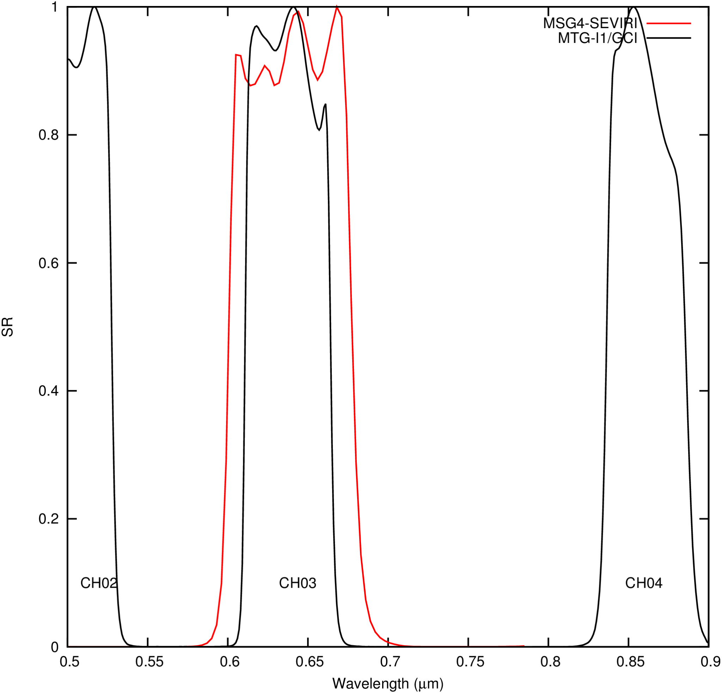
SEVIRI VIS006
The band is accurately estimated from the corresponding CH03 channel of the FCI instrument. The reflectances in the CH03 are in general lower than the VIS006 ones by about 0.6%. This is corrected by a spectral band adjustment factor of about 1.006. Using a least mean square minimization software, the following regressions between the channels are obtained (all angular geometries together):

Regressions for VIS006 = | RMSE | (%)
= CH03  = 1.0061 * CH03 | 0.0038  0.0021 | 0.9  0.5
= 0.000236 + 1.005716 * CH03 | 0.0021 | 0.50%
= -0.000387 + 1.003075 * CH03 + 0.005888 * CH07 | 0.0016 | 0.38%
(...)
Linear regression on all the 8 solar channels | 0.0012 | 0.29%

It is possible to (slightly) improve the performance of the regressions by making them dependent on the SZA (for instance in steps of 10° between 0° and 80°, although here we just report results at 0°, 30° and 60°). The improvement is however not deemed to be sufficient to justify the SZA dependency of the adjustment.
SZA | Regressions for VIS006 = | RMSE | (%)
0 | = 0.000764 + 1.003164 * CH03  = 0.000010 + 1.002340 * CH03 + 0.004156 * CH07 | 0.0015  0.0012 | 0.38  0.32
30 | = 0.000711 + 1.003490 * CH03  = -0.000001 + 1.002391 * CH03 + 0.004205 * CH07 | 0.0015  0.0012 | 0.39  0.32
60 | = 0.000399 + 1.005624 * CH03  = -0.000094 + 1.002637 * CH03 + 0.004621 * CH07 | 0.0019  0.0013 | 0.43  0.33
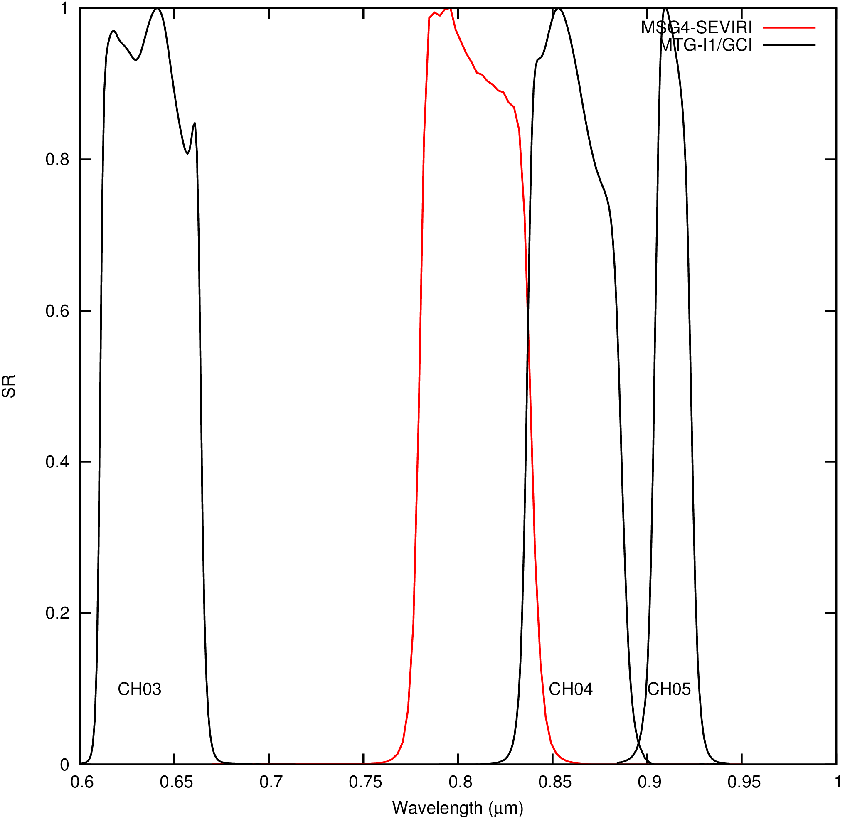
SEVIRI VIS008
This band is much more difficult to estimate from the CH04 reflectance. A simple linear regression is affected by a residual RMS error of 0.0242 which is 5.1% of the average reflectance in the channel. To improve the VIS008 estimation, a step-wise analysis is performed amongst the other FCI channels:

Regressions for VIS008 = | RMSE | (%)
= CH04  = 0.9977 * CH04 | 0.0248  0.0247 | 5.2  5.2
= -0.008042 + 1.008179* CH04 | 0.0242 | 5.1%
= 0.001684 + 0.757720 * CH04 + 0.281424 * CH05 | 0.0116 | 2.4%
= -0.001942 + 0.067589* CH02 + 0.735623* CH04 + 0.240638* CH05 | 0.0080 | 1.7%
= -0. 001420 + 0.057381 * CH02 + 0.759262 * CH04 + 0. 236671 * CH05 -0.024829 * CH08 | 0.0070 | 1.5%
(...)
Linear regression on all the 8 solar channels | 0.0068 | 1.4%

The addition of the CH05 (0.9µm) in the regression significantly improves the VIS008 estimation. Further addition of the CH02 (0.5µm) has a positive significant effect on the RMSE. Adding more channels does not bring further significant improvement.
Making the regression dependent on the SZA does not improve significantly the performances (at least when the 3 channels are used):
SZA | Regressions for VIS008 | RMSE | (%)
0° | = -0.004122 + 0.064963 * CH02 + 0.735035 * CH04 + 0.251225 * CH05 | 0.0080 | 1.80
30° | = -0.003931 + 0.064712 * CH02 + 0.735811 * CH04 + 0.249871 * CH05 | 0.0079 | 1.78
60° | = -0.003323 + 0.064582 * CH02 + 0.737741 * CH04 + 0.245351 * CH05 | 0.0078 | 1.71

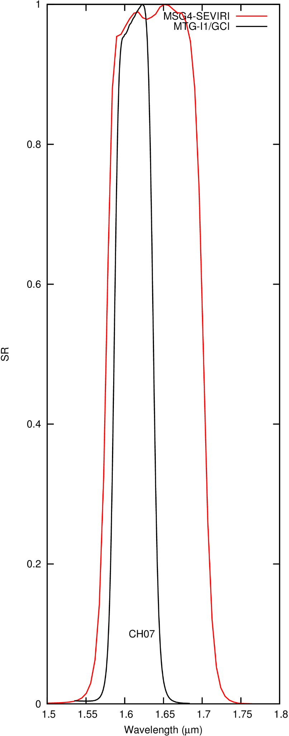
SEVIRI IR_016
The channel is much broader than the CH07 of FCI, and there is also a shift in central wavelength. The reflectances are in general 1.8% higher for SEVIRI IR_016 than in the FCI CH07. The addition of the CH05 (0.9µm) in the regression significantly improves the IR_016 estimation. Adding more channels does not bring further significant improvement.
Regressions for IR_016 = | RMSE | (%)
= CH07 | 0.0116 | 3.9%
= 1.0181 * CH07 | 0.0091 | 3.1%
=0.003937 + 1.010943* CH07 | 0.0087 | 2.9%
= -0.000813 + 0.026045 * CH05 + 0.991830 * CH07 | 0.0052 | 1.7%
(...)
Linear regression on all the 8 solar channels | 0.0047 | 1.6%

As for the VIS008 channel, taking into account the SZA does not improve significantly the SBAF:
SZA | Regressions for IR_016 = | RMSE | (%)
0° | -0.000177 + 0.019934 * CH05 + 0.996687 * CH07 | 0.0045 | 1.7%
30° | -0.000124 + 0.020321 * CH05 + 0.996252 * CH07 | 0.0044 | 1.7%
60° | -0.000321 + 0.022386 * CH05 + 0.994629 * CH07 | 0.0046 | 1.6%

Summary
In summary, the following relations are proposed to get the SEVIRI solar channels from MTG-I1/FCI (all quantities as reflectances):
Regressions | RMSE | (%)
VIS006 = 0.000236 + 1.005716 * CH03 | 0.0021 | 0.5%
VIS008 = - 0.001942 +0.067589* CH02 + 0.735623* CH04 + 0.240638* CH05 | 0.0080 | 1.7%
IR_016 = - 0.000813 + 0.026045 * CH05 + 0.991830 * CH07 | 0.0052 | 1.7%

Figure 19 shows how these SBAF corrections are performing to simulate the 3 SEVIRI solar channels. The red dots correspond to the uncorrected reflectances in corresponding channels (VIS006 and CH03, VIS008 and CH04, IR_016 and CH07). The black dots correspond to spectrally adjusted FCI reflectances, to mimic the SEVIRI channels. The bottom right image shows the effect of the SBAF on the NDVI estimation (NDVI = (ref_08 - ref_06) / (ref_08+ref_06) ). The FCI NDVIs (from CH04 and CH03) are in general slightly higher than the corresponding SEVIRI NDVI (from VIS008 and VIS006). The SBAF corrects this efficiently.
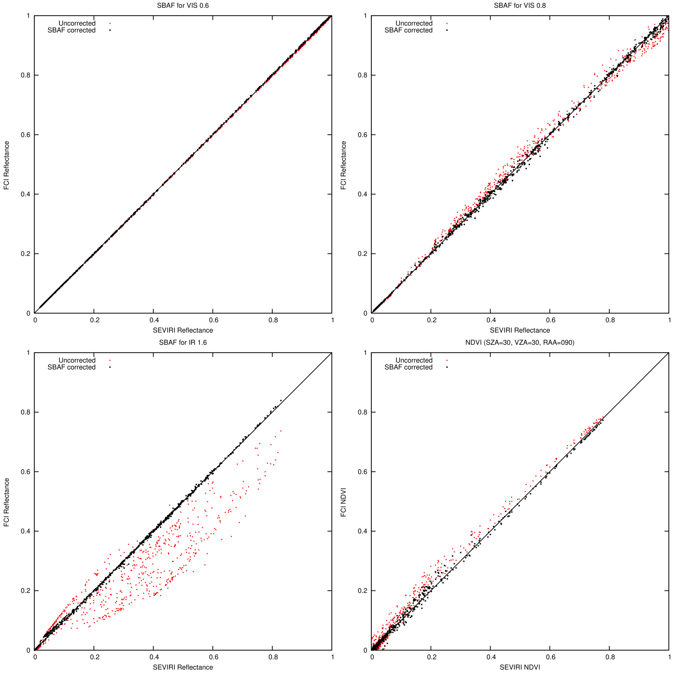
Figure 19 : Scatter plots of FCI and SEVIRI reflectance in the 0.6 (top left), 0.8 (top right) and 1.6µm (bottom left) channels without (red dots) and with (black dots) spectral band adjustment of the FCI channels to mimic the SEVIRI channels. The bottom-right image shows the scatter plot of NDVI values.

Annex 2 : Spectral band adjustments for thermal channels
Notes:
- In this section, the channel’s signals are expressed in brightness temperature, in Kelvin.
- The simulations used to fit the thermal spectral band adjustment do not account for spectral variation of the surface emissivity. This has to be kept in mind for the SBAF for channels IR_039 and IR_087 in which there exists significant reduction of emissivity, especially over sandy and rocky surfaces (deserts).
- The brightness temperatures have been computed from the effective radiances using the standard fit recommended by EUMETSAT (with the 3 parameters A, B, ν). It is possible that the SBAF corrections discussed in this section do not correspond to physically meaningful effect (e.g. atmospheric absorption) but just to correct errors introduced by the radiance to BT conversion fits.
SEVIRI IR_039
The channel is a bit larger than the CH09 of FCI, and therefore includes more signal from the CO₂ band. A linear relation seems not optimum and it is better to use 2 separate regressions, according to the CH09 BT.
# | Regressions for IR_039 = | RMSE | (%)
 | = CH09 | 2.66K | 0.99%
 | = 0.991701 * CH09 | 1.41K | 0.52%
1 | = 28.591102 + 0.887667 * CH09 | 2.1 K | 0.81%
1b | CH09> 240K : IR_039 = 8.448914 + 0.964314 * CH09  CH09<240 : IR_039 = 56.269095 + 0.763111 * CH09 | 0.6K  2.3K | 0.22%  1.00%
2 | A second order regression on the CH09 and CH13 | 1.00 K | 0.38%
3 | A second order regression on the CH09, CH13 and CH16 | 0.73 K | 0.28%
 | (...)
8 | A second order regression on all the 8 thermal channels | 0.62K | 0.24%

As indicated, due to the variability of surface emissivity, it is not recommended to correct the CH09 using other FCI channels (such as CH09 and CH13).
SEVIRI WV_062
The channel is well estimated from the corresponding CH10 of the FCI. The estimation could be slightly improved using the CH11 (7.3µm). Here the surface emissivity should not be a problem, as the contribution from the surface is negligible.
Regressions for WV_062 = | RMSE | (%)
= CH10 | 1.20K | 0.53%
= 0.995086 * CH10 | 0.43K | 0.19%
= 7.075719 + 0.964002 * CH10 | 0.28 K | 0.12%
WV_062 = 1.880384 +1.041622 * CH10 - 0.051980 * CH11 | 0.21 K | 0.09%
(...)
A first order regression on all the 8 thermal channels | 0.12 K | 0.05%

SEVIRI WV_073
The channel is relatively well estimated with a linear SBAF on the corresponding CH11 of the FCI. The estimation could be slightly improved using the CH16 and, later, CH10.
Regressions for WV_073 = | RMSE | (%)
= CH11 | 1.22K | 0.51%
= 0.995435 * CH11 | 0.55K | 0.23%
= 5.571428 + 0.972246 * CH11 | 0.47 K | 0.20%
= 3.023211 + 1.085200 * CH11 -0.102003 * CH16 | 0.23 K | 0.10%
= -1.722645 + 0.050784 * CH10 + 1.038748 * CH11 -0.083994 * CH16 | 0.17 K | 0.07%
(...)
A first order regression on all the 8 thermal channels | 0.12 K | 0.05%

SEVIRI IR_087
The channel is very well estimated with a linear SBAF on the corresponding CH12 of the FCI.
Regressions for IR_087 = | RMSE | (%)
= CH12 | 0.56K | 0.21%
= 0.997896 * CH12 | 0.04K | 0.02%
= 0.096498 +0.997533 * CH12 | 0.04 K | 0.02%
(...)
A first order regression on all the 8 thermal channels | 0.02 K | 0.01%

SEVIRI IR_096
The channel is very well estimated from the corresponding CH12 of the FCI. The residual error can largely be corrected using the CH14.
Regressions for IR_096 = | RMSE | (%)
= CH13 | 0.50K | 0.21%
= 0.998171 * CH13 | 0.24K | 0.10%
= 2.538192 + 0.987543 * CH13 | 0.20K | 0.09%
= 0.204206 + 1.012747 * CH13 -0.014151 * CH14 | 0.04 K | 0.02%
(...)
A first order regression on all the 8 thermal channels | 0.01 K | 0.00%

SEVIRI IR_108
The channel is well estimated from the corresponding CH14 of the FCI. As expected the CH15 can be used to improve the estimation (the SEVIRI 10.8 is between the FCI 10.5µm and 12.3µm channels).
Regressions for IR_108 = | RMSE | (%)
= CH14 | 0.63K | 0.24%
= 0.997897 * CH14 | 0.31K | 0.12%
= -0.701797 + 1.000577 * CH14 | 0.30 K | 0.12%
= -3.008842 + 0.890533 * CH14 + 0.120727 * CH15 | 0.14 K | 0.06%
= 0.039111 + 0.873278 * CH14 + 0.163838 * CH15 -0.037421 * CH16 | 0.08 K | 0.03%
(...)
A first order regression on all the 8 thermal channels | 0.05 K | 0.02%

SEVIRI IR_120
The channel is well estimated from the corresponding CH15 of the FCI. As expected the CH14 can be used to improve the estimation (the SEVIRI 12.0 is between the FCI 10.5µm and 12.3µm channels). Later, the CH16 can also help the estimation.
Regressions for IR_120 = | RMSE | (%)
= CH15 | 2.18K | 0.85%
= 1.007093 * CH15 | 1.19K | 0.46%
= -6.326247 + 0.239276 * CH14 + 0.788620 * CH15 | 0.29 K | 0.11%
= 0.111141+0.208530 * CH14 + 0.866020 * CH15 -0.075872 * CH16 | 0.13 K | 0.05%
(...)
A first order regression on all the 8 thermal channels | 0.07 K | 0.03%

SEVIRI IR_134
The channel is relatively well estimated from the corresponding CH16 of the FCI. The CH13 (9.7µm) can be used to improve the estimation. However, the CH09 can be affected by surface emissivity problems. It is therefore not recommended to add it in the regression.
Regressions for IR_134 = | RMSE | (%)
= CH16 | 2.86K | 1.20%
= 0.989832 * CH16 | 1.49 K | 0.62%
= 19.312592 + 0.909768 * CH16 | 0.94 K | 0.39%
= 14.233301 + 0.090829 * CH13 + 0.840898 * CH16 | 0.76 K | 0.32%
(...)
A first order regression on all the 8 thermal channels | 0.58 K | 0.24%

Summary
In summary, the following relations are proposed for MTG-I1/FCI (all quantities in brightness temperature, in Kelvin):
Regressions | RMSE | (%)
CH09> 240K : IR_039 = 8.448914 + 0.964314 * CH09  CH09<240 : IR_039 = 56.269095 + 0.763111 * CH09 | 0.6K  2.3K | 0.22%  1.00%
WV_062 = 1.880384 +1.041622 * CH10 - 0.051980 * CH11 | 0.21 K | 0.09%
WV_073 = -1.722645 + 0.050784 * CH10 +1.038748*CH11-0.083994 * CH16 | 0.17 K | 0.07%
IR_087 = 0.245946 + 0.996822 * CH12 | 0.03 K | 0.01%
IR_096 = 0.204206 + 1.012747 * CH13 -0.014151 * CH14 | 0.04 K | 0.02%
IR_108 = -3.008842 + 0.890533 * CH14 + 0.120727 * CH15 | 0.14 K | 0.06%
IR_120 = 0.111141+0.208530*CH14 + 0.866020 * CH15 -0.075872 * CH16 | 0.13 K | 0.05%
IR_134 = 19.312592 + 0.909768 * CH16 | 0.94 K | 0.39%

Figure 20 illustrates the spectral band correction to simulate the SEVIRI thermal channels from the MTG thermal channels. Each point corresponds to one radiative transfer simulation in the database #1. Note that the IR_039 channel is not used in the GERB ED01 product.
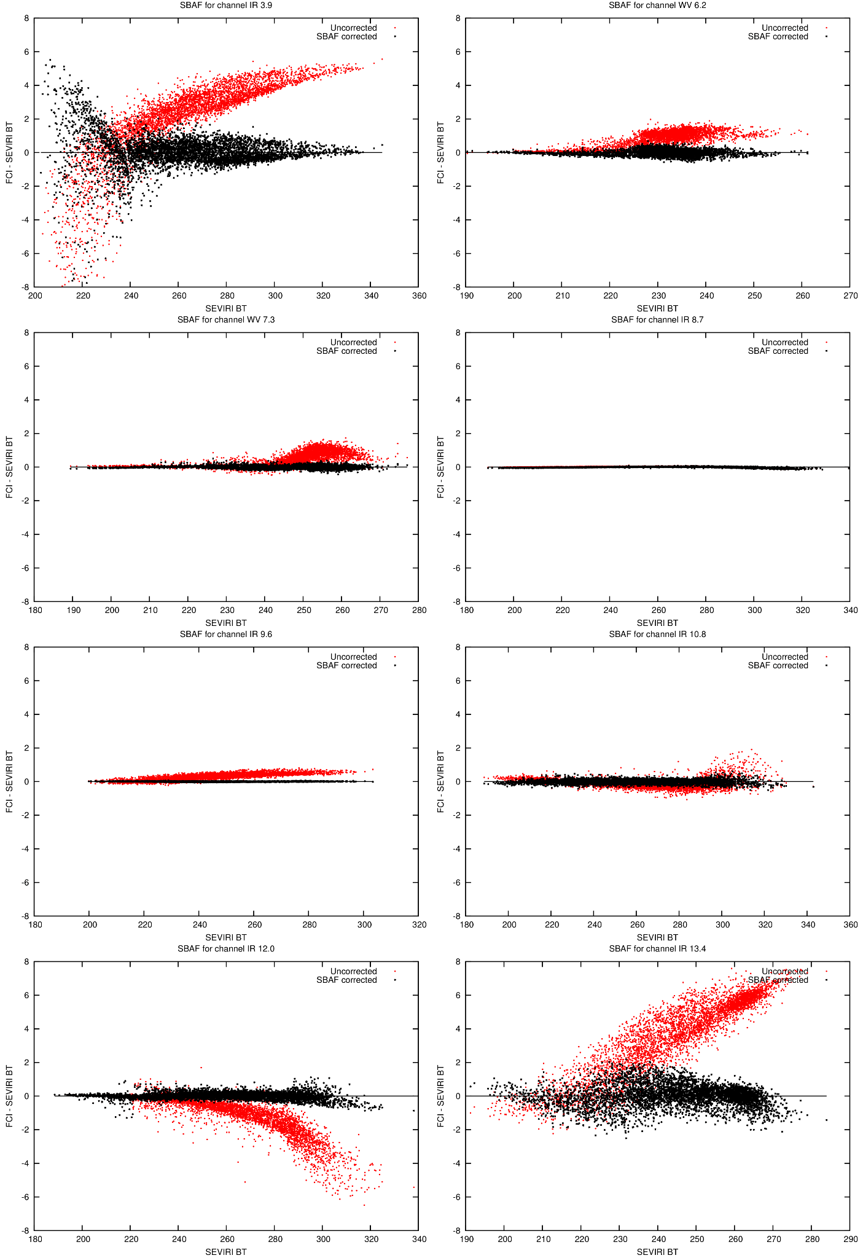
Figure 20 : scatter plots of the difference in brightness temperature (in K) as a function of the scene brightness temperature (K) without (red dots) and with (black dots) spectral band adjustment. The 8 panels correspond to the 8 thermal channels.

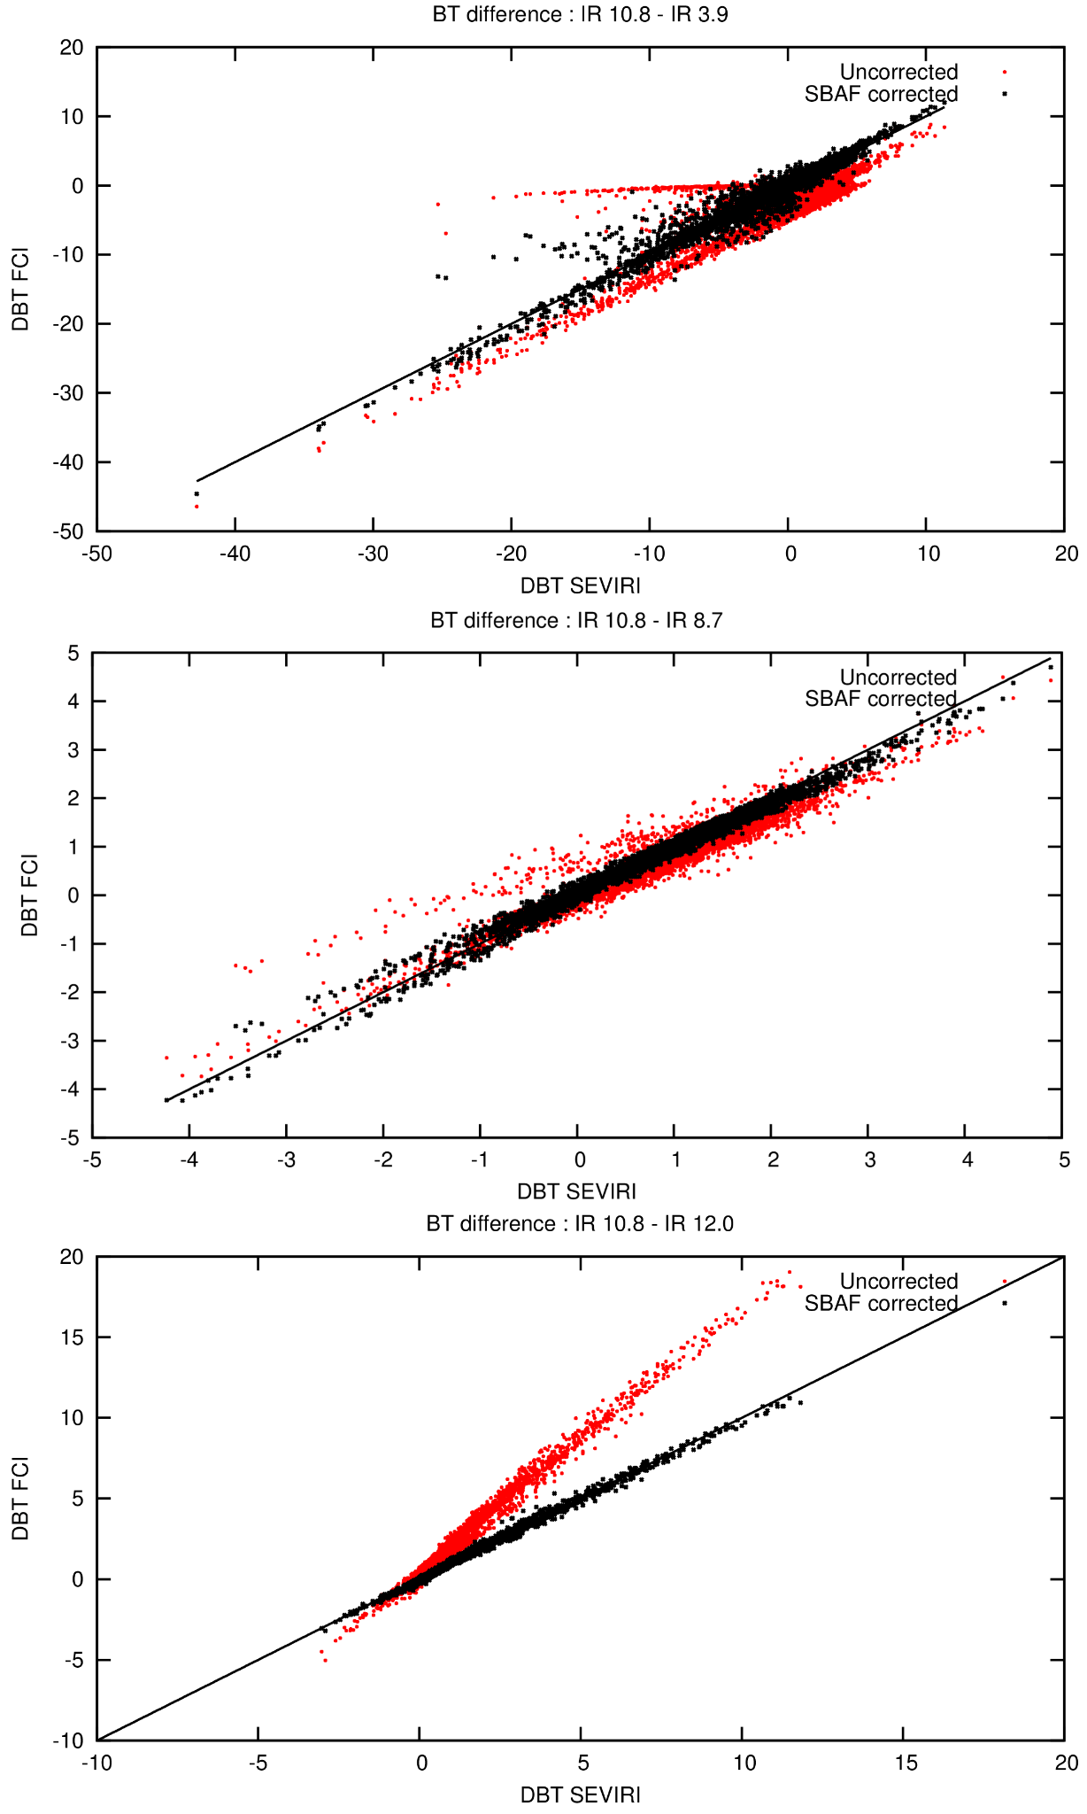
The Brightness Temperature Difference (BTD) between the SEVIRI 10.8µm and 12.0µm channels is an important proxy for semi-transparent clouds and is therefore an important input to estimate the OLR from the thermal radiances. Given the spectral shifts, this BTD between FCI CH14 and CH15 is significantly higher than the difference between SEVIRI 10.8 µm and 12 µm. Figure 21 shows how the SEVIRI brightness temperature differences can be correctly estimated from the FCI when SBAFs are applied. The importance of the SBAF is especially important for the BTD (10.8 - 12.0).
Figure 21 : Difference in brightness temperature difference (in K) between FCI and SEVIRI, without (red dots) and with (black dots) spectral band adjustment functions. Top is for the IR 10.8 µm – IR 3.9 µm, middle is for IR 10.8 µm – IR 8.7 µm, bottom is for IR 10.8 µm – IR 12 µm.

Annex 3 : Meteosat Reference Operation Baseline (as of March 2022)

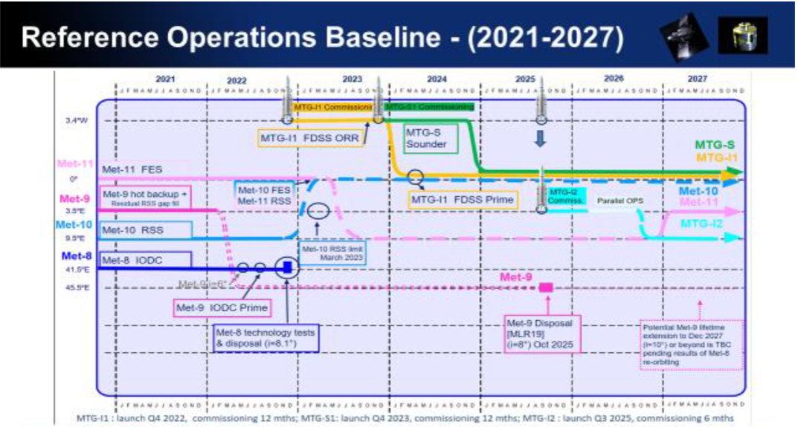

Annex 4 : Prepare for future instruments and releases (WP 2340) - Extract from the CDOP3 Project proposal

In order to be able to continue with its core TCDRs, it is important on one hand to exploit and prepare first steps on the transition between MSG and MTG as well as EPS and EPS-SG and on the other to be aware of recent steps towards the use of satellite data for model evaluation with Obs4MIPs. For the first theme, the CLAAS data record exploits the full record of MSG SEVIRI observations. Towards CDOP-4 it is important to prepare the homogeneous continuation of this data record using SEVIRIs follow-up instrument: FCI on MTG. The work includes tests with the cloud mask (including the probabilistic option) and cloud-top height software (currently from NWC SAF, but this will be reevaluated for CLAAS edition 3) to check to what extent these products derived from FCI have the same characteristics as from SEVIRI. If needed, adjustments to the software will be made, which may for example imply not using certain new channels available on FCI or downgrading the spatial resolution. For the CPP products a similar activity has to be undertaken. In addition to the above described work, which aims to use FCI as a SEVIRI heritage instrument, possibilities for new and improved products offered by the FCI sensor will be explored. This is preparatory work towards potential future FCI-specific data records that have a shorter temporal extent but more fully exploit this novel instrument. Similarly, TOA radiation products derived from MTG/FCI will be investigated as potential continuation of the operational GERB mission. The overlap period will be used to derive and evaluate empirical relations between the FCI narrowband and the GERB broadband observations. Cloud properties, an important input for accurate radiance-to-flux conversion, will be provided by the CPP applied to FCI. This activity will be done in close collaboration with the GERB level 2 processing team. For the second topic, it is necessary to further enhance the promotion of the CM SAF products, in particular in fora relevant to the global and regional climate modelling community. The Observations for Climate Model Intercomparisons (Obs4MIPS) activity has the objective to make observational products more accessible for climate model intercomparisons and thus provides an ideal platform to approach the climate modelling community, including the CMIP. The requirements for data record submission are summarised at https://www.earthsystemcog.org/projects/obs4mips/how_to_contribute. Besides making available the data on the Earth System Grid Federation (ESGF) CM SAF would need to adapt the format of the CM SAF data records according to Obs4MIPS requirements and prepare and submit a technical note and a proposal form to Obs4MIPS. During CDOP-2 CM SAF started to transform some of its TCDRs into the Obs4MIPS format and supplied it to ESGF grid. For CDOP-3, it is envisaged to submit such forms for all CM SAF TCDRs to Obs4MIPS.
Tasks in the WPDS for WP 2340 :
- RMIB : Develop and evaluate the transition of Top of the Atmosphere Radiation components from GERB/SEVIRI to MTG / FCI (where the broadband GERB instrument is no longer present).
- SMHI: Investigate potential for introducing probabilistic cloud masking for MTG/FCI
- DWD: develop and evaluate approaches for a homogeneous transitions from SEVIRI-based (MSG) to FCI-based (MTG) cloud properties in data record generation (CLAAS-heritage data record). Compare the operational and, if available, the reprocessed EUMETSAT IASI/MW product with the CM SAF ATOVS product to start preparing the utilization of EUMETSAT IASI/MW products as replacement for the ATOVS. Supporting the generation of Obs4MIPS compatible data records
- KNMI : develop and evaluate for MTG-FCI: make CPP retrieval consistent with MSG-SEVIRI

