EUMETSAT Satellite Application Facility on Climate Monitoring



Product User Manual
GEO-Ring-based ISCCP-NG Demonstrator Dataset from CM SAF version 0.1: Surface radiation, latent and sensible heat fluxes, evapotranspiration and land surface temperature

Surface Radiative Budget CM-25271
Latent and Sensible Heat Fluxes, evapotranspiration CM-25811
Land Surface Temperature CM-25921

Reference Number: | SAF/CM/MeteoSwiss/GEO/PUM
Issue/Revision Index: | 1.0
Date: | 09.09.2026
Document Signature Table
 | Name | Function | Signature | Date
Authors | Anke Tetzlaff  Varun Sharma  William Moutier  Miguel Barrios  Jan De Pue | CM SAF scientist (MeteoSwiss)  CM SAF scientist (MeteoSwiss)  CM SAF scientist (RMIB) |  | 09.09.2026
Editor | Marc Schröder | Science Coordinator |  | 09.09.2026
Approval | - | - | - | -
Release | Rainer Hollmann | Project Manager

Distribution List
Internal Distribution
Name | No. Copies
DWD / Archive  CM SAF Team | 1  1

External Distribution
Company | Name | No. Copies
Public |  | 1

Document Change Record
Issue/ Revision | Date | DCN No. | Changed Pages/Paragraphs
1.0 | 09.09.2026 | SAF/CM/MeteoSwiss/GEO/PUM | First version

Applicable Documents
Reference | Title | Code
AD 1 | CDOP-4 Product Requirements Document | SAF/CM/DWD/PRD 4.4

Reference Documents
Reference | Title | Code
RD 1 | Product User Manual GEO-Ring-based ISCCP-NG Demonstrator Dataset from CM SAF version 0.1: Clouds and Top-Of-Atmosphere Radiation | SAF/CM/KNMI/GEO/PUM
RD 2 | CM SAF Algorithm Theoretical Basis Document. Meteosat Latent and Sensible heat fluxes – Edition 1.2 | SAF/CM/RMIB/ATBD/MET/LEH/1.2
RD 3 | CM SAF Algorithm Theoretical Basis Document – HOAPS-5.0 | SAF/CM/DWD/ATBD/HOAPS/3.1
RD 4 | Validation Report HOAPS-5.0 | SAF/CM/DWD/VAL/HOAPS/3.0
RD 5 | LSA SAF Algorithm Theoretical Basis Document, For Evapotranspiration and Surface Fluxes version 1.1 | SAF/LAND/IM/ATBD_ETv2HLE/1.1
RD 6

Table of Contents
1 The EUMETSAT SAF on Climate Monitoring (CM SAF) 8
2 Product description 9
2.1 Algorithm description 10
2.2 Limitations 15
2.3 Validation 18
2.5 Recommended application 38
2.6 Changes to heritage version and evolution 38
3 Data format description 39
3.1 General variables 40
3.2 Product specific data fields 40
4 Data access 42
4.1 Product ordering process 42
4.2 Contact user help desk 42
4.3 User problem report 42
4.4 Service messages / log of changes 42
5 Feedback 44
5.1 User feedback 44
5.2 Specific requirements for future products 44
5.3 User workshops 44
6 Citation, copyright, acknowledgement, disclaimer 45
7 References 47
8 Glossary – List of Acronyms 50

List of Tables
Table 2-1: Overview of key characteristics of the demonstration dataset for clouds and top-of-atmosphere radiation. See also [AD 1]. 8
Table 2-2: Spectral channels offered by geostationary imagers included in the L1g input data. Numbers represent the nominal spatial resolution in km at the subsatellite point. Blank cells represent absent channels. Channels used for the demonstration data record are indicated in bold. Table adapted from Heidinger et al. (2026). 10
Table 2-3: Statistical metrics (mean bias, unbiased root-mean-square difference [uRMSD], mean absolute difference [MAD], and correlation coefficient [R²]) for hourly latent heat flux, calculated per site and averaged across the selected stations. 18
Table 2-4: Statistical metrics (mean bias, unbiased root-mean-square difference [uRMSD], mean absolute difference [MAD], and correlation coefficient [R²]) for daily latent heat flux from CM SAF GEO-Ring, GLEAM v4.2a, GLEAM v4.2b, ERA5-Land, GLDAS, and FLUXCOM, calculated per site and averaged across the selected stations. 18
Table 2-6: Statistical metrics (mean bias, unbiased root-mean-square difference [uRMSD], mean absolute difference [MAD], and correlation coefficient [R²]) for hourly sensible heat flux, calculated per site and averaged across the selected stations. 23
Table 2-7: Statistical metrics (mean bias, unbiased root-mean-square difference [uRMSD], mean absolute difference [MAD], and correlation coefficient [R²]) for daily sensible heat flux from CM SAF GEO-Ring, GLEAM v4.2a, GLEAM v4.2b, ERA5-Land, GLDAS, and FLUXCOM, calculated per site and averaged across the selected stations. 23
Table 3-11: File name format. 27
Table 3-12: General variables in each product. 28
Table 3-13: Main variables in the ISCCP-NG Demo L3 latent and sensible heat fluxes and evapotranspiration products files. 28
Table 3-14: Main variables in the ISCCP-NG Demo L3 land surface temperature products files 29
Table 3-15: Main variables in the ISCCP-NG Demo L3 surface radiative budget products files. 29

List of Figures
Figure 2-1: Organization of L1g data. The GEO-Ring reflectance and brightness temperature measurements are divided in different layers, of which the first layer includes the data with the smallest viewing zenith angle. The left panel shows an example of a GEO-Ring 11-µm brightness temperature image, while the right panel shows the contribution of different satellites to this image. Figure credits: Coda Phillips (CIMSS). 10
Figure 2-2: GEO-Ring image of brightness temperature difference (K) between 12- and 11-µm channels on 25 February 2021 at 14:00 UTC. 14
Figure 2-3: Log of standard deviation of brightness temperature difference between 12- and 11-µm channels at 14:00 UTC for every day in 2021 over a region in the Pacific covered by GOES-17 (left) and a region in the Atlantic covered by GOES-16/Meteosat-11 (right). 14
Figure 4: Localisation of eddy covariance stations used to evaluate the CM SAF GEO-Ring dataset. 18
Figure 5: Mean Absolute Difference (MAD) of Latent heat flux (LE, W m⁻², left axis; mm day⁻¹, right axis) across IGBP land cover classes for CM SAF GEO-Ring, GLEAM v4.2a, GLEAM v4.2b, FLUXCOM, ERA5-Land and GLDAS. Values (n) above each group of bars indicate the number of in situ stations per IGBP class. 20
Figure 7: Global spatial distribution, for the season (June-July-August), of Latent heat flux (LE; W m⁻²) from CM SAF GEO-Ring, ERA5-Land, GLDAS, GLEAM (v4.2a and 4.2b), and FLUXCOM. The right panel displays the corresponding longitudinal mean profile as a function of the latitude. 22
Figure 19: Mean Absolute Difference (MAD; W m-2) of Sensible heat flux (H) across IGBP land cover classes for CM SAF GEO-Ring, GLEAM v4.2a, GLEAM v4.2b, ERA5-Land and GLDAS. Values (n) above each group of bars indicate the number of in situ stations per land cover classes. 24
Figure 20: Global spatial distribution, for the season (June-July-August), of Sensible heat flux (H; W m⁻²) from CM SAF GEO-Ring, ERA5-Land, GLDAS, and GLEAM (v4.2a and 4.2b). The right panel displays the corresponding longitudinal mean profile as a function of the latitude. 25

The EUMETSAT SAF on Climate Monitoring (CM SAF)
The EUMETSAT Satellite Application Facility on Climate Monitoring (CM SAF, https://www.cmsaf.eu), together with the EUMETSAT Secretariat, holds the role as main implementer of EUMETSAT’s commitments in support to climate monitoring.
Since the beginning in 1999, CM SAF has developed and will continue to develop capabilities for a sustained generation and provision of Climate Data Records (CDR’s) of Essential Climate Variables (ECVs) as defined by the Global Climate Observing System (GCOS), derived from operational meteorological satellites. In particular, the generation of long-term data records is pursued that are suitable for the analysis of climate variability and potentially the detection of climate trends. Here, the main focus in CM SAF is on those ECVs that describe important components of the Earth’s energy budget and its water cycle.
Another essential task of CM SAF is to produce data records that can serve applications related to the Global Framework of Climate Services initiated by the WMO World Climate Conference-3 in 2009. For this, CM SAF is supporting climate services at national meteorological and hydrological services with long-term data records but also with data sets produced in a seamless and coherent way close to real time that can be used to, e.g., prepare monthly/annual updates of the state of the climate. These so-called Interim Climate Data Records (ICDRs) together with the CDRs allow for a consistent description of mean values, anomalies, variability and potential trends for the considered ECVs. CM SAF CDRs also facilitate scientific applications such as for example process studies and evaluation of climate models at regional and global scales.
Furthermore, CM SAF contributes to advancing the availability, quality and usability of Fundamental Climate Data Records (FCDRs) in close collaboration with the EUMETSAT Secretariat and other satellite operators.
CM SAF is connected to the global scientific community ensuring a steady exchange of knowledge to continuously improve the data records and services, among others, through its engagement in international data assessments and through taking over responsibility in various international coordination bodies.
The international consortium of CM SAF currently comprises the Deutscher Wetterdienst (DWD) as host institute, the Royal Meteorological Institute of Belgium (RMIB), the Finnish Meteorological Institute (FMI), the Royal Meteorological Institute of the Netherlands (KNMI), the Swedish Meteorological and Hydrological Institute (SMHI), the Meteorological Service of Switzerland (MeteoSwiss), the Meteorological Service of the United Kingdom (UK Met Office) and the Centre National de la Recherche Scientifique (CNRS).
More information, including a complete catalogue of all CM SAF products, can be found at CM SAF’s webpage, https://www.cmsaf.eu. Accessing all data products is facilitated through the CM SAF web user interface: https://wui.cmsaf.eu/.

Product description
The GEO-Ring-based ISCCP-NG Demonstrator Dataset from CM SAF (version 0.1) contains a range of variables derived from the combination of geostationary (GEO) meteorological imagers encircling the Earth (GEO-Ring). This document describes land surface temperature, surface radiative budget as well as latent and sensible heat fluxes (and evapotranspiration) products, while a collection of surface variables (cloud and top-op-atmosphere radiation products) are detailed in [RD 1]. ISCCP is the International Satellite Cloud Climatology Project (Schiffer and Rossow, 1983; Rossow, 2022), and ISCCP-NG refers to the Next Generation of ISCCP, which is yet to be shaped (Heidinger et al., 2026). The current dataset serves as a demonstration of how an ISCCP-NG data record could look like. More details of the products described in this product user manual (PUM) are provided in Table 2-1.
Table 2-1: Overview of key characteristics of the demonstration dataset for clouds and top-of-atmosphere radiation. See also [AD 1].
Parameters | Product family | Spatial and temporal resolution | Spatial coverage | Temporal coverage
Land Surface Temperature (LST) | ISCCP-NG LST demonstration data record (CM-25921) | Hourly mean / 0.05°  Daily mean / 0.05°  Monthly mean / 0.05°  Monthly mean diurnal cycle / 0.25° | GEO-Ring | 2021
Surface Radiative Budget | ISCCP-NG SRB demonstration data record (CM-25271) | Hourly mean / 0.05°  Daily mean / 0.05°  Monthly mean / 0.05°  Monthly mean diurnal cycle / 0.25 | GEO-Ring | 2021
Latent heat flux (LE)  Evapotranspiration (ET)  Sensible heat flux (H) | ISCCP-NG LEH demonstration data record (CM-25811) | Hourly mean (accumulation) / 0.05°  Daily mean (accumulation) / 0.05°  Monthly mean (accumulation) / 0.05°  Monthly mean diurnal cycle (accumulation) / 0.05° | GEO-Ring | 2021

Algorithm description

Input data
The basic input for the demonstration data record are radiances measured by geostationary satellites. These radiances have been combined and aggregated in a so-called L1g format on a global 0.05°×0.05° latitude-longitude grid with a 30-minute time step, and converted to reflectances and brightness temperatures for the shortwave and longwave channels, respectively. The data is organized in different layers, of which only the first layer, representing the geostationary satellite with the smallest viewing zenith angle (VZA) (see Figure 2-1), is used here. Measurements are included from the Advanced Baseline Imager (ABI) on the Geostationary Operational Environmental Satellite (GOES), the Spinning Enhanced Visible and Infra-Red Imager (SEVIRI) on Meteosat Second Generation (MSG), and the Advanced Himawari Imager (AHI) on Himawari. The spectral channels available from these imagers along with their spatial resolution are listed in Table 2-2, and the channels used to create the current demonstration data record are also highlighted. The L1g products used for the current demonstration dataset were generated at the Cooperative Institute for Meteorological Satellite Studies (CIMSS) in collaboration with the National Oceanic and Atmospheric Administration (NOAA) and CM SAF (see https://cimss.ssec.wisc.edu/isccp-ng/), while further development and operationalization is performed by EUMETSAT. More details on the GEO-Ring L1g product and its envisioned applications can be found in Heidinger et al. (2026).
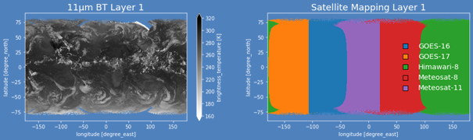
Figure 2-1: Organization of L1g data. The GEO-Ring reflectance and brightness temperature measurements are divided in different layers, of which the first layer includes the data with the smallest viewing zenith angle. The left panel shows an example of a GEO-Ring 11-µm brightness temperature image, while the right panel shows the contribution of different satellites to this image. Figure credits: Coda Phillips (CIMSS).

Table 2-2: Spectral channels offered by geostationary imagers included in the L1g input data. Numbers represent the nominal spatial resolution in km at the subsatellite point. Blank cells represent absent channels. Channels used for the demonstration data record are indicated in bold. Table adapted from Heidinger et al. (2026).
Nominal wavelength (µm) | GOES-ABI | MSG-SEVIRI | Himawari-AHI
0.47 | 1 |  | 1
0.51 |  |  | 1
0.65 | 0.5 | 3 | 0.5
0.86 | 1 | 3 | 1
1.38 | 2
1.6 | 1 | 3 | 1
2.2 | 2 |  | 1
3.8 | 2 | 3 | 2
6.2 | 2 | 3 | 2
6.9 | 2 |  | 2
7.3 | 2 | 3 | 2
8.5 | 2 | 3 | 2
9.6 | 2 | 3 | 2
10.5 | 2 |  | 2
11.0 | 2 | 3 | 2
12.0 | 2 | 3 | 2
13.3 | 2 | 3 | 2

The L1g product is based on nominal calibration as provided by the respective space agencies. This calibration is used here without adjustments, except for the MSG-SEVIRI solar channels, for which calibration coefficients were derived using Moderate Resolution Imaging Spectroradiometer (MODIS) as a reference, following Meirink et al. (2013).
The satellite instruments constituting the GEO-Ring (Figure 2-1) carry comparable spectral channels but the spectral response functions are slightly different. For that reason, a homogenization is applied: the measurements of all instruments are converted to ‘Meteosat-11-SEVIRI-like’ by means of spectral band adjustment factors (SBAFs). The SBAFs have been derived using the same methodology as in Stengel et al. (2020). Briefly, collections of SCanning Imaging Absorption For Atmospheric CHartographY (SCIAMACHY; for shortwave channels) and Infrared Atmospheric Sounding Interferometer (IASI; for longwave channels) spectra were convoluted with the spectral response functions of the respective GEO imager channels. Subsequently, the SBAFs were obtained as the coefficients of linear fits between each GEO imager channel and the corresponding Meteosat-11 SEVIRI channel in reflectance or brightness temperature space.
Apart from the measured reflectances and brightness temperatures, the retrieval algorithms require a number of variables as input.
- Several parameters, including skin temperature, vertical profiles of temperature, moisture and geopotential height, wind speed at 10 m, and snow depth, are extracted from the ECMWF Reanalysis 5th Generation (ERA5; Hersbach et al., 2020).
- Surface albedo is based on gap-filled MODIS data (MCD43GF).
- Surface emissivity input consists of monthly climatologies based on MODIS data.
- Sea ice concentration is taken from the OSI-430b product provided by the OSI SAF.
- Satellite and solar zenith and azimuth angles are provided in the L1g files.
- Annual land cover maps with IGBP types are based on MODIS data (MCD12C1v061).
- Several parameters, including 2-m air temperature, 2-m dew-point temperature, wind speed at 10-m (U and V components), surface pressure, soil temperature level (level 1 to 4), volumetric soil water content (layer 1 to 4) soil type, land sea mask and geopotential height are extracted from ERA5-Land (Muñoz Sabater et al., 2021).
- Yearly land cover map from ESA CCI Land Cover (Harper et al., 2023).
- 8-DailyLeaf Area Index (LAI) from GLASS dataset (Liang et al., 2021).
- Static Tree height map (Simard et al., 2011).
- Daily Snow cover (Dietz et al., 2015).
- C3/C4 classification (Still et al., 2009).
- Static Digital elevation model (GMTED2010; Danielson and Gesh 2011).

Land surface temperature retrieval algorithm

Surface radiative budget retrieval algorithm

Latent and sensible heat fluxes retrieval algorithm
The surface latent and sensible heat fluxes, as well as evapotranspiration, are retrieved using a methodology developed by the Land Surface Analysis Satellite Application Facility (LSA SAF) v5.0.3 (Ghilain et al., 2011, 2012, 2020; Barrios et al. ,2024; RD 5). The current version of the algorithm is based on the CM SAF LandFlux Edition 1 retrieval scheme from CDOP-3 (RD 2). The underlying model is a tile-based Surface Vegetation-Atmosphere Transfer (SVAT) scheme derived from TESSEL/H-TESSEL (Van den Hurk et al., 2000; Viterbo and Beljaars, 1995, Balsamo et al, 2009; Albergel et al, 2012), modified to integrate satellite-based data and numerical weather prediction (NWP) models’ outputs (ECMWF reanalysis) as forcing. To extend the coverage to a quasi-global domain, the primary satellite inputs are derived from the GEO-Ring data. The surface radiation components—including Surface Incoming Shortwave radiation (SIS), Surface Downward Longwave radiation (SDL), Surface Albedo (SAL), and surface emissivity—are retrieved using the CM SAF software “GeoSatClim” (RD X). These radiative drivers are complemented by other parameters (e.g., Leaf Area Index (LAI)) from satellite products and meteorological forcing from ECMWF reanalysis.
Concerning the physical model approach, each pixel is split into a maximum of 4 tiles based on land cover fractions, selected from 12 distinct land cover types to account for surface heterogeneity. The algorithm is an energy balance model aiming to partition the available energy between LE, H and heat conduction flux into the ground (G). Thus, for each tile, a closure of the surface energy budget is obtained. Turbulent fluxes (H and LE) are calculated at the tile level through aerodynamic and canopy/surface resistance networks, combining a response of the stomata closure by environmental stress (canopy resistance to transpiration) and the aerodynamic resistance. An iterative scheme is applied until T_{sk} (skin temperature) ​, H, and LE values reach convergence. The final pixel value is then obtained by a weighted contribution of all tiles composing it.
To facilitate global-scale climate monitoring and water energy budget analyses, daily and monthly latent heat flux (LE) outputs are merged with ocean evaporation data from HOAPS product. (RD 3). The original HOAPS dataset at 0.5° resolution is not modified. Instead, the 0.5° HOAPS values are directly mapped to the corresponding 0.05° GEO-Ring grid pixel over the ocean. In addition, coastal water gaps are filled using a simple nearest-neighbour approach to ensure spatial continuity along coastlines

Highlights
This new demonstration dataset provides a comprehensive suite of land surface temperature, surface radiative budget as well as latent and sensible heat fluxes (and evapotranspiration) products derived from a homogenized combination of observations from multiple geostationary satellites. By integrating measurements from the GEO-Ring, the dataset offers near-global coverage, enabling consistent monitoring of clouds and the Earth's radiation budget on continental to global scales.
A key strength of the dataset is its high temporal resolution, which captures the full diurnal cycle of cloud evolution and radiative fluxes. This allows users to investigate rapidly changing atmospheric processes and improve the characterization of cloud-radiation interactions.
Compared to data records relying on one visible and one thermal infrared window channel, a wider range of cloud properties, including microphysical properties, can be retrieved and in general a higher accuracy can be reached (Heidinger et al., 2026).
Finally, the cloud and TOA radiation products are generated within an internally consistent processing framework. As a result, the radiation products are directly linked to the retrieved cloud properties, ensuring physical consistency across the dataset.

Limitations
The data record is meant for demonstrational purposes. There are still some issues and limitations that users need to be aware of when working with the data.
It is recalled here that the input L1g prototype data were generated at CIMSS in collaboration with NOAA and CM SAF. It is noted that EUMETSAT leads an international effort with other space agencies on further developing, improving, reprocessing and operationalising GEO-Ring based L1g data. It is anticipated that at least a subset of the limitations will not be applicable anymore once the new final L1g data, covering the full period of observations by geostationary observations, will become available in late 2027.

Quality of GOES-17 thermal infrared measurements
Due to a loop heat pipe anomaly, the infrared detectors on GOES-17 ABI could not be sufficiently cooled, leading to saturation of the infrared channels (Yu et al., 2019). The degree of saturation varies with season and time of day, and also depends on the channel. An example of a strongly affected time stamp is shown in Figure 2-2, with considerable striping in the GOES-17 part of the domain.
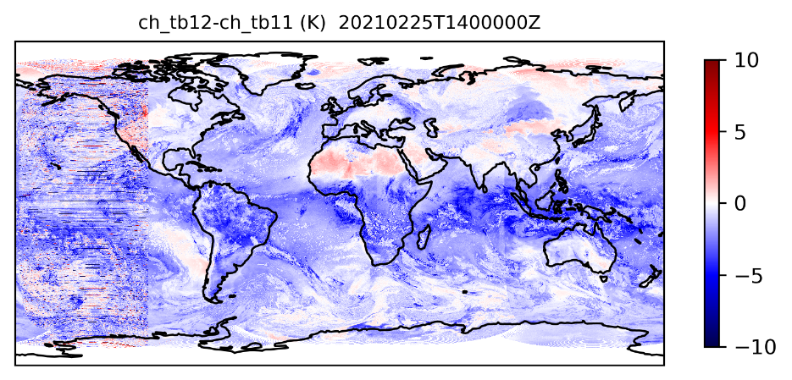
Figure 2-2: GEO-Ring image of brightness temperature difference (K) between 12- and 11-µm channels on 25 February 2021 at 14:00 UTC.

The issue is further illustrated in Figure 2-3. The left panel shows the daily standard deviation of 12- and 11-µm channel brightness temperature difference in the GOES-17 area at 14:00 UTC. This corresponds to around 3-6 AM local time, when the saturation problems are typically worst. In general, the problems are restricted between 8:30 and 19:30 UTC, i.e., night and early morning, while daytime data are of good quality. For comparison, the right panel in Figure 2-3 shows the same brightness temperature difference for an area covered by GOES-16 and Meteosat-11. There, the standard deviation is very stable throughout the year. Thus, while the GOES-17 nighttime infrared channel anomalies are strongest during four periods before and after the two equinoxes, the much more variable standard deviation, compared to GOES-16/Meteosat-11 suggests that issues are in fact present during the entire year. This should be kept in mind when using the GEO-Ring demonstrator products.
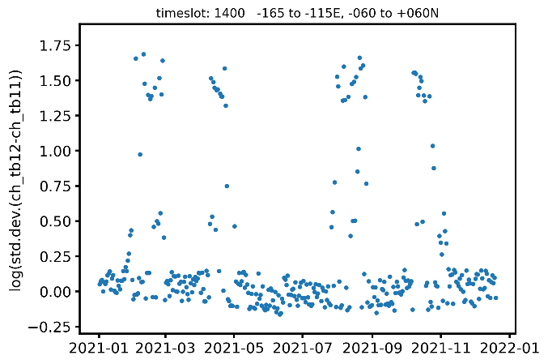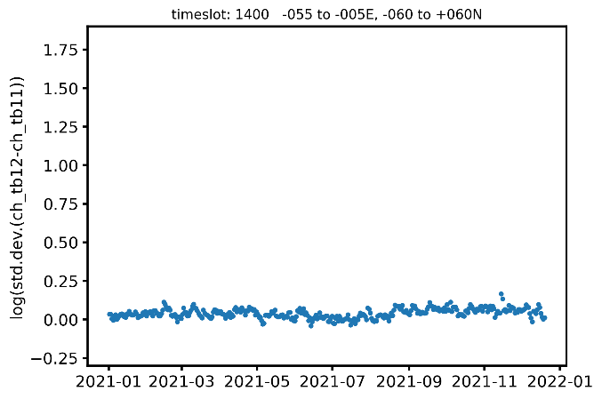
Figure 2-3: Log of standard deviation of brightness temperature difference between 12- and 11-µm channels at 14:00 UTC for every day in 2021 over a region in the Pacific covered by GOES-17 (left) and a region in the Atlantic covered by GOES-16/Meteosat-11 (right).

Imperfect calibration and SBAFs
As outlined in Section 2.1.1, the L1g data are based on nominal calibration of the respective GEO sensors, except for the shortwave channels on MSG-SEVIRI. Even though on-board calibration devices were applied in most cases, these calibrations are not perfect. In addition, the SBAF approach may not succeed to entirely homogenize reflectances and brightness temperatures between sensors. These factors may explain some of the discontinuities between cloud and TOA products from different GEO sensors, as observed in Section 2.3.
To further investigate the discontinuities, all L1g reflectances (both for the 0.65-µm and 0.86-µm channels) of January 2021 were averaged for the timeslot having the sun directly overhead the separation meridian between MSG-IODC and Himawari (i.e., 31 time slices). The viewing and illumination geometry are then identical on both sides. A discontinuity between L1g data from the two satellites was clearly visible in the aggregated maps (figures not shown). Specifically, the Himawari-8 AHI reflectances were, for both channels, larger than the Meteosat-8 SEVIRI reflectances, consistent with the discontinuities in COT (2) and RSF (2). This is a qualitative but strong indication that L2 discontinuities originate from L1g, and that calibrations and/or SBAFs must be improved in the future.

Solar and satellite angle calculation
After the data record had been produced, two mistakes were discovered regarding the calculation of the solar and satellite angles:
- The solar zenith and azimuth angles are based on the timestamp of the L1g file rather than the actual pixel acquisition time. The former can be up to 12 minutes earlier than the latter, resulting in slightly wrong angles, depending on the geographic location. This has a small but non-negligible impact on all products derived from solar channel measurements.
- The viewing zenith and azimuth angles are based on the nominal positions of the GEO satellites rather than their actual positions. This has the largest effect in the Meteosat-8 domain because this satellite experiences the largest deviations from its nominal position. However, even in that domain the impact on the cloud and TOA radiation products is minor.

Other limitations
The L1g dataset is more or less complete apart from rare occasions of missing data from individual satellites. An exception is the last day of the year, 31 December 2021, for which most time slots are missing, and no level-3 products are generated. Therefore, this day is not represented in the monthly mean of December.
A final issue is that reflectances have been cut off at a value of 200% and set to fill values. Such high reflectances only occur for very high solar zenith angles (SZAs), at which the ‘daytime’ products such as cloud optical thickness are not produced. However, for the basic cloud products and RSF, the consequence is some missing data in cases for which normally a valid retrieval should be present. The impact of this issue on level-3 products is marginal.

Validation
In this section, a selection of validation results is presented. This is not meant to be an exhaustive validation exercise but should give the user an impression of the data quality.

Land surface temperature

Surface radiative budget

Latent and sensible heat fluxes
CM-25811 outputs have been compared with:
- In situ datasets: FLUXNET Shuttle dataset (Pastorello et al., 2020; Papale et al., 2020; https://data.fluxnet.org/) at selected locations in different climatic/vegetation conditions.

- Reanalysis: output of models (ingesting satellite data or not) recognized to produce valuable meteorological information in about the same conditions: near-real time and intra-day variations of evapotranspiration and fluxes, e.g., GLDAS Noah (v2.2; Rodell et al., 2004) and ERA5-Land (Muñoz Sabater et al., 2021).

- Satellite-based and fused-data products: GLEAM (v4.2a and v4.2b, Miralles et al., 2011; 2024) and FLUXCOM X-BASE (hereafter FLUXCOM; Nelson et al., 2024).
These products have been selected because of their temporal coverage and their spatial and temporal resolutions.
First, hourly and daily CM SAF outputs are evaluated against gap-filled and energy-balance-corrected in situ measurements obtained through the FLUXNET Shuttle database. To assess performance of daily data relative to other existing products, comparisons are also conducted against GLEAM, GLDAS, FLUXCOM, and ERA5-Land. For all products, values are extracted at their native spatial resolution from the grid pixel closest to each station location.
Hourly and daily in situ values are filtered using three criteria: i) strict quality control requiring good-quality data (QC <= 1, encompassing both measured data with QC = 0 and high-quality gap-filled data with QC = 1) for hourly data and at least 90% good-quality data for daily aggregates, ii) a minimum of 60 valid matchups per station, and iii) common data availability across all evaluated products to enable direct inter-product comparison. Because sub-daily measurements in the Shuttle dataset are provided at half-hourly resolution, hourly values were obtained by averaging half-hourly records into 1-hour time bins, strictly requiring both half-hourly slots (N = 2) to be valid. Thus, outputs have been compared with values from 237 (hourly) and 239 (daily) stations distributed worldwide (Figure 4), covering a wide range of International Geosphere-Biosphere Program (IGPB) land cover classes and Köppen-Geiger climate zones. Comparisons are not performed for monthly and monthly mean diurnal cycle data due to limited sample sizes (1 year of data).
To harmonize variables across datasets, two distinct conversion approaches were applied depending on the evaluation context: i) For station-level validations (hourly and daily), a constant conversion factor of 28.35 W m⁻² per mm day⁻¹ was applied to convert LE to ET (and conversely, ET to LE for products like GLEAM and FLUXCOM) and ii)For global spatial comparison using monthly products, FLUXCOM and GLEAM monthly ET (mm month⁻¹) was converted to latent heat flux LE (W m⁻²) using: LE = ET × Lv(T) / (N × 86400), where Lv(T) = 2.501×10⁶ − 2361·T (J kg⁻¹, T in °C) the temperature-dependent latent heat of vaporization, T is the monthly-mean 2 m air temperature from ERA5-Land, and N the number of days in the month.
Note that in situ flux eddy covariance-based measurements are typically subject to uncertainty from 10% to 30% (average 20%) as derived from the non-closure of the energy balance (e.g., Wilson et al., 2002; Foken, 2008; Franssen et al., 2010; Stoy et al., 2013; Senay et al., 2020; Mauder et al., 2020). The fluxes used in this validation were corrected for energy balance closure in the ONE-Flux postprocessing pipeline (Pastorello et al., 2020).

Second, grid-based comparisons are carried out on a common 0.25° × 0.25° latitude–longitude grid at monthly temporal resolution. Global spatial patterns are evaluated for the summer period (June, July, August; JJA). Over oceans and coastal waters, which are identified by a specific flag, values are assigned using nearest neighbour resampling from HOAPS native 0.5° data without model recalculation. These water pixels are omitted from the current evaluation since HOAPS data are validated independently by the HOAPS project team (RD 4). Thus, all evaluations (both in situ and grid-based) are restricted exclusively to land pixels.

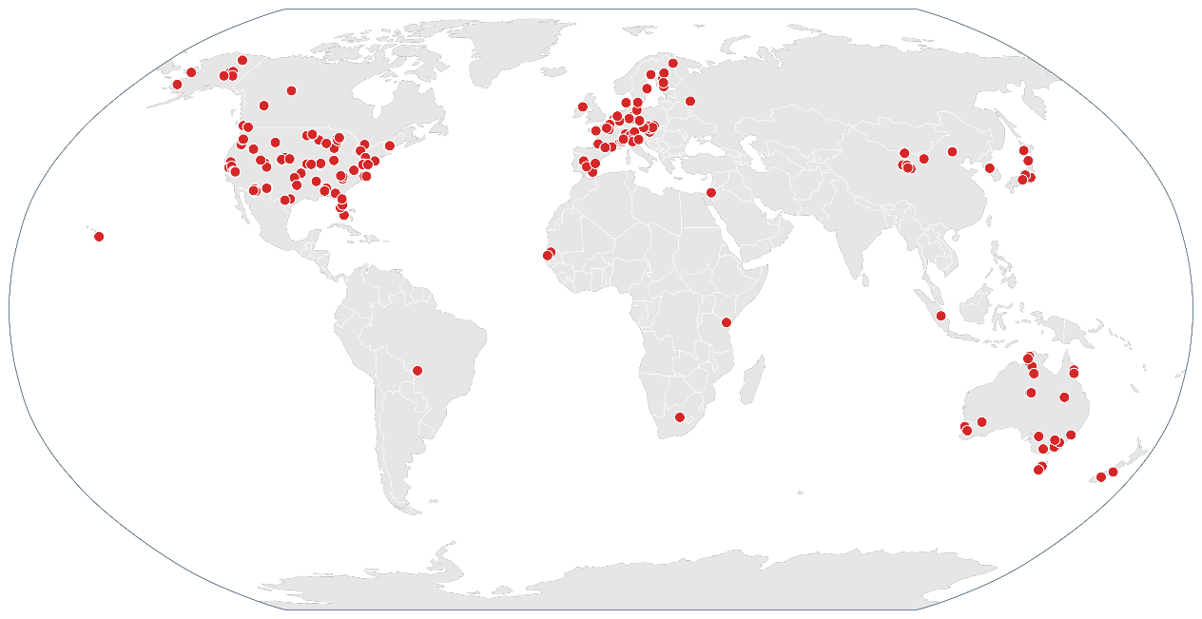
Figure 4: Localisation of eddy covariance stations used to evaluate the CM SAF GEO-Ring dataset.

Latent heat flux
Overall performance metrics for CM SAF latent heat flux (LE) at hourly resolution, and alongside key benchmark datasets at daily resolution, are summarized in Table 2-3. Results for CM SAF LE are consistent with performance ranges reported in the literature (e.g., Loew et al., 2016; Guo et al., 2022; Miralles et al., 2024). At hourly resolution, CM SAF exhibits an overall underestimation with a mean bias of -12.8 W m⁻². Hourly bias varies considerably across surface land cover classes, ranging from -1.0 W m⁻² in Savannas (SAV) to -23.5 W m⁻² in Woody Savannas (WSA) (results not shown).

Table 2-3: Statistical metrics (mean bias, unbiased root-mean-square difference [uRMSD], mean absolute difference [MAD], and correlation coefficient [R²]) for hourly latent heat flux, calculated per site and averaged across the selected stations.
Dataset | Nbr stations | bias | uRMSD | MAD | R²
CM SAF GEO-Ring | 237 | -12.8 | 52.1 | 30.5 | 0.68

Table 2-4: Statistical metrics (mean bias, unbiased root-mean-square difference [uRMSD], mean absolute difference [MAD], and correlation coefficient [R²]) for daily latent heat flux from CM SAF GEO-Ring, GLEAM v4.2a, GLEAM v4.2b, ERA5-Land, GLDAS, and FLUXCOM, calculated per site and averaged across the selected stations.
Dataset | Nbr stations | bias | uRMSD | MAD | R²
CM SAF GEO-Ring | 239 | -7.0 | 24.0 | 21.2 | 0.65
GLEAM v4.2a | 239 | -9.2 | 26.8 | 23.7 | 0.55
‍ GLEAM v4.2b | 239 | -0.8 | 29.9 | 26.7 | 0.48
‍ERA5-Land | 239 | -0.1 | 25.4 | 22.2 | 0.61
‍ GLDAS | 239 | -6.0 | 37.8 | 31.6 | 0.50
‍ FLUXCOM | 239 | -7.7 | 22.9 | 19.6 | 0.66

At the daily scale (Table 2-4), CM SAF exhibits a reduced mean bias of -7.0 W m⁻², achieving a mean absolute difference (MAD) of 21.2 W m⁻² and an R² of 0.65. While benchmark products such as GLEAM v4.2b and ERA5-Land exhibit near-zero mean daily biases, CM SAF demonstrates higher precision than GLEAM and GLDAS, performing comparably to ERA5-Land and FLUXCOM. Across IGBP land cover classes, daily underestimation persists for most classes, with positive biases restricted to Mixed Forests (MF, +3.0 W m⁻²) and Savannas (SAV, +7.6 W m⁻²). Nevertheless, CM SAF maintains consistently low daily MAD values across most individual IGBP classes (≈7.1 to 29.5 W m⁻² Figure 5) notably outperforming GLDAS (which reaches 44.2 W m⁻² in DBF) and GLEAM v4.2b (34.2 W m⁻² in DBF).

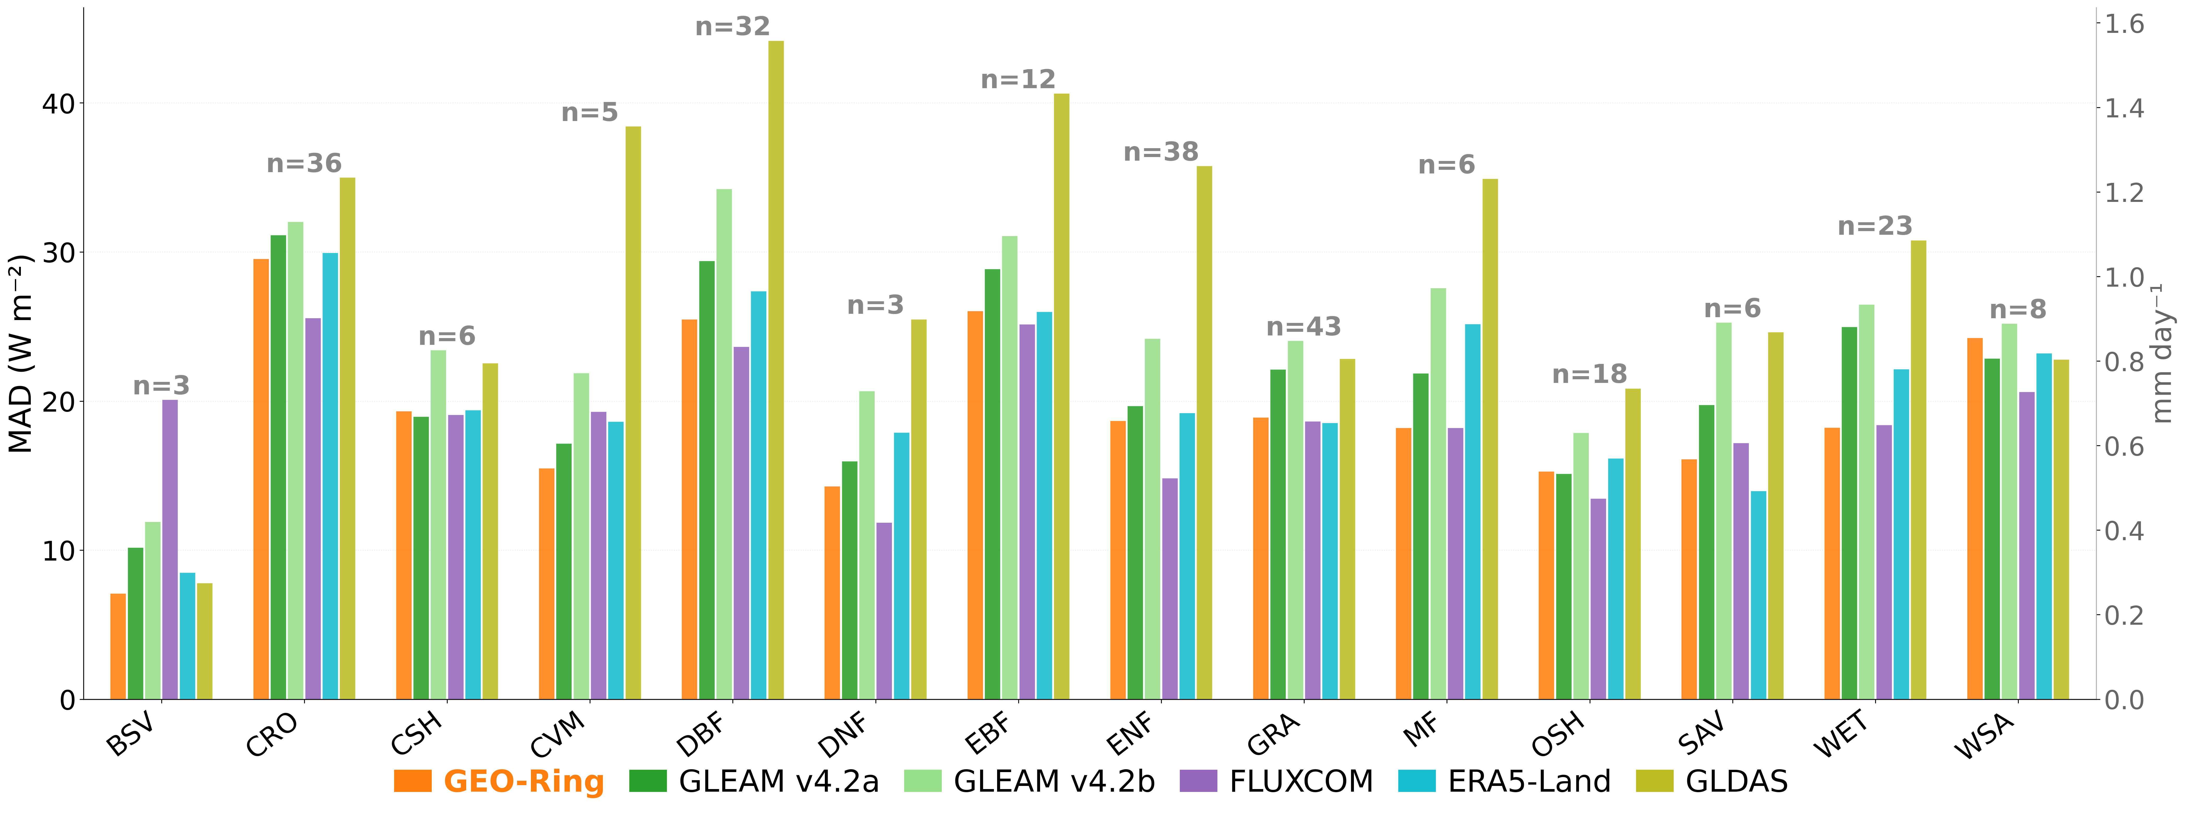
Figure 5: Mean Absolute Difference (MAD) of Latent heat flux (LE, W m⁻², left axis; mm day⁻¹, right axis) across IGBP land cover classes for CM SAF GEO-Ring, GLEAM v4.2a, GLEAM v4.2b, FLUXCOM, ERA5-Land and GLDAS. Values (n) above each group of bars indicate the number of in situ stations per IGBP class.

Discrepancies between estimated and observed latent heat fluxes can be attributed to four main sources of uncertainty: (i) input forcing errors, such as reanalysis soil moisture, incoming radiation, land cover, and leaf area index; (ii) surface energy partitioning and parameterization inaccuracies; (iii) spatial representativeness mismatch between local station footprints and satellite/reanalysis pixel scales; and (iv) intrinsic in situ measurement uncertainties.

First, the accuracy of flux estimates depends heavily on driving input quality, particularly soil moisture, incoming surface radiation, leaf area index, and land cover maps. Static yearly land cover products omit intra-annual vegetation dynamics, such as seasonal changes in bare soil fraction and canopy development. Errors in the reanalysis soil moisture driver can severely degrade flux estimates: the absence of irrigation in ERA5-Land (ECMWF, 2023; Tang et al., 2023) leads to strong underestimation over managed agricultural land. At the US-UTW site, active center-pivot irrigation drives observed latent heat fluxes exceeding 400 W m⁻², whereas the reanalysis soil moisture remains near the permanent wilting point, forcing estimated LE close to zero.
Similar errors in the LE estimates can be found in inland river deltas, for example at the CN-HeM station, in the Ejina oasis of the lower Heihe River basin. The region is hyper-arid, with about 37 mm of rain per year (ICOS Carbon Portal). The surface is a riparian forest of Populus euphratica and Tamarix, sustained mainly by groundwater and water ultimately derived from the Heihe River rather than by local rainfall (Cheng et al., 2014; Li et al., 2019). In the Ejina Oasis, shallow groundwater is primarily recharged by infiltration of Heihe River water (Cheng et al., 2014; Zhang et al., 2015; Li et al., 2019). Seasonal upstream water releases, occurring several times per year, deliver river water to the riparian forest and contribute to seasonal variations in shallow soil moisture and groundwater availability (Li et al., 2019; Liu et al., 2023). ERA5-Land has no groundwater and no lateral water supply (ECMWF 2023), so it only sees the dry local soil column. As a result, reanalysis soil moisture at CN-HeM consistently stays below the permanent wilting point, triggering complete soil moisture stress with LE approaching zero. These limitations degrade site-level performance, with hourly (daily) MAD reaching 99 (110) W m⁻² at US-UTW, and 131 (132) W m⁻² at CN-HeM. Note that at the daily scale, similarly large errors are observed across all other products at CN-HeM (MAD ranging from 118 W m⁻² for FLUXCOM to 134 W m⁻² for GLDAS) and US-UTW (MAD ranging from 91 W m⁻² for GLEAM v4.2b to 106 W m⁻² for GLDAS).
Second, model parameterization inaccuracies in surface energy partitioning introduce further error, particularly at high temporal resolution. A key example is the ground heat flux (G), currently estimated as a fixed fraction of net radiation per surface type. This formulation is widely used but has known limitations at hourly resolution, since the G/Rn ratio is not constant through the day (Santanello and Friedl, 2003). A static ratio cannot capture this diurnal cycle, introducing errors in available energy mainly at the hourly scale. Because G integrates to near zero over a full diurnal cycle, these instantaneous errors largely cancel out once fluxes are aggregated to daily means. This is confirmed by an energy residual analysis, defined per station as Residual = Bias(LE) + Bias(H). A residual near zero indicates that a mismatch between simulated and observed LE is compensated by an equal and opposite mismatch in H, while a non-zero residual points to an error in total available energy (Rn − G). Across the station network, the median residual drops from -19 W m⁻² at hourly resolution (n = 237) to -5 W m⁻² at daily resolution (n = 239), confirming that hourly errors are particularly sensitive to the current G parameterization and highlighting a priority area for future refinement.
Third, comparing a point-scale station measurement to a pixel-scale model estimate introduces a fundamental representativeness mismatch. Following the H-TESSEL tiling approach, the 0.05° grid cell accounts for surface heterogeneity through four surface tiles, each potentially assigned a different land cover type. However, the station itself represents a single, fixed land cover, and there is no guarantee that this land cover corresponds to the tile or tiles dominating the pixel. When the station's land cover is a minority component of the pixel, the driving inputs used in the tile-level computation, such as soil moisture, radiation, and other surface characteristics, largely reflect conditions outside what the station actually observes, which can drive a significant mismatch between the two.
Fourth, in situ eddy covariance observations typically lack energy balance closure, with turbulent fluxes underestimating available energy by approximately 20-30% (Mauder et al., 2020). The FLUXNET correction closes this gap by distributing the residual between LE and H while preserving the Bowen ratio (Foken et al., 2008; Pastorello et al., 2020), an assumption that does not necessarily hold everywhere. Across the 239 stations, the station-level median daily correction factor ranges from 0.62 to 2.21 (median 1.22, Q25-Q75: 1.13-1.35). Model performance on daily data degrades where the correction is large: at the 82 stations with a factor below 0.7 or above 1.3, bias, MAD and uRMSD reach -10.5, 26.0 and 29.0 W m⁻², compared with -5.2, 18.7 and 21.4 W m⁻² at the other stations.
Future operational releases will target reduced regional biases through refined land surface input datasets, variable vegetation cover based on satellite LAI, and improved diurnal ground heat flux (G) parameterizations.

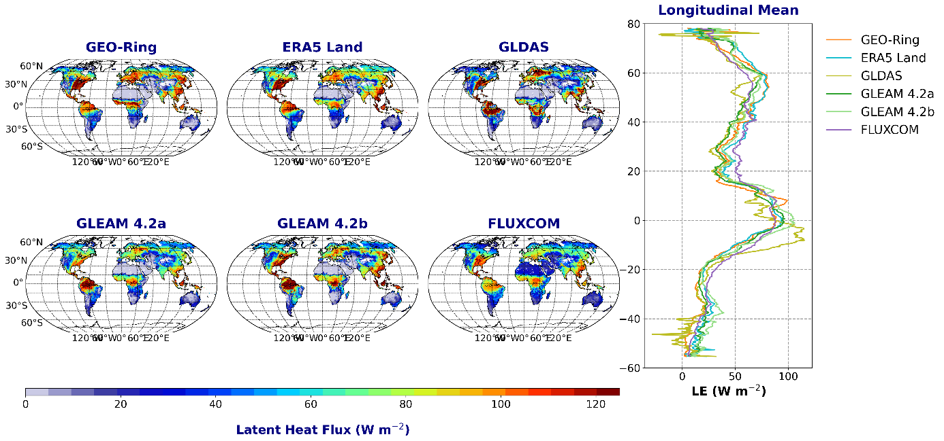
Figure 7: Global spatial distribution, for the season (June-July-August), of Latent heat flux (LE; W m⁻²) from CM SAF GEO-Ring, ERA5-Land, GLDAS, GLEAM (v4.2a and 4.2b), and FLUXCOM. The right panel displays the corresponding longitudinal mean profile as a function of the latitude.

Grid-based global comparisons on a common 0.25° grid for the JJA season (Figure 7) show consistent spatial patterns and comparable flux magnitudes across the evaluated products. In the absence of a true global product, CM SAF reproduces the spatial gradients seen in established reference datasets, although substantial inter-product differences remain in some tropical and high-latitude regions. Over the Amazon core (10°S-5°N, 75°W-50°W), CM SAF exhibits a spatial pattern comparable to ERA5-Land and FLUXCOM, with a mean flux of 94.9 W m⁻² (versus 99.6 W m⁻² for ERA5-Land and 93.0 W/m² for FLUXCOM), while remaining lower than GLEAM (113.8-120.7 W m⁻²) and GLDAS (108.3 W m⁻²). Over the Congo Basin (5°S-5°N, 15°E-30°E), CM SAF shows lower mean fluxes over the central rainforest (85.9 W/m²) than GLEAM (94.2-106.4 W m⁻²) and FLUXCOM (94.9 W m⁻²), but exhibits a distinct band of high values north of the central basin (approximately 4-10°N), where CM SAF provide higher mean values (108.1 W m⁻²) than all other products (32.3–100.4 W m⁻²). GLDAS shows marked differences in particular, with lower values across north-eastern Asia (50°N-70°N, 60°E-180°E; 44.0 W m⁻²) and high-latitude North America (50°N-70°N, 170°W-50°W; 41.3 W m⁻²) compared with the other products (55.5-71.0 W m⁻² and 46.3-62.7 W m⁻², respectively). For the remaining seasons (DJF, MAM, SON), the products show generally consistent results, although regional differences remain apparent, particularly in tropical regions.

Sensible heat flux
Overall performance metrics for CM SAF sensible heat flux (H) at hourly resolution, and alongside benchmark datasets at daily resolution, are summarized in Table 2-6. Similar to latent heat flux, the performance metrics for H fall well within the expected range reported in the literature (e.g., Loew et al., 2016; Liang et al., 2025). At hourly resolution, CM SAF exhibits a negative bias of -6.1 W m⁻² with an R² of 0.67. Hourly bias varies across IGBP surface land cover classes, ranging from underestimations in Savannas (SAV, -27.0 W m⁻²), to overestimations in Closed Shrublands (CSH, +12.2 W m⁻²) (results not shown).

Table 2-6: Statistical metrics (mean bias, unbiased root-mean-square difference [uRMSD], mean absolute difference [MAD], and correlation coefficient [R²]) for hourly sensible heat flux, calculated per site and averaged across the selected stations.
Dataset | Nbr stations | bias | uRMSD | MAD | R²
Hourly | 237 | -6.1 | 65.8 | 45.7 | 0.67

Table 2-7: Statistical metrics (mean bias, unbiased root-mean-square difference [uRMSD], mean absolute difference [MAD], and correlation coefficient [R²]) for daily sensible heat flux from CM SAF GEO-Ring, GLEAM v4.2a, GLEAM v4.2b, ERA5-Land, GLDAS, and FLUXCOM, calculated per site and averaged across the selected stations.
Dataset | Nbr stations | bias | uRMSD | MAD | R²
CM SAF GEO-Ring | 239 | -0.3 | 29.8 | 26.7 | 0.40
GLEAM v4.2a | 239 | 3.4 | 29.3 | 26.0 | 0.50
‍GLEAM v4.2b | 239 | 22.4 | 31.9 | 33.8 | 0.53
‍ ERA5-Land | 239 | -6.0 | 26.7 | 23.9 | 0.51
‍ GLDAS | 239 | 4.1 | 43.5 | 36.7 | 0.30

At the daily scale (Table 2-7) , CM SAF exhibits no overall mean bias, comparing favorably to other product where bias vary between -6.0 W m⁻² (ERA5-Land) and +22.4 W m⁻² ⁽GLEAM v4.2b). Overall, CM SAF achieves a mean absolute difference (MAD) of 26.7 W m⁻² and an uRMSD of 29.8 W m⁻². In term of MAD, CM SAF performs comparably toERA5-Land (23.9 W m⁻²) and GLEAM v4.2a (26.0 W m⁻²), while demonstrating lower overall error metrics than GLDAS (36.7 W m⁻²) and GLEAM v4.2b (33.8 W m⁻²). Across IGBP categories, CM SAF maintains consistently low daily MAD values (≈18.8 to 31.0 W m⁻²,Figure 19), showing errors comparable to ERA5-Land and GLEAM v4.2a, and lower discrepancies than GLDAS (reaching 50.2 W m⁻² in ENF) and GLEAM v4.2b (42.9 W m⁻² in WSA).
The main sources of discrepancy between estimated and observed sensible heat fluxes are similar to those detailed for latent heat flux in Section 2.3.3.1: (i) input forcing errors, such as reanalysis soil moisture, incoming radiation, land cover, and leaf area index; (ii) surface energy partitioning and parameterization inaccuracies; (iii) spatial representativeness mismatch between local station footprints and satellite/reanalysis pixel scales; and (iv) intrinsic in situ measurement uncertainties.
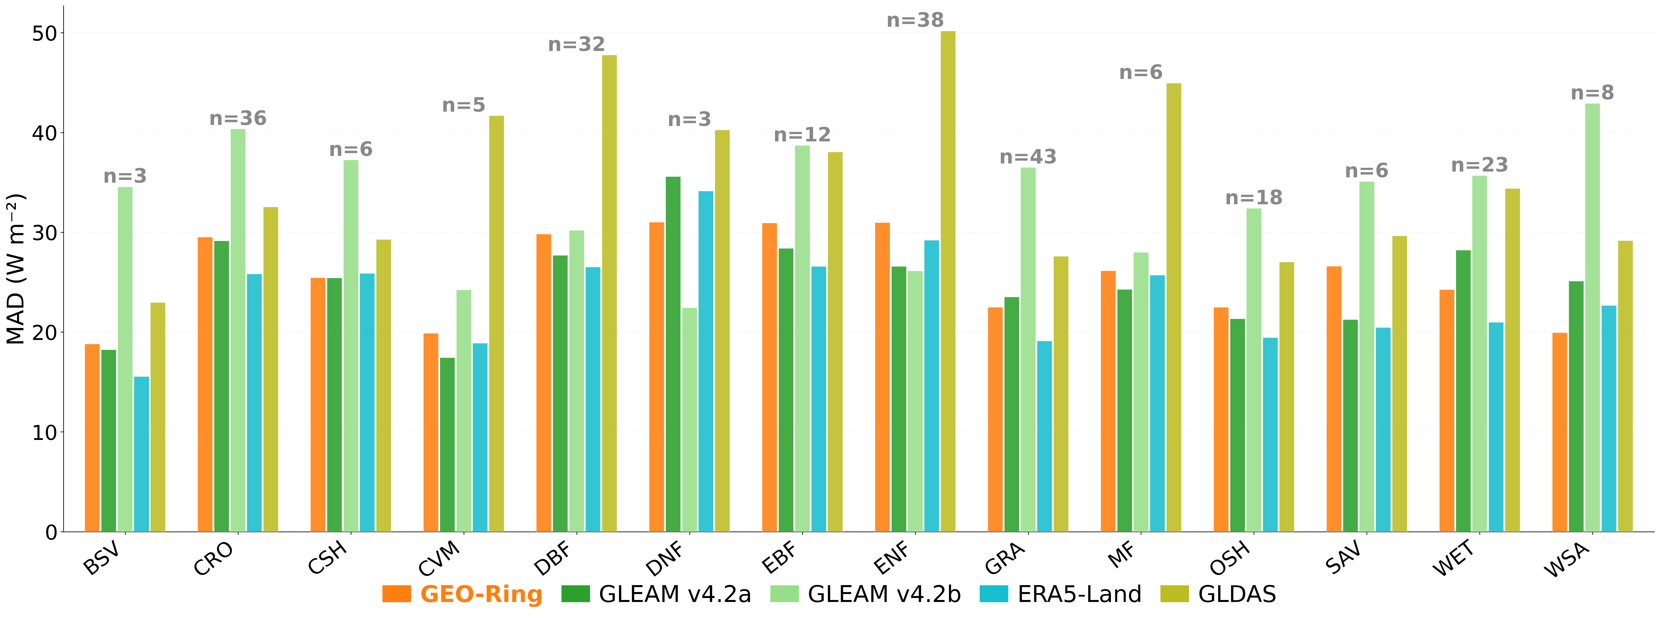
Figure 19: Mean Absolute Difference (MAD; W m-2) of Sensible heat flux (H) across IGBP land cover classes for CM SAF GEO-Ring, GLEAM v4.2a, GLEAM v4.2b, ERA5-Land and GLDAS. Values (n) above each group of bars indicate the number of in situ stations per land cover classes.
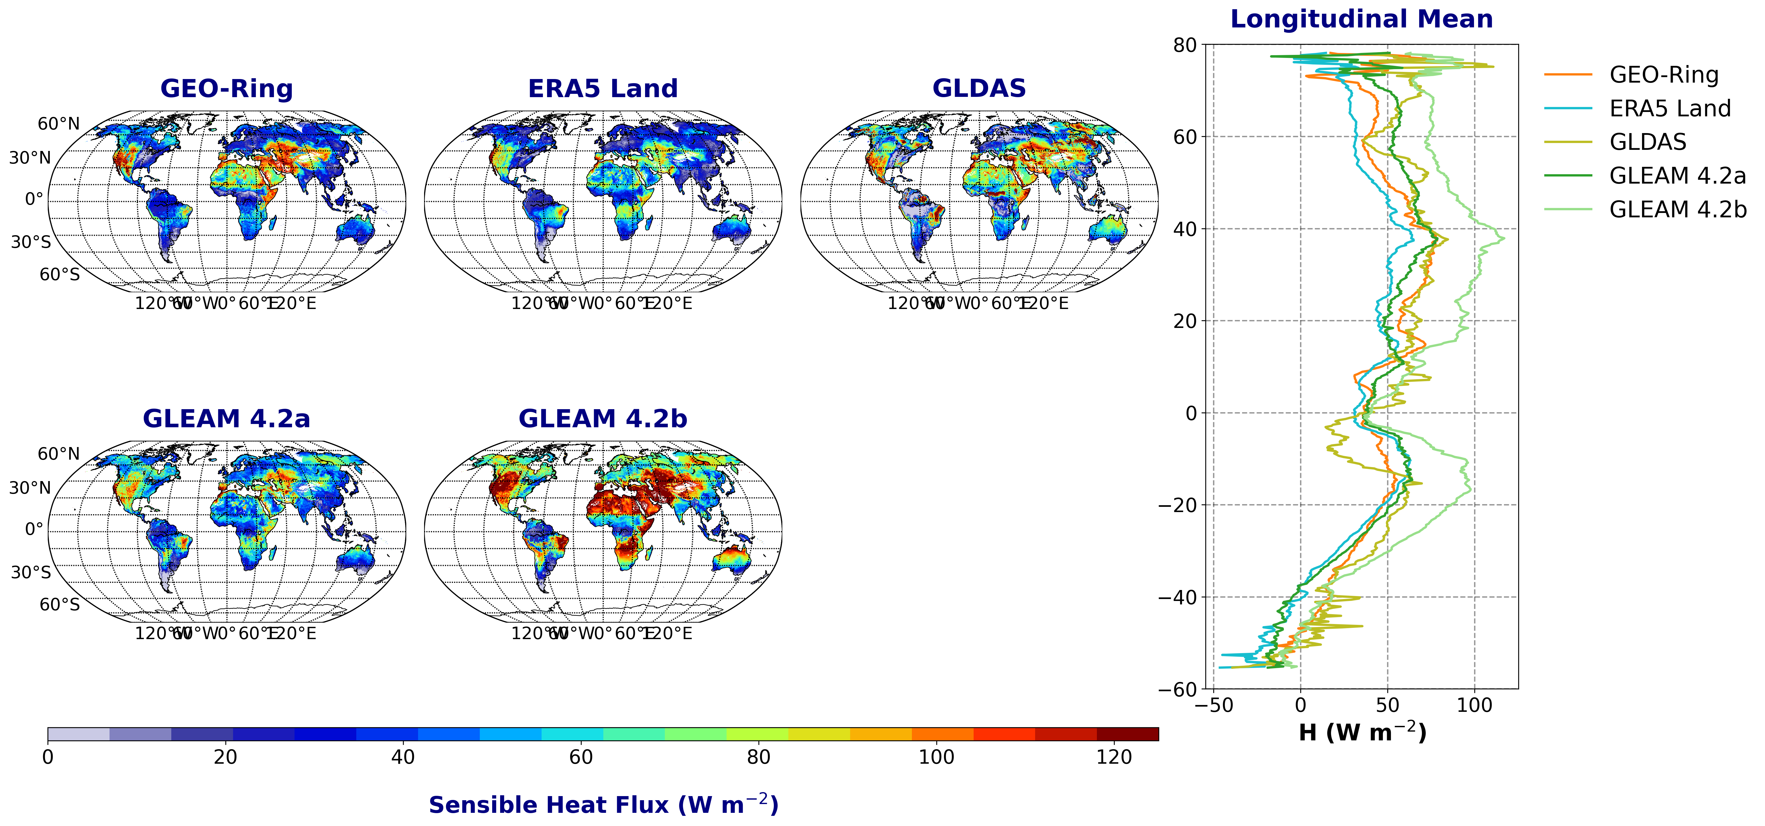
Figure 20: Global spatial distribution, for the season (June-July-August), of Sensible heat flux (H; W m⁻²) from CM SAF GEO-Ring, ERA5-Land, GLDAS, and GLEAM (v4.2a and 4.2b). The right panel displays the corresponding longitudinal mean profile as a function of the latitude.
Grid-based global comparisons on a common 0.25° grid (Figure 20) show a systematic feature across all seasons: GLEAM 4.2b exhibits higher sensible heat flux values compared to all other datasets except around the equator. Beyond this, notable variability remains among the other products, which underlines the difficulty of labelling a single product as a reference across all regions. For the JJA season specifically, over the Amazon core (10°S-5°N, 75°W-50°W), CM SAF gives 31.2 W m⁻², above GLDAS and ERA5-Land (23.9 to 27.5 W m⁻²) and below GLEAM (35.6 to 35.9 W m⁻²). Over the Congo basin core (5°S-5°N, 15°E-30°E), the pattern differs: CM SAF (29.7 W m⁻²) is just above GLDAS (28.9 W m⁻²) and well below ERA5-Land and GLEAM (33.6 to 43.9 W m⁻²). North of the basin (4°N-10°N, 15°E-30°E), CM SAF gives the lowest value among all products at 18.6 W m⁻², whereas other datasets range from 36.9 W m⁻² (ERA5-Land) to 94.3 W m⁻² (GLDAS). As expected this low H values mirrors the higher LE values observed for CM SAF in the same area (see section 2.3.3.1) At higher latitudes, CM SAF shows intermediate values compared to the other products, for instance 48.2 W m⁻² over high-latitude North America (50°N-70°N, 170°W-50°W) and 40.7 W m⁻² over north-eastern Asia (50°N-70°N, 60°E-180°E), compared with 32.3 and 32.6 W m⁻² for ERA5-Land in the same two regions.

For the other seasons, CM SAF also gives lower H values than the other products at high latitudes, but the affected latitude range change according to the season. In DJF, this feature extends from 60°N poleward. In MAM, it is confined to 70-80°N. In SON, it covers 60-80°N and strengthens toward the pole. Part of the future work will focus on these high-latitude regions.

Recommended application
By combining quasi-global coverage, high-frequency observations, and internally consistent retrievals, the demonstration dataset can be a valuable resource for studying atmospheric processes, evaluating weather and climate models, and investigating variability across a wide range of temporal and spatial scales.
The dataset should be helpful in evaluating the physical consistency between variables, identifying biases, and improving the representation of key processes in coupled climate models. The high temporal resolution can enable meaningful analysis of mean diurnal cycles of clouds and the radiation budget, a critical aspect of climate model behavior.
Furthermore, the dataset may allow process-based analyses of high-frequency observations that could improve the understanding of differences in cloud feedbacks between models.
The current demonstrator covers only one year and has a number of limitations as described in Section 2.2. Therefore, some applications may not be fully feasible, but might be realized as a proof-of-principle.

Changes to heritage version and evolution
The demonstrator is the first GEO-Ring land surface temperature, surface radiative budget as well as latent and sensible heat fluxes (and evapotranspiration) dataset created by CM SAF.
CM SAF will continue to generate all products and will release reprocessed ISCCP-NG-like products in 2031. These products will be based on reprocessed GEO-Ring L1g data, will again be accompanied cloud and TOA radiation, all on the same high spatial, high temporal resolution grid and in the same format.

Data format description
The GEO-Ring-based ISCCP-NG Demonstrator Dataset is provided as NetCDF-4 (Network Common Data Format v4) files (http://www.unidata.ucar.edu/software/netcdf/). The data files are created following NetCDF Climate and Forecast (CF) Metadata Convention version 1.12 (https://cfconventions.org/Data/cf-conventions/cf-conventions-1.12/cf-conventions.html) and NetCDF Attribute Convention for Dataset Discovery version 1.3 (http://wiki.esipfed.org/index.php/Attribute_Convention_for_Data_Discovery_1-3).
For data processing and conversion to various graphical packages input format, the CM SAF recommends the usage of the climate data operators (CDO), available under GNU Public License (GPL) from MPI-M (http://www.mpimet.mpg.de/~cdo).
A separate output file is available for each time step. The filenames follow the naming convention below.
Averaged hourly Level 3 (L3) files:
[PROD][t][s][yyyy][mm][dd]T[HH][MM]_ISCCPNG_DemoData_V01.nc,
where the meaning of the identifiers between brackets is given in Table 3-11.
Averaged daily Level 3 (L3) files:
[PROD][t][s][yyyy][mm][dd]_ISCCPNG_DemoData_V01.nc
Averaged monthly Level 3 (L3) files:
[PROD][t][s][yyyy][mm]_ISCCPNG_DemoData_V01.nc
Averaged monthly mean diurnal cycle Level 3 (L3) files:
[PROD][t][s][yyyy][mm]T[HH][MM]_ISCCPNG_DemoData_V01.nc

Table 3-11: File name format.
Abbreviation | Meaning
PROD | Product name, e.g., LST, SRB, LEH
t | time interval (h=hourly, m=monthly, d=daily)
s | time statistics (n = none, m=mean, h=histogram)
yyyy | year
mm | month
dd | day
HH | hour
MM | minute

The string _ISCCPNG_DemoData_V01 is the CM SAF specific demonstration data suffix. The file type identifier .nc stands for a NetCDF file.
For example, LSThm20210616T1200_ISCCPNG_DemoData_V01.nc is a file containing the hourly land surface temperature parameter for 16 June 2021 12:00 UTC and LEHmm202106_ISCCPNG_DemoData_V01.nc is a file containing the monthly mean latent and sensible heat fluxes and evapotranspiration parameters for June 2021.

General variables
Table 3-12: General variables in each product.
Name | Description
time | observation timestamp in days since 1970-01-01 00:00 UTC
time_bnds | time bounds (L3 only)
lat | latitude in degrees north
lon | longitude in degrees east
lat_bnds | latitude bounds
lon_bnds | longitude bounds
latlon_grid | grid mapping variable to specify the coordinate reference system
record_status | overall status of each record in the file: 0: “ok”, 1: “void”, 2: “bad_quality”

Product specific data fields
This section provides a description of main variables in the ISCCP-NG Demo L2 and L3 products.
All variables are three-dimensional, with dimensions (time, lat, lon) except for the JCH histogram.

Table 3-13: Main variables in the ISCCP-NG Demo L3 latent and sensible heat fluxes and evapotranspiration products files.
Product name (ID) | Variable | Description | Unit
Surface Latent and Sensible heat flux (LE/H) | le | Surface latent heat flux | W m⁻²
Surface Latent and Sensible heat flux (LE/H) | h | Surface sensible heat flux | W m⁻²
Surface Latent and Sensible heat flux (LE/H) | et | Evapotranspiration | mm h⁻¹; mm day⁻¹; mm month⁻¹
Surface Latent and Sensible heat flux (LE/H) | g | Ground heat flux | W m⁻²

Table 3-14: Main variables in the ISCCP-NG Demo L3 land surface temperature products files
Product name (ID) | Variable | Description | Unit
Land Surface Temperature (LST)
‍
‍

Table 3-15: Main variables in the ISCCP-NG Demo L3 surface radiative budget products files.
Product name (ID) | Variable | Description | Unit
Surface Radiative Budget (SRB)

Data access
Information and documentation about the CM SAF and the CM SAF products are available from the CM SAF homepage (https://www.cmsaf.eu). The webpage also contains a specified section for Demonstrator datasets.
The corresponding information on the GEO-Ring-based ISCCP-NG land surface temperature, surface radiative budget, latent and sensible heat fluxes (and evapotranspiration) Demonstrator Dataset can be found here or directly by visiting https://www.cmsaf.eu/demo_ISCCPNG.

Product ordering process
The GEO-Ring-based ISCCP-NG land surface temperature, surface radiative budget, latent and sensible heat fluxes (and evapotranspiration) Demonstrator Dataset is saved in a dedicated S3 bucket within the European Weather Cloud (EWC). The bucket is accessible from outside the EWC, however access credentials are needed.
For getting access to the S3 bucket, users are asked to contact the CM SAF User Help Desk (contact.cmsaf@dwd.de). The User Help Desk will provide further details on the dataset location and access details.
The distribution of this demonstrational product is free of charge (please note the Copyright and Disclaimer in Section 6).

Contact user help desk
In case of questions the contact information of the User Help Desk is available via the CM SAF home webpage (www.cmsaf.eu).

User problem report
Users of CM SAF products and services are encouraged to provide feedback on the CM SAF product and services to the CM SAF team. Users can contact the User Help Desk (see Section 4.2).

Service messages / log of changes
Service messages and a log of changes are also accessible from the CM SAF main webpage (www.cmsaf.eu) and provide useful information on product status, versioning and known deficiencies. Service messages and a log of changes are also accessible from the CM SAF home webpage (http://www.cmsaf.eu) and provide useful information on product status, versioning and known deficiencies.

Feedback

User feedback
Users of the CM SAF products and services are encouraged to provide feedback on the CM SAF product and services to the CM SAF team. CM SAF is keen to learn of what use the CM SAF data are. So please feedback your experiences as well as your application area of the CM SAF data.
The EUMETSAT CM SAF is a user-driven service and is committed to consider the needs and requirements of its users in the planning for product improvements and additions. Please provide your feedback e.g. to our User Help Desk (e-mail address contact.cmsaf@dwd.de).

Specific requirements for future products
Beside your general feedback you are cordially invited to provide your specific requirements on future products for your applications. Please provide your requirements e.g. to our staff or via our User Help Desk (e-mail address contact.cmsaf@dwd.de).

User workshops
The CM SAF organizes training workshops on regular basis in order to facilitate the use of our data. Furthermore, through our regular (approximately every four years) user’s workshop our product baseline is revisited. Your participation in any of these workshops is highly appreciated. Please have a look at on the CM SAF home web page (www.cmsaf.eu) to get the latest news on upcoming events.

Citation, copyright, acknowledgement, disclaimer
The user of CM SAF data agrees to respect the following regulations:
Copyright
All intellectual property rights of the CM SAF products belong to EUMETSAT. The use of these products is granted to every interested user, free of charge.
License Attribution Guidance (examples):
License Statement:
The CM SAF products are licensed under Creative Commons Attribution 4.0 International License (CC-BY-4.0, https://creativecommons.org/licenses/by/4.0/deed.en) by EUMETSAT.
Whether you’re displaying the product as-is or if you have used it as input data, please use one of the following attributions:
Figures (short, example):
EUMETSAT CM SAF [Product Identifier + Version] (e.g., “EUMETSAT CM SAF CM-25011 v0.1, under CC-BY-4.0 license”).
Texts (long, example):
”EUMETSAT CM SAF, GEO-Ring-based ISCCP-NG Demonstrator Dataset from CM SAF: Clouds and Top-Of-Atmosphere Radiation (2026), CM-25011/CM-25311.”
Papers (example):
“EUMETSAT Satellite Application Facility on Climate Monitoring, GEO-Ring-based ISCCP-NG Demonstrator Dataset from CM SAF: Clouds and Top-Of-Atmosphere Radiation (2026), CM-25011/CM-25311.”
Acknowledgement
When exploiting EUMETSAT/CM SAF data in publications you are kindly requested to acknowledge this contribution accordingly and make reference to the CM SAF, e.g. by stating “The work performed was done by using data from EUMETSAT’s Satellite Application Facility on Climate Monitoring (CM SAF)”.
If you cite any CM SAF product in publications, please let us know by sending the title and DOI to contact.cmsaf@dwd.de.
Disclaimer
EUMETSAT offers no warranty and accepts no liability in respect of the SAF on Climate Monitoring products. EUMETSAT neither commits to nor guarantees the continuity, availability, or quality or suitability for any purpose of the SAF on Climate Monitoring products.

References

Heidinger, A.K., Stephens, G, Schulz, J, John, V.O., Meirink, J.F., Stengel, M., Phillips, C, Knapp, K.R., Luffarelli, M., Eliasson, S., Fiolleau, T., Roca, R., L’Ecuyer, T., and Horn, C., 2026: A GEO-Ring of Spectral Radiances: Toward a Next Generation of the International Satellite Cloud Climatology Project (ISCCP-NG). Bull. Amer. Meteor. Soc., 107, E291–E308, https://doi.org/10.1175/BAMS-D-24-0161.1.
Hersbach, H., et al., (2020): The ERA5 global reanalysis, Q. J. Roy. Meteor. Soc., 146, 1999–2049, https://doi.org/10.1002/qj.3803, 2020.

Meirink, J.F., R.A. Roebeling and P. Stammes, 2013: Inter-calibration of polar imager solar channels using SEVIRI, Atm. Meas. Tech., 6, 2495-2508, doi:10.5194/amt-6-2495-2013.

Rossow, W. B., 2022: History of the International Satellite Cloud Climatology Project. WCRP Rep. 6/2022, 95 pp., https://doi.org/10.13021/gewex.isccp.
Schiffer, R. A., and W. B. Rossow, 1983: The International Satellite Cloud Climatology Project (ISCCP): The first project of the World Climate Research Programme. Bull. Amer. Meteor. Soc., 64, 779–784, https://doi.org/10.1175/1520-0477-64.7.779.

Stengel, M., Stapelberg, S., Sus, O., Finkensieper, S., Würzler, B., Philipp, D., Hollmann, R., Poulsen, C., Christensen, M., and McGarragh, G., 2020: Cloud_cci Advanced Very High Resolution Radiometer post meridiem (AVHRR-PM) dataset version 3: 35-year climatology of global cloud and radiation properties, Earth Syst. Sci. Data, 12, 41–60, https://doi.org/10.5194/essd-12-41-2020.

Yu, F., Wu, X., Yoo, H., Wang, Z., Qian, H., and Shao, X., 2019: Radiometric calibration performance of GOES-17 Advanced Baseline Imager (ABI), Proc. SPIE 11127, 111271C, doi:10.1117/12.2531407.

Albergel, C., Rüdiger, C., Pellarin, T., Calvet, J. C., Fritz, N., Froissard, F., Suquia, D., Petitpa, A., Piguet, B., & Martin, E. (2008). From near-surface to root-zone soil moisture using an exponential filter: an assessment of the method based on in-situ observations and model simulations. Hydrology and Earth System Sciences, 12, 1323–1337, doi:10.5194/hess-12-1323-2008

Balsamo, G., Beljaars, A., Scipal, K., Viterbo, P., van den Hurk, B., Hirschi, M., & Betts, A. K. (2009). A revised hydrology for the ECMWF model: Verification from field site to terrestrial water storage and impact in the Integrated Forecast System. Journal of hydrometeorology, 10(3), 623-643, doi:10.1175/2008JHM1068.1
Barrios, J., Arboleda, A., Dutra, E., Trigo, I., and Gellens-Meulenberghs, F. (2024). Evapotranspiration and surface energy fluxes across europe, africa and eastern south america throughout the operational life of the meteosat second generation satellite. Geoscience Data Journal, 11(4):589–607.

Cheng, G., Li, X., Zhao, W., Xu, Z., Feng, Q., Xiao, S., & Xiao, H. (2014). Integrated study of the water–ecosystem–economy in the Heihe River Basin. National science review, 1(3), 413-428.
Danielson, J. J., & Gesch, D. B. (2011). Global multi-resolution terrain elevation data 2010 (GMTED2010).

Dietz, A. J., Kuenzer, C., & Dech, S. (2015). Global SnowPack: a new set of snow cover parameters for studying status and dynamics of the planetary snow cover extent. Remote sensing letters, 6(11), 844-853.

ECMWF. Part IV: Physical processes. In IFS Documentation CY48R1; Number 4 in IFS Documentation; ECMWF, 2023, 10.21957/02054f0fbf

Foken, T. (2008). The energy balance closure problem: an overview. Ecological Applications, 18(6), 1351-1367.

Franssen, H. H., Stöckli, R., Lehner, I., Rotenberg, E., & Seneviratne, S. I. (2010). Energy balance closure of eddy-covariance data: A multisite analysis for European FLUXNET stations. Agricultural and Forest Meteorology, 150(12), 1553-1567.

Gellens-Meulenberghs, F., Arboleda, A., & Ghilain, N. (2006, March). Status of development of the LSA–SAF evapotranspiration product. In Proc. 2nd LSA–SAF Training Workshop (pp. 8-10).

Gellens-Meulenberghs, F., Arboleda, A., & Ghailain, N. (2007). Towards a continuous monitoring of evapotranspiration based on MSG data. IAHS PUBLICATION, 316, 228.

Ghilain, N., Arboleda, A., & Gellens-Meulenberghs, F. (2011). Evapotranspiration modelling at large scale using near-real time MSG SEVIRI derived data. Hydrology & Earth System Sciences, 15(3), doi:10.5194/hess-15-771-2011

Ghilain, N., Arboleda, A., Sepulcre-Canto, G., Batelaan, O., Ardo, J., & Gellens-Meulenberghs, F. (2012). Improving evapotranspiration in a land surface model using biophysical variables derived from MSG/SEVIRI satellite, doi:10.5194/hess-16-2567-2012

Ghilain, N., Arboleda, A., Barrios, J. M., & Gellens-Meulenberghs, F. (2020). Water interception by canopies for remote sensing based evapotranspiration models. International Journal of Remote Sensing, 41(8), 2934-2945, doi:10.1080/01431161.2019.1698072
Guo, X., Meng, D., Chen, X., & Li, X. (2022). Validation and Comparison of Seven Land Surface Evapotranspiration Products in the Haihe River Basin, China. Remote Sensing, 14(17), 4308.

Harper, K. L., Lamarche, C., Hartley, A., Peylin, P., Ottlé, C., Bastrikov, V., San Martín, R., Bohnenstengel, S. I., Kirches, G., Boettcher, M., Shevchuk, R., Brockmann, C., and Defourny, P.: A 29-year time series of annual 300 m resolution plant-functional-type maps for climate models, Earth Syst. Sci. Data, 15, 1465–1499, https://doi.org/10.5194/essd-15-1465-2023, 2023.

Li, E., Tong, Y., Huang, Y., Li, X., Wang, P., Chen, H., & Yang, C. (2019). Responses of two desert riparian species to fluctuating groundwater depths in hyperarid areas of Northwest China. Ecohydrology, 12(3), e2078.

Liang, S., Cheng, J., Jia, K., Jiang, B., Liu, Q., Xiao, Z., ... & Zhou, J. (2021). The global land surface satellite (GLASS) product suite. Bulletin of the American Meteorological Society, 102(2), E323-E337.

Liu, S., Xu, Z., Che, T., Li, X., Xu, T., Ren, Z., ... & Ma, Y. (2023). A dataset of energy, water vapor and carbon exchange observations in oasis-desert areas from 2012 to 2021 in a typical endorheic basin. Earth System Science Data Discussions, 2023, 1-45.

Loew, A., Peng, J., & Borsche, M. (2016). High-resolution land surface fluxes from satellite and reanalysis data (HOLAPS v1. 0): evaluation and uncertainty assessment. Geoscientific Model Development, 9(7), 2499-2532.

Mauder, M., Foken, T., & Cuxart, J. (2020). Surface-Energy-Balance Closure over Land: A Review: M. Mauder et al. Boundary-layer meteorology, 177(2), 395-426.

Miralles, D.G., Holmes, T.R.H., de Jeu, R.A.M., Gash, J.H., Meesters, A.G.C.A., Dolman, A.J. (2011). Global land-surface evaporation estimated from satellite-based observations, Hydrology and Earth System Sciences, 15, 453–469.

Miralles, D. G., Bonte, O., Koppa, A., Villanueva, O. B., Tronquo, E., Zhong, F., Beck, H. E., Hulsman, P., Dorigo, W., Verhoest, N. E. C., & Haghdoost, S. (2024). GLEAM4: global land evaporation dataset at 0.1 resolution from 1980 to near present.

Muñoz-Sabater, J., Dutra, E., Agustí-Panareda, A., Albergel, C., Arduini, G., Balsamo, G., ... & Thépaut, J. N. (2021). ERA5-Land: A state-of-the-art global reanalysis dataset for land applications. Earth system science data discussions, 2021, 1-50.

Nelson, J. A., Walther, S., Gans, F., Kraft, B., Weber, U., Novick, K., ... & Jung, M. (2024). X-BASE: the first terrestrial carbon and water flux products from an extended data-driven scaling framework, FLUXCOM-X. Biogeosciences, 21(22), 5079-5115.

Papale, D. (2020). Ideas and perspectives: enhancing the impact of the FLUXNET network of eddy covariance sites. Biogeosciences, 17(22), 5587-5598.

Pastorello, G., Trotta, C., Canfora, E., Chu, H., Christianson, D., Cheah, Y. W., ... & Law, B. (2020). The FLUXNET2015 dataset and the ONEFlux processing pipeline for eddy covariance data. Scientific data, 7(1), 225.

Rodell, M., Houser, P. R., Jambor, U. E. A., Gottschalck, J., Mitchell, K., Meng, C. J., ... & Toll, D. (2004). The global land data assimilation system. Bulletin of the American Meteorological society, 85(3), 381-394.

Santanello Jr, J. A., & Friedl, M. A. (2003). Diurnal covariation in soil heat flux and net radiation. Journal of Applied Meteorology, 42(6), 851-862.

Senay, G. B., Kagone, S., & Velpuri, N. M. (2020). Operational global actual evapotranspiration: Development, evaluation, and dissemination. Sensors, 20(7), 1915.

Simard, M., Pinto, N., Fisher, J. B., & Baccini, A. (2011). Mapping forest canopy height globally with spaceborne lidar. Journal of Geophysical Research: Biogeosciences, 116(G4), doi: 10.1029/2011JG001708
Still, C. J., Berry, J. A., Collatz, G. J., & DeFries, R. S. (2003). Global distribution of C3 and C4 vegetation: carbon cycle implications. Global biogeochemical cycles, 17(1), 6-1.

Stoy, P. C., Mauder, M., Foken, T., Marcolla, B., Boegh, E., Ibrom, A., ... & Varlagin, A. (2013). A data-driven analysis of energy balance closure across FLUXNET research sites: The role of landscape scale heterogeneity. Agricultural and forest meteorology, 171, 137-152.
Tang, L. I., & McColl, K. A. (2023). An Observational, Irrigation-Sensitive Agricultural Drought Record from Weather Data. Journal of Hydrometeorology, 24(11), 2091-2103.

Van den Hurk, B. J. J. M., Viterbo, P., Beljaars, A. C. M., & Betts, A. K. (2000). Offline validation of the ERA40 surface scheme, ECMWF TechMemo 295. Reading, UK.
Viterbo, P., & Beljaars, A. C. (1995). An improved land surface parameterization scheme in the ECMWF model and its validation. Journal of climate, 8(11), 2716-2748, 10.1175/1520-0442(1995)008<2716:AILSPS>2.0.CO;2
Wilson, K., Goldstein, A., Falge, E., Aubinet, M., Baldocchi, D., Berbigier, P., ... & Verma, S. (2002). Energy balance closure at FLUXNET sites. Agricultural and Forest Meteorology, 113(1-4), 223-243.

Zhang, A., Zheng, C., Wang, S., & Yao, Y. (2015). Analysis of streamflow variations in the Heihe River Basin, northwest China: Trends, abrupt changes, driving factors and ecological influences. Journal of Hydrology: Regional Studies, 3, 106-124.

Glossary – List of Acronyms
ABI Advanced Baseline Imager
AHI Advanced Himawari Imager
ATBD Algorithm Theoretical Basis Document
bc bias-corrected
CALIPSO Cloud-Aerosol Lidar and Infrared Pathfinder Satellite Observations
CALIOP Cloud-Aerosol Lidar with Orthogonal Polarization
CFC Cloud Fractional Coverage
CDOP Continuous Development and Operational Phase
CDR Climate Data Record
CERES Clouds and the Earth's Radiant Energy System
CIMSS Cooperative Institute for Meteorological Satellite Studies
CM SAF Satellite Application Facility on Climate Monitoring
CMA Cloud Mask
CMAPROB Probabilistic Cloud Mask
COT Cloud Optical Thickness
CPH Cloud Phase
CPP Cloud Physical Properties
CTO Cloud Top level, expressed as pressure, temperature or height
CTP Cloud Top Pressure
CWP Cloud Water Path
DWD Deutscher Wetterdienst
ECV Essential Climate Variable
ERA5 ECMWF Reanalysis 5th Generation
EUMETSAT European Organisation for the Exploitation of Meteorological Satellites
FCDR Fundamental Climate Data Record
FOV Field Of View
GEO Geostationary
GEWEX Global Energy and Water Exchanges
GOES Geostationary Operational Environmental Satellite
IASI Infrared Atmospheric Sounding Interferometer
ISCCP International Satellite Cloud Climatology Project
ISCCP-NG ISCCP - Next Generation
KNMI Royal Netherlands Meteorological Institute
MAB Mean Absolute Bias
MODIS Moderate-Resolution Imaging Spectroradiometer
MSG Meteosat Second Generation
NOAA National Oceanic and Atmospheric Administration
OLR Outgoing Longwave Radiation
PRD Product Requirements Document
PUM Product User Manual
RMIB Royal Meteorological Institute Belgium
RMSE Root Mean Square Error
RSF Reflected Solar Flux
SBAF Spectral Band Adjustment Factor
SCIAMACHY SCanning Imaging Absorption For Atmospheric CHartographY
SEVIRI Spinning Enhanced Visible and Infrared Imager
SMHI Swedish Meteorological and Hydrological Institute
SZA Solar Zenith Angle
VZA Viewing Zenith Angle

